ENVIRONMENTAL AND SOCIAL IMPACT ASSESSMENT (ESIA) FOR THE PROPOSED MUBI INTERNATIONAL CATTLE MARKET, MUBI SOUTH LOCAL GOVERNMENT AREA, ADAMAWA STATE, NIGERIA
PREPARED BY
INCLUSIVE BASIC SERVICE DELIVERY AND LIVELIHOOD EMPOWERMENT INTEGRATED PROGRAMME (IBSDLEIP)
SUBMITTED TO

FEDERAL MINISTRY OF ENVIRONMENT, MABUSHI, ABUJA FEDERAL CAPITAL TERRITORY
FINAL REPORT

SEPTEMBER, 2023

TABLE OF CONTENTS

TABLE OF CONTENTS ii
LIST OF TABLES vii
LIST OF FIGURES ix
LIST OF ABBREVIATIONS AND ACRONYMS xi
LIST OF ESIA STUDY TEAM AND REPORT PREPARERS xiii
EXECUTIVE SUMMARY xiv
ACKNOWLEDGEMENT xx
CHAPTER ONE 1
INTRODUCTION 1
1.1 Background Information 1
1.5 Purpose and Objectives of ESIA 2
1.6 The Scope of the ESIA Study 4
1.7 Administrative and Legal Framework for ESIA 5
1.7.1 ESIA Legal Framework and Regulatory Authorities in Nigeria 6
1.6.2 National Legislations 7
1.6.3 International legislation of relevance to EIA/SIA 10
1.7.2 International financial institutions safeguards 11
1.8 Key Elements of the ESIA Process 14
1.1.3 Structure of ESIA Report 15
CHAPTER TWO 18
PROJECT JUSTIFICATION 18
2.1 Need for the Project 18
2.2 Value of the Project 18
CHAPTER THREE 21
PROJECT AND PROCESS DESCRIPTION 21
3.1 Type of Project 21
3.2 Project Site 21
3.3 Survey Plan of the Site 21
3.4 Existing Land use 24
3.5 Land Use Plan for the Proposed Project 24
3.6 Building Plans 29
3.7 Accessibility to the Site 35
3.8 Plans on Cattle Routes 35
3.9 Compliance with Planning Regulations 37
3.9.1 Setbacks 37
3.9.2 Plot Coverage and Accommodation Capacity 38
3.9.3 Airspace 38
3.10 Workforce Requirement 38
3.11 Construction Process 38
3.12 Construction materials 39
3.13 Construction equipment 39
3.14 Energy Consumption 39
3.15 Project Traffic Management Plan 39
3.16 Waste Management 41
3.16.1 Waste Generation and Sources 41
3.16.2 Overall Waste Management 42
3.17 Project Implementation Schedule 43
CHAPTER FOUR 45
DESCRIPTION OF THE PROJECT ENVIRONMENT 45
4.1 Introduction 45
4.2 Methodological Approach to the study 45
4.3 Climate 47
4.3.1 Rainfall 48
4.3.2 Temperature 49
4.3.3 Relative Humidity 50
4.3.4 Wind 50
4.4 Vegetation Study 51
4.5 Air Quality 51
4.5.1 Carbon monoxide (CO) 52
4.5.2 Sulphur Dioxide (SO₂) 53
4.5.3 Nitrogen Dioxide (NO₂) 53
4.6 Noise 53
4.7 Water Quality 53
4.8 Soil 54
4.8.1 Heavy Metals Concentration 54
4.8.1.1 Arsenic (As) 54
4.8.1.2 Lead (Pb) 56
4.8.1.3 Cadmium (Cd) 56
4.8.1.4 Zinc (Zn) 56
4.8.1.5 Chromium (Cr) 56
4.8.1.6 Nikel (Ni) 56
4.8.1.7 Copper (Cu) 56
4.8.1.8 Iron (Fe) 57
4.8.1.9 Mercury (Hg) 57
4.8.2 Soil Quality 57
4.8.2.1 Soil pH 57
4.8.2.2 Sulphate (SO4-2) 57
4.8.2.3 Nitrogen (Total N) 59
4.8.2.4 Phosphorus (Av. P) 59
4.8.2.5 Phosphate (PO4-2) 59
4.8.2.6 Nitrate-nitrogen (NO3-N) 59
4.8.2.7 Nitrites (NO2-N) 59
4.8.2.8 Magnesium (Mg) 60
4.8.2.9 Potassium (K) 60
4.8.2.10 Organic carbon (OC) 60
4.9 Traffic Volume 60
4.10 Social and Economic Baseline Conditions of the Area 65
4.10.1 The Demographic Conditions 66
4.10.2 Communities and People of Mubi 66
4.10.3 Bio-Data Analysis 67
4.11 Health Survey/Analysis 68
4.11.1 Knowledge of Environmental Threats Associated With the Proposed Project 68
4.11.2 Health Status Assessment 68
4.11.3 The Current Health Status in the Study Area 68
4.11.4 Lifestyle and Wellness in Mubi Community 69
4.11.5 Cause of Health Problems in the area 69
4.11.6 Health Care Facilities 69
4.11.7 Types of HCFs 69
4.11.8 Physical Status of HCFs 70
4.11.9 Availability of Amenities 70
4.12 Public participation 70
CHAPTER FIVE 72
POTENTIAL AND ASSOCIATED IMPACTS 72
5.1 Introduction 72
5.2 Defining the Impact Scope and Indicators 72
5.3 Environmental Components and Impact Indicators 72
5.4 Impact Identification and Evaluation 73
5.5 Summary of Impacts 76
5.5.1 Significant Positive Impacts 76
5.5.2 Significant Negative Impacts 76
5.5.3 Irreversible Changes 77
5.5.4 Cumulative/Secondary Impacts 77
CHAPTER SIX 78
MITIGATION MEASURES 78
6.1 Introduction 78
6.2 Contingency Plan 78
6.2.1 Area of Emergency 78
6.2.2 Emergency Response Procedure 78
6.2.3 Emergency Plan 79
6.2.4 The Emergency Response 79
6.3 Mitigation Measures 80
6.3.1 Traffic Impacts 80
6.3.2 Noise 80
6.3.3 Decommissioning Impacts 81
6.3.4 Solid Waste 81
6.3.5 Soil and Ground Water Contamination 82
6.3.6 Impact on Electricity 83
6.3.7 Water Supply 83
6.3.8 Impact on Vegetation/Fauna/Flora 83
6.3.9 Impact on Health 84
6.3.10 Environmental Pollution 84
6.3.11 Fire Hazards 85
CHAPTER SEVEN 86
ENVIRONMENTAL AND SOCIAL MANAGEMENT PLAN (ESMP) 86
7.1 Introduction 86
7.2 Scope of Monitoring 86
7.3 Remediation Measures 92
7.4 Ambient Monitoring 94
CHAPTER EIGHT 95
REMEDIATION PLANS AFTER DECOMMISIONING 95
8.1 Decommissioning Phase 95
8.2 Highlight of Some Specific Impacts 95
8.2.1 Biophysical Impacts 95
8.2.2 Impacts on Climate 96
8.2.3 Noise Impacts 96
8.2.4 Impact on Geology 97
8.2.5 Soil Impact 98
8.2.6 Impacts on Water Resources 98
8.3 Health and Safety Impact 100
8.3.1 Injuries 100
8.3.2 Noise Impact on Health 100
8.3.3 Health Damage from Air Pollution 101
CHAPTER NINE 103
CONCLUSION AND RECOMMENDATIONS 103
9.1 Conclusion 103
9.2 Recommendations 103
REFERENCES 106
APPENDICES 107
APPENDIX I: SURFACE WATER ANALYSIS 107
APPENDIX II: WELL WATER ANALYSIS 110
APPENDIX III: QUESTIONNAIRE 113

LIST OF TABLES
Table 1. AfDB Integrated Safeguard System. 13
Table 2. Coordinates of the site. 24
Table 3. Land Use Analysis of Proposed Development. 29
Table 4. Waste Profile of the Proposed Mubi International Cattle Market. 42
Table 5. Summary of Mubi International Cattle Market Waste Management Plan. 42
Table 6. Sampling Points 47
Table 7. Average Rainfalls (mm) in Mubi. 49
Table 8. Monthly Mean Temperature (ºC) in Mubi. 49
Table 9. Relative Humidity (%) in Mubi. 50
Table 10. Air Quality Measurements at the Proposed Site. 52
Table 11. Heavy Metal Concentrations at the Proposed Site of Mubi International Cattle Market and Environs. 55
Table 12. Soil Properties in the Proposed Mubi International Cattle Market and Environs. 58
Table 13. Traffic Volume along Tike Road on Tuesday and Wednesday. 61
Table 14. Summary of Respondents on Gender, Marital status and Qualification. 67
Table 15. Summary of Respondents on Employment, Income and Occupation. 67
Table 16. Environmental Components and Impact Indicators. 73
Table 17. Consequence Severity, Likelihood Ranking & Risk Matrix Tables. 74
Table 18. Risk Assessment Matrix Table. 75
Table 19. Environmental and Social Management Plan for Construction and Operation Phases. 87
Table 20. Health Risk Assessment. 100
Table 21. Summary of Impact of Air Pollutants on Health. 101

LIST OF FIGURES
Figure 1. Location of Proposed Mubi International Cattle Market. 22
Figure 2. Location of the Proposed Project Site overlayed on Google Earth image. 23
Figure 3. Survey Plan of the Proposed Project Site. 25
Figure 4. Existing Land use around the Project Site. 27
Figure 5. Land use Plan of the Proposed Mubi International Cattle Market. 27
Figure 6. Detailed Site Plan of the Proposed Mubi International Cattle Market.. 28
Figure 7. Floor Plan of Proposed Livestock Sic Bar and Veterinary Clinic. 30
Figure 8. Roof Plan of Proposed Livestock Sic Bar and Veterinary Clinic. 30
Figure 9. Elevations of Proposed Livestock Sic Bar and Veterinary Clinic. 31
Figure 10. Side Elevations of Proposed Livestock Sic Bar and Veterinary Clinic. 31
Figure 11. Floor Plan of Proposed Cattle Loading Bar. 32
Figure 12. Section of Proposed Cattle Loading Bar. 32
Figure 13. Floor Plan of Proposed Livestock Pens with 305 Tether/Iron Poles. 33
Figure 14. Elevation of Proposed Livestock Pens with 305 Tether/Iron Poles. 33
Figure 15. Section of Proposed Livestock Pens with 305 Tether/Iron Poles. 34
Figure 16. Floor Plan of Proposed Trucks Weighing Scale. 34
Figure 17. Accessibility to the Proposed Project Site. 36
Figure 18. Plan of Cattle Routes in- and out to the Market. 37
Figure 19. Project Implementation Plan. 44
Figure 20. Spatial Distribution of Sampling points for various parameters. 48
Figure 21. Average Wind Speed (km/h) in Mubi (Source: https://www.weather-atlas.com/en/nigeria/mubi-climate). 51
Figure 22. Ahmadu Bello Way to Cattle Market on Tuesday (Field Survey, 2022). 62
Figure 23. Cattle Market to Ahmadu Bello Way on Tuesday (Field Survey, 2022). 62
Figure 24. Lamurde to Cattle Market on Tuesday (Field Survey, 2022). 63
Figure 25. Cattle Market to Lamurde on Tuesday (Field Survey, 2022). 63
Figure 26. Ahmadu Bello Way to Cattle Market on Wednesday (Field Survey, 2022). 64
Figure 27. Cattle Market to Ahmadu Bello Way on Wednesday (Field Survey, 2022). 64
Figure 28. Lamurde to Cattle Market on Wednesday (Field Survey, 2022). 65
Figure 29. Cattle Market to Lamurde on Wednesday (Field Survey, 2022). 65

LIST OF PLATES
Plate 1. The site of the project (Field Survey, 2022). 23
Plate 2. Inspection of Project Site with Staff of FMEnv, Adamawa State Ministry of Environment, Mubi South LGA and IBSDLEIP (Field Survey, 2022). 46
Plate 3. Nature of Vegetation Cover of the Proposed Site (Source: Field Survey, 2022). 52
Plate 4. Conducting Traffic Survey (Field Survey, 2022). 60
Plate 5. Photo after Stakeholder’s Meeting (Field Survey, 2022). 71

LIST OF ABBREVIATIONS AND ACRONYMS
ADSU - Adamawa State University
AEPA - Adamawa Environmental Protection Agency
AfDB - African Development Bank
As – Arsenic
Av. P – Phosphorus
Cd – Cadmium
CEAA - Canadian Environmental Assessment Act
CHC - Comprehensive Health Centers
CO - Carbon Dioxide
Cr – Chromium
Cu – Copper
dB – Decibels
DPR - Department of Petroleum Resources
EC – European Commission
EHS - Environmental, Health and Safety
EIA - Environmental Impact Assessment
ESIA - Environmental and Social Impact Assessment
ESMP - Environmental and Social Management Plan
Fe – Iron
FEPA - Federal Environmental Protection Agency
FMEnv - Federal Ministry of Environment
GPS - Global Positioning System
Ha – Hectares
HCF - Health Care Facility
Hg – Mercury
IBSDLEIP - Inclusive Basic Service Delivery and Livelihood Empowerment Integrated Programme
IFC - International Finance Corporation
ISS - Integrated Safeguard System
K – Potassium
MCH - Maternity Centers and Homes
Mg – Magnesium
NEPA - National Environmental Policy Act
NESREA - National Environmental Standards and Regulations Enforcement Agency
Ni – Nikel
NO₂ - Nitrogen Dioxide
NO2-N - Nitrite – nitrogen
NO3-N - Nitrate – nitrogen
OC - Organic Carbon
OECD - Organisation for Economic Co-operation and Development
OSs - Operating Safeguards
Pb – Lead
pH – Potentials of Hydrogen
PHC - Primary Health Care Centers
PO4-2 – Phosphate
POP - Plaster of Paris
RMA - New Zealand Resource Management Act
SEA - Strategic Environmental Assessments
SIA - Social Impact Assessment
SO₂ - Sulphur Dioxide
SO4-2 – Sulphate
Total N – Nitrogen
UN - United Nations
UNECE - United Nations Economic Commission for Europe
USA - United States of America
UTM - Universal Traverse Mercator
WBG - World Bank Group Operational Policies
WGS - World Geodetic System
Zn – Zinc

LIST OF ESIA STUDY TEAM AND REPORT PREPARERS
S/N | Name | Qualifications | Role Played
1. | Mohammed Halilu | BSc. Geology | Overall job execution and delivery
2. | Eng. Hussain M. Lakuza | B.Eng. Agricultural Engineering | Irrigation Expert
3. | Emmanuel Esley | BSc. Geology, MSc. Environmental Engineering | Environmental Engineering Expert
4. | Dr. Raji Muktar Modibbo | Ph.D. (Urban & Regional Planning), MNITP, TOPREC, NSE | Team Leader ESIA
5. | Dr. Abdur-Rahman Belel Ismaila | B.Tech. URP, Ph.D. (Geodetic & Geographic Information Technologies), MNITP, TOPREC | GIS Expert, ESIA, Field Work Coordinator
6. | Mohammed Shall | B.Tech. Biology Education | Biodiversity studies, Flora and Fauna.
7. | Alfarisu Tanko | B.Tech. Geology, MSc. Environmental Management | Environmental Geology, Geotechnical and Soil Analysis
8. | Garba Usman Mohammed | BSc. Soil Science | Soil Analysis
9. | Usman Gada’a | HND Urban & Regional Planning | Questionnaire Administrator, Soil, Air, and Noise Sample
10. | Dauda T. Malgwi |  | Water Sample and Analysis

EXECUTIVE SUMMARY
Introduction
The Adamawa State Government, through the Inclusive Basic Service Delivery and Livelihood Empowerment Integrated Programme (IBSDLEIP), is collaborating with the Federal Government of Nigeria and the African Development Bank (AfDB) to develop a new modern, integrated, and comprehensive Mubi International Cattle Market. The facility is intended to serve as a local, national, and international trading and commercial centre for cattle and other livestock. This Environmental and Social Impact Assessment (ESIA) was conducted in accordance with Nigerian Legislation and the AfDB Operating Safeguards. Chapter 1 of this ESIA contains a summary of the contents of each chapter that is required for the ESIA to meet the Federal Ministry of Environment and AfDB requirements/guidelines. The scoping stage of the ESIA identified the need to consider potential impacts during the construction and operational phases of the Project on climate change, soils, surface water, groundwater, air quality, noise, transport and access, visual, waste management, biodiversity and socio-economic characteristics on the functionality of the Project.
The Objectives of the Environmental and Social Impact Analysis:
- to describe the Project and associated works together with the requirements and environmental benefits for carrying out the Project;
- to identify and describe elements of community and environment likely to be affected by the Project and/or likely to cause adverse impacts to the Project, including natural and man-made environment and the associated environmental constraints;
- to provide information on the consideration of alternative options of the Project including alternative sitting, scale and size, extent, layout, configuration and orientation, transport linkage, people dispersion routes/methods after major events and construction methods to avoid and minimise potential environmental impacts to environmentally sensitive areas and sensitive uses;
- to compare the environmental benefits and constraints/problems of different options; to provide reasons for selecting the preferred option(s) and to describe the part environmental factors played in the selection of preferred option(s);
- to identify and quantify emission sources, including air and gaseous emission, noise emission, sewage and wastewater emission, waste generation and contaminated material generation and determine the significance of impacts on sensitive receivers and potential affected uses;
- to identify and quantify any potential losses or damage to flora, fauna and natural habitats;
- to identify and systematically evaluate any potential landscape and visual impacts and to propose measures to mitigate these impacts;
- to identify any negative impacts on sites of cultural heritage and to propose measures to mitigate these impacts; to propose the provision of infrastructure or mitigation measures to minimize pollution, environmental disturbance and nuisance during construction and operation of the Project;
- to investigate the feasibility, practicability, effectiveness and implications of the proposed mitigation measures;
- to identify, predict and evaluate the residual environmental impacts (i.e., after practicable mitigation) and the cumulative effects expected to arise during the construction and operation phases of the Project in relation to the sensitive receivers and potentially affected uses;
- to identify, assess and specify methods, measures and standards to be included in the detailed design, construction and operation of the Project which are necessary to mitigate these environmental impacts and cumulative effects and reduce them to acceptable levels;
- to investigate the extent of the secondary environmental impacts that may arise from the proposed mitigation measures and to identify constraints associated with the mitigation measures recommended in the EIA study, as well as the provision of any necessary modification; and
- to design and specify environmental monitoring and audit requirements to ensure the effective implementation of the recommended environmental protection and pollution control measures.
Terms of Reference
- The sampling was based on one season as approved by the Federal Ministry of Environment. The baseline information obtained was supplemented and supported with relevant information from the existing literature.
- The study methodology is in line with both National and International Environmental guidelines and standards for projects of this nature. This means that all applicable and mandatory local and global environmental-related conservation, preservation and best management practices are strictly taken into consideration and adhered to.
- Field survey and data collection methods as well as laboratory procedures are consistent and in conformity with established standards and methodologies.
- The study area is properly delineated indicating the proposed site and buffer areas to determine extreme boundaries of environmental influence.
- The report of this study is presented based on the following:
- Legal and Administrative Framework
- Project description
- Literature review and baseline information on environmental characteristics as well as other relevant data required
- Project justification and alternatives
- Identification and projection of associated and associated impacts.
- Design mitigation and remedial measures and instruments.
- Articulate Environmental Management Plan
Project Justification
In view of the growing population and general needs for economic growth and general physical regulated activities, the Adamawa State Government through the African Development Bank (AfDB) planned to develop a new modern, integrated and comprehensive International Cattle Market at Mubi. The facility is intended to serve as a local, national and international hub for cattle and other livestock trading and commercial centers. The market and the facilities would have auction grounds, health facilities in terms of a veterinary clinic, clinic/dispensary, hostel-like accommodation, offices, water and power infrastructure, sewerage plant, drainages, waste disposal, parking, loading and off-loading bay, etc. among many other utilities to make up for the general commercial interest and support livelihood in the town in particular and the State in general. Based on population projection, which is determined at a 3% annual growth rate, there is a need for upgrading and expansion of cattle and livestock trading and commercial centers in Mubi as well as in other viable locations in the State. There appears to be inadequate, poor-quality utilities and a general lack of proper commercial planning of trading hubs in the State, particularly in relation to cattle and other livestock products.
Description of the Environment
Project Site
The Project site covers a land area of about 25.248 hectares and is located between Latitude 10° 13' 39" N to 10° 14' 0.6" N and Longitude 13° 14' 11.4" E to 13° 14' 36.6" E in Mubi South Local Government Area of Adamawa State. It is bounded by residential development to the north, Mubi – Maiha Trunk ‘A’ Federal Highway to the west, and range of mountains to both south and east. It is also 4.5 km from the existing location of the Mubi Cattle Market. The designated site of proposed project to be Mubi International Cattle Market is presently a farmland. The Universal Traverse Mercator (UTM) Coordinates of project site is presented below;
Coordinates of the site
Beacons | Easting (m) | Northing (m)
TP01 | 240729.596 | 1021938.700
TP02 | 240956.703 | 1022013.563
TP03 | 241305.138 | 1022099.243
TP04 | 241350.258 | 1021929.771
TP05 | 241144.253 | 1021883.849
TP06 | 240764.805 | 1021773.453
Note: Coordinate System/Datum: WGS 1984, UTM Zone 33 N
The terrain on the site is generally rough, with hills that are sparsely distributed. The elevation in the project area ranged from 644m (at its highest point) to 613.5m (lowest). The site is drained from east to west, with three (3) streams emptying into the main stream alongside the Mubi-Maiha Trunk 'A' Federal Highway, which eventually empties into the River Buladega. The site is oriented north-south.
Plan of the Site
The Project site is approximately 25.248 hectares in size. The market and facilities would include auction grounds, health facilities such as a veterinary clinic, clinic/dispensary, hostel-like accommodation, offices, storage areas, drainages, water and electricity infrastructure, sewage treatment works, waste disposal, roads, parking, loading and off-loading bays, and so on, among many other facilities to make up for the general commercial interest and support livelihood in the town in particular and the State in general.
Diversity of Flora around and within the site
The diversity and resources of Fauna around and within the site is similar to those within the region as well as the ecosystem. The site is located within Sudan savannah region of Adamawa State. The common trees are eucalyptus, neem, baobab, tamarind, etc. while elephant grass is common in the area. Most of area of proposed development is vacant. This habitat was disturbed by human but has been vacant for a long period. Vegetation found in this habitat is practically non-existent. No exotic species were identified.
Fauna Diversity
The Fauna species within and around the site is mainly vertebrate and invertebrate animals No avifauna species with conservation importance were recorded in the vacant Area. No uncommon or rare species was found in this habitat.
The Host Community
The majority of people within and around the proposed sites are farmers and traders. The area is characterised by several ethnic and social groups. Prominent ethnic identities in the community are the Fali, Fulani, Marghi, Gude, Hausa and sub-varieties of these tribes. The major economic activities in the area are farming and rearing of animals.
Significant Impacts and Mitigation Measures
The majority of impacts were assessed to be of minor negative significance. The moderate residual negative effects of the project arise from the risk of pollution of soils, noise from construction and decommissioning activities, and waste management. The moderate residual positive effects of the project arise from an increase in employment opportunities and demand for goods and services in the region.
Mitigation Measures
Several measures have been identified as necessary to minimize and control the risk of erosion and water pollution to surrounding farming activities. Water use and pollution would need to be monitored in the future to limit residual effects on other water users and aquatic ecosystems. An Environment and Social Management Plan (ESMP) has been developed. The ESMP represents IBSDLEIP commitment to address and manage the potential negative and positive impacts associated with the Proposed Mubi International Cattle Market Project. The key intent of the ESMP is to ensure that the environmental and social objectives of the project are met and it is based on the various components of the Project throughout the design, construction and operational phases. The ESIA has not identified any fatal flaws which would restrict the development of the Proposed Mubi International Cattle Market Project.
Environmental and Social Management Plan (ESMP)
It has been proved that construction of this nature and similar projects do have significant environmental and social impacts. Therefore, it is important that adverse impacts are reduced/averted and positive ones maximized. In this regard, the EIA Expert developed an Environmental and Social Management Plan (ESMP) to aid the proponent in managing significant environmental impacts associated with the project.
The ESMP has been developed to provide a basis for an Environmental Management System for the project. It is noteworthy that key factors and processes may change throughout the life of the project and considerable provisions have been made. As such, the ESMP will be subject to a regular regime of periodic review.
Conclusions/Recommendations
The Environmental and Social Impact Assessment (ESIA) of the commercial development has been carried out and documented in this report. The process started with literature survey to ensure that all relevant laws, regulations and similar exercises in the project area were captured and taken into account, to arrive at a sound and realistic environmental impact statement for this project.

ACKNOWLEDGEMENT
Inclusive Basic Service Delivery and Livelihood Empowerment Integrated Programme (IBSDLEIP) wishes to express its sincere appreciation to the Consultancy Team (Dr. M.M. Raji, Dr. A.B. Ismaila, Eng. Hussain M. Lakuza, Mal. Mohammed I. Shall, Al-Farisu Aliyu, Emmanuel Esley) and host communities for the successful execution of the Environmental and Social Impact Assessment (ESIA) Study of the proposed modern, integrated and comprehensive International Cattle Market at Mubi South Local Government Area. The invaluable contributions, cooperation and support of the Federal Ministry of Environment, State Ministry of Environment and other relevant stakeholders are also highly appreciated.

CHAPTER ONE

INTRODUCTION

1.1 Background Information
The commercial and trading centres are usually places of interaction, sharing of ideas and exchange of goods. In the olden days trading centres, market squares and other marketing venues are regarded as national assets and growth points. Most modern-day developments are off-shoots of market squares. Therefore, Markets play a key role in the socio-economic development of any nation. The Mubi cattle market is significant during pre-colonial as well as during colonial times. After independence, the market assumed an international status drawing both sellers and buyers from within and beyond the country. The market becomes a major trading port of cattle and other livestock for West and Central African countries. Before the local government reforms of 1976, the traditional leadership under the emirate controlled and managed the affairs of the market under the leadership of SARKI TIKE who was responsible to the emir. The market was placed under the Agricultural Services Department of the South Local Government Council. Because of the importance of the market in the economic development of the area, the State Government and Development partner (AfDB) have decided to intervene and provide a conducive environment to enhance the commercial value of the market.
While the justification of market development projects from socio-economic considerations cannot be overemphasized, the cumulative environmental consequences of such projects need to be brought to the fore. To ensure environmental protection and safety of the population, vis-à-vis, the international cattle market projects of such magnitudes, an Environmental and Social Impact Assessment (ESIA) which is mandatory in Nigeria as stipulated by Environmental Impact Assessment Decree No. 86 of 1992 of the Federal Ministry of Environment (formerly Federal Environmental Protection Agency (FEPA) is required. Similarly, the multilateral aid agencies, including the World Bank, and African Development Bank require ESIA as part of their conditions for project funding.
It is noteworthy that an ESIA has an important role to play in addressing these environmental problems through its ability to contribute to environmentally sound and sustainable development. At the project planning level, ESIA is the primary tool for integrating environmental considerations into project design and execution. In general, it is used to identify and quantify various potential impacts associated with the project activities. A successful ESIA will also suggest effective mitigation measures to ameliorate any potentially negative impacts on the environment. In addition, it should be sensitive to local socio-economic, cultural, and ecological aspects. An ESIA requires the recognition and application of local knowledge; hence, it focuses on key environmental issues identified early in the process through consultations with stakeholders in affected communities.
1.2 Description of the Project:
The Project site is approximately 25.248 hectares in size. The market and facilities would include auction grounds, health facilities such as a veterinary clinic, clinic/dispensary, hostel-like accommodation, offices, storage areas, drainages, water and electricity infrastructure, sewage treatment works, waste disposal, roads, parking, loading and off-loading bays, and so on, among many other facilities to make up for the general commercial interest and support livelihood in the town in particular and the State in general.
1.3 Project Proponent:
The Adamawa State Government, through the Inclusive Basic Service Delivery and Livelihood Empowerment Integrated Programme (IBSDLEIP), is collaborating with the Federal Government of Nigeria and the African Development Bank (AfDB) to develop a new modern, integrated, and comprehensive Mubi International Cattle Market.
The Inclusive Basic Service Delivery and Livelihood Empowerment Integrated Programme (IBSDLEIP) is the organ within the Adamawa State Government overseeing the implementation and operation of the project on behalf of the State and will be in charge of implementing the Environmental and Social Management Plan (ESMP).
1.4 Location of Project:
The Project is located in Mubi South Local Government Area, Adamawa State. It lies between latitudes 10° 13' 39" N and 10° 14' 0.6" N, and longitudes 13° 14' 11.4" E and 13° 14' 36.6" E. It is bounded to the north by residential development, to the west by Military Barracks (23 Armoured Brigade), and to the south and east by a range of mountains. The site is presently farmland.

1.5 Purpose and Objectives of ESIA
The purpose of the ESIA is to assess and predict potential adverse social and environmental impacts and to develop suitable mitigation measures, which are documented in an Environmental and Social Management Plan (ESMP).
In accordance with the EIA/SIA Study Brief, the objectives of the EIA/SIA study are:
- to describe the Project and associated works together with the requirements and environmental benefits for carrying out the Project;
- to identify and describe elements of community and environment likely to be affected by the Project and/or likely to cause adverse impacts to the Project, including natural and man-made environment and the associated environmental constraints;
- to provide information on the consideration of alternative options of the Project including alternative sitting, scale and size, extent, layout, configuration and orientation, transport linkage, people dispersion routes/methods after major events and construction methods with a view to avoiding and minimizing potential environmental impacts to environmentally sensitive areas and sensitive uses;
- to compare the environmental benefits and constraints/problems of different options; to provide reasons for selecting the preferred option(s) and to describe the part environmental factors played in the selection of preferred option(s);
- to identify and quantify emission sources, including air and gaseous emission, noise emission, sewage and wastewater emission, waste generation and contaminated material generation and determine the significance of impacts on sensitive receivers and potential affected uses;
- to identify and quantify any potential losses or damage to flora, fauna and natural habitats;
- to identify and systematically evaluate any potential landscape and visual impacts and to propose measures to mitigate these impacts;
- to identify any negative impacts on sites of cultural heritage and to propose measures to mitigate these impacts; to propose the provision of infrastructure or mitigation measures so as to minimize pollution, environmental disturbance and nuisance during construction and operation of the Project;
- to investigate the feasibility, practicability, effectiveness and implications of the proposed mitigation measures;
- to identify, predict and evaluate the residual environmental impacts (i.e., after practicable mitigation) and the cumulative effects expected to arise during the construction and operation phases of the Project in relation to the sensitive receivers and potential affected uses;
- to identify, assess and specify methods, measures and standards to be included in the detailed design, construction and operation of the Project which are necessary to mitigate these environmental impacts and cumulative effects and reduce them to acceptable levels;
- to investigate the extent of the secondary environmental impacts that may arise from the proposed mitigation measures and to identify constraints associated with the mitigation measures recommended in the EIA study, as well as the provision of any necessary modification; and
- to design and specify environmental monitoring and audit requirements to ensure the effective implementation of the recommended environmental protection and pollution control measures.
The primary goal of an ESIA is to ensure that the proposed development is environmentally sound and socially acceptable and thus contributes to the development of local communities' environmental and social functions. It is also expected to provide a mechanism for improving the project's overall environmental performance and social benefits. This ESIA was prepared to meet the requirements of the African Development Bank and Nigeria's Environmental Impact Assessment Act. CAP. E12 LFN 2004.
The goal of the ESIA phase is to conduct an assessment of those potential impacts identified during the scoping phase that are likely to have significant effects. The Scoping Phase, which took place in December 2021, determined the Terms of Reference for the ESIA. The ESIA will:
- Comply with Nigerian EIA regulations;
- Comply with AfDB Operating safeguards;
- Provide input to the Project Engineering Team to ensure that the design minimizes environmental and socio-economic impacts and maximises sustainability opportunities wherever possible;
- Identify cross-cutting issues and coordinate mitigation measures across topics to be incorporated into an ESMP; and
- Incorporate stakeholders into the ESIA process in accordance with AfDB stakeholder engagement requirements.

1.6 The Scope of the ESIA Study
This EIA report addresses all key potential environmental issues associated with the construction and operation phases of the Project as specified under National Building code of Nigeria as well as other National and International regulations.
Figure 1, summarises the main ESIA procedures followed in the assessment of any environmental or social component.
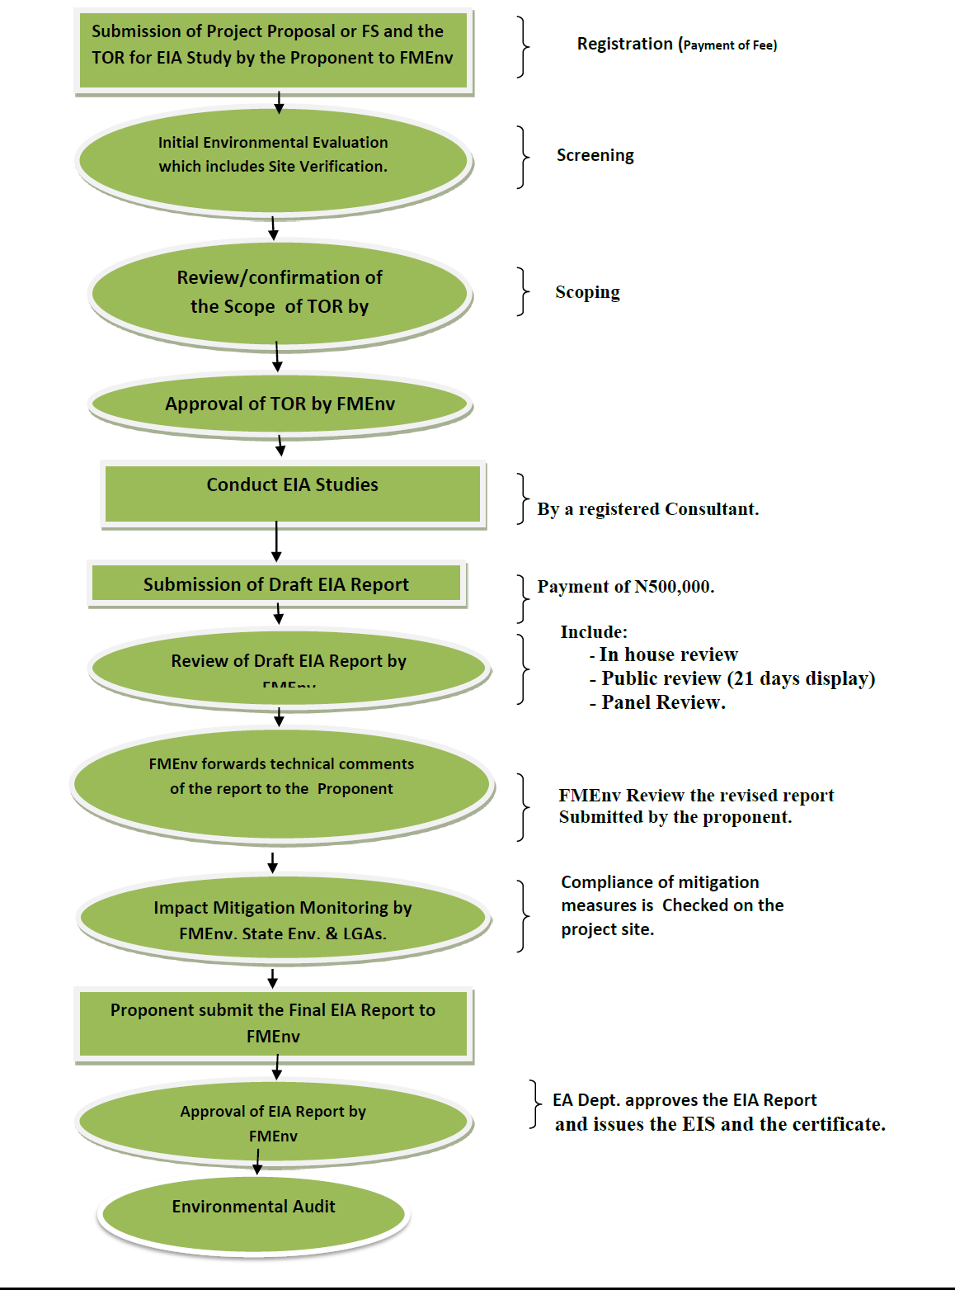
Figure 1. EIA Flowchart (Source: https://ead.gov.ng/wp-content/uploads/2017/04/EIA-Flowchart-new.pdf).

1.7 Administrative and Legal Framework for ESIA
Legal provisions for ESIA can be found in general environmental or resource management law which incorporates ESIA requirements and procedure and in ESIA specific law.

1.7.1 ESIA Legal Framework and Regulatory Authorities in Nigeria
In any EIA studies, all actions that will result in physical, chemical, biological, cultural and social modifications of the environment as a result of new project/ development must be assessed. Also, the EIA report is expected to serve as a means of assessing environmental impacts of the proposed project, rather than as a justification for decisions already made or actions already taken. The EIA study is usually carried out using a systematic, multi-disciplinary approach, which usually incorporates all relevant analytical disciplines to provide meaningful database, upon which scientific inferences can be drawn. Also, EIA studies are carried out within the framework of both local and international environmental guidelines and regulations.
The legal and regulatory framework governing such projects in Nigeria are contained in the Acts of relevant institutions, national law, and international environmental conventions and treaties that Nigeria is signatory to. These regulations are established for the purpose of preventing environmental pollution. The regulations and institutions that ensure compliance in reducing environmental pollution when engaging in such building projects are explained below.

1.7.1.1 Federal Ministry of Environment
Act 58 of 30 December 1988 established the Federal Environmental Protection Agency now Federal Ministry of Environment (FMEnv), as the chief regulatory body for environmental protection in Nigeria., while Act No. 86 of 1992 enacted the EIA Law in the country. FMEnv is vested with the responsibility of ensuring that all industrial activities, operations and emissions are within the limits prescribed in the National Guidelines and Standards. The Federal Government of Nigeria established the Federal Ministry of Environmental from the defunct FEPA with an overall mandate to protect, restore and preserve all ecosystem of the Nigerian environment. Twenty-one guidelines for pollution abatement in all categories of industries were laid. Part of the guidelines is a mandatory requirement for environmental auditing of all existing industries and Environmental Impact Assessment (EIA) of new industries and major development projects. Thus, The Federal Ministry of Environment (FMEnv) was created in 1999 to take over the function of the Federal Environmental Protection Agency (FEPA).

1.7.1.2 National Environmental Standards and Regulations Enforcement Agency (NESREA)
The National Environmental Standards and Regulations Enforcement Agency (NESREA) were established under Act No. 25 of 31st July, 2007. NESREA is responsible for the protection and development of the environment, biodiversity conservation, sustainable development of Nigeria’s natural resources and environmental technology. They co-ordinate and liaise with relevant stakeholders within and outside Nigeria on matters of enforcement of environmental standards. The Agency's vision is to ensure a cleaner and healthier environment for all Nigerians, while their mission is to inspire personal and collective responsibility in building an environmentally conscious society for the achievement of sustainable development in Nigeria.

1.6.1.3 Adamawa State Ministry of Environment
The Adamawa State Ministry of Environment is the arm of government responsible for regulating the environment in Adamawa State of Nigeria. Depending on certain peculiarities of the state, the Ministry has made and established its own laws and environmental standards, which are not inconsistent with Federal laws.

1.6.1.4 Adamawa State Ministry of Lands and Surveys
The Ministry of Lands and Surveys deals with land issues, plans and controls development, establishes residential, commercial and industrial layouts and execute in the state the Nigerian Urban and Regional Planning law.

1.6.2 National Legislations
The National legislation applicable to this project includes:
Environmental Impact Assessment Act CAP E12 LFN 2004
EIA act was promulgated in 1992. It makes environmental impact assessment (EIA) mandatory for all new major projects. Therefore, an EIA permit is required for the proposed project.
National Guidelines and Standards for Environmental Pollution Control in Nigeria 1991
This schedule deals with the control of industrial effluent discharge, gaseous emissions and hazardous wastes, so also noise pollution control. This schedule established environmental guidelines and standards for the abatement and control of all forms of pollution.
The proposed project would therefore have to ensure that any discharges into the land, water and atmosphere are of acceptable quality to ensure that there are no legal repercussions under this schedule.
National Environmental Protection (Effluent Limitation) Regulations 1991
These Regulations give the parameters in industrial gaseous emissions and wastewater (effluents) and their limitations, concentration and standards for discharge into land, atmosphere and receiving surface waters.
The proposed project would therefore have to ensure that any discharges into the land, water and atmosphere are of acceptable quality to ensure that there are no legal repercussions under this schedule.
National Environmental Protection (Management of Solid and Hazardous Wastes) Regulations 1991
This regulation requires that all steps that are necessary must be taken for the effective management of solid and hazardous wastes in order to safeguard public health, ensure that waste is collected, stored, transported, recycled, reused or disposed in an environmentally sound manner and promote safety standards in relation to such waste.
National Environmental (Surface and Ground Water Quality Control) Regulations, 2011
The purpose of these Regulations is to restore, enhance and preserve the physical, chemical and biological integrity of the nation’s surface waters, and to maintain existing water uses. The standards are to provide for the protection of surface waters from pollutants so that the waters shall be protected, used, developed, conserved, managed and controlled in ways which take into account amongst other factors;
- Citizens’ right of access to clean water and sanitation;
- Protection of the water environment for sustainability of the resources and protection of aquatic ecosystems; and
- Reduction and prevention of pollution and degradation of surface water resources and recognition of the preventive, precautionary and polluter-pays-principles.
National Environmental (Sanitation and Waste Control) Regulations, 2009)
The purpose of these regulations is the adoption of sustainable and environment friendly practices in environmental sanitation and waste management to minimize pollution. The provisions of the regulations state that a person in care, management or control of any industrial facility shall:
- Provide educational and pictorial signs to direct persons where they can drop waste.
- Provide receptacles for recyclable materials in appropriate and easily accessible locations.
- Keep the premises, drains and all public or private lands, street, lanes, walkways; beaches or docks within 5 meters of the boundary of the property free from litter at all times.
- Ensure that discarded materials are regularly collected and disposed of sanitarily.
- Ensure that recyclable materials are properly packed and neatly stacked.
- Ensure sorting and segregation of solid waste at source.
National Environmental (Noise Standards and Control) Regulations, 2009
The purpose of these regulations is to ensure maintenance of a healthy environment for all people in Nigeria, the tranquility of their surroundings and their psychological well-being by regulating noise levels and generally, to elevate the standard of living of the people. The regulations among others state the permissible noise levels to which a person may be exposed; control and mitigation of noise; permits for noise emissions in excess of permissible levels; and enforcement.
Labour Act Cap L1, LFN 2004
The Labour Act is the primary law protecting the employment rights of individual workers. The Act covers protection of wages, contracts, employment terms and conditions, and recruitment; and classifies types of workers and special workers.
Fire Service Act,
1981 An act to make provision for the organisation, discipline, powers and duties of the federal fire service and for matters incidental thereto or connected therewith. Section 18(2) of the fire service act 1981 states: -it shall be the duty of every person having control over premises to which this section applies to take all reasonable measures to guard against the outbreak of fire on such premises, and to ensure that as far as it is reasonably practicable the safety of the person on the premises in the event of an outbreak of fire.
Employee Compensation Act, 2010
The Act provides compensation to employees who suffer from occupational diseases or sustain injuries arising from accidents at workplace or in the course of employment. Payment of compensation (to the worker or to his dependents in case of death) by the employer is rooted in the accepted principle that the employer has a duty of care to protect the health, welfare and safety of workers at work.
National Gender Policy (Revised 2021)
The overall objective of the gender equality goal is a society in which women and men; girls and boys; and other vulnerable groups enjoy the same opportunities, rights, and obligations in all spheres of life. Thus, like the 2006 NGP, the goal of 2021 is –
“to build a just society devoid of discrimination, where the needs and concerns of women, men, girls, boys, and other vulnerable groups are mainstreamed equitably into all sectors of national development”
The revised policy is premised on the following key principles:
- That the promotion and protection of women’s rights as human rights, provision of social buffers and safety nets, social justice, and equity are critical to national cohesion, growth, and stability;
- That the peculiarity of the needs of women and girls, as distinct from men and boys, are demonstrably not homogeneous, originate from varying circumstances and therefore demand distinct policy responses at sector and sub-sector levels;
- That the gender policy is central to the achievement of overall national development goals, objectives, and targets on many fronts and from both the macro to the micro economic levels as gender equality is a driver of growth and good governance;
- That the cooperative interaction of all stakeholders including government, private sector, civil society organisations, traditional and religious leaders, community-based organisations and development partners at all levels is required to drive effective implementation of the policy;
- That implementation shall build on existing structures and draw on international policy frameworks, protocols, experiences and practices including affirmative action interventions targeting women and girls, recognising them as corrective measures to bridge gaps in opportunities and access to resources; and
- That gender analysis is seen as an integral part and essential component of all policy articulation, implementation, monitoring and evaluation.
The Urban and Regional Planning Law Act No. 88 of 1992
Decree 88 of 1992 established a Development Control Department (DCD) charged with the responsibility for matters relating to the development, control and implementation of physical development plans at Federal, State, and Local Government levels within their respective jurisdictions.
National Policy on Renewable Energy Development
The primary objective of the National Policy on Renewable Energy Development is to encourage the diversification of sources of energy supply through renewable energy, and as such improve the energy security of the country.

1.6.3 International legislation of relevance to EIA/SIA
Significant developments have taken place in international environmental law which is relevant to or applicable by the EIA/SIA systems of all countries. These can be divided into:
- Non-binding instruments, such as the Rio Declaration on Environment and Development which calls for the use of EIA as an instrument of national decision-making (Principle 17) and also contains other principles relevant to EIA practice (e.g., Principle 15 on the application of the precautionary approach).
- Legal conventions and treaties related to environmental protection at the global or regional level which carry obligations for signatory countries that may be met through EIA arrangements. This includes the UN Conventions on Climate Change and Biological Diversity (1992) which cites EIA as an implementing mechanism in Articles 4 and 14.
- Examples of International EIA legislation that sets precedents include the:
  - US National Environmental Policy Act (NEPA 1969) - The US was the first country to enact legislation requiring assessment of potential environmental impacts by proponents of development projects. The NEPA Act provided the template of similar legislation in other parts of the country.
  - New Zealand Resource Management Act (RMA 1991) - RMA is an omnibus law aimed at promoting the sustainable management of natural and physical resources.
  - Canadian Environmental Assessment Act (CEAA 1993, proclaimed 1995) - CEAA is an example of a comprehensive EIA-specific law. It entrenches the principle of public participation, designates the responsibilities of federal authorities in regulations and prescribes the requirements and procedures for undertaking different levels of EIA.
  - European Commission (EC) Directive of EIA (1985, amended 1997) - The Directive is a framework that is binding upon member States. It sets out the principles and procedural requirements for EIA within the EU, leaving it to the discretion of member States as to how these are transformed into national legislation.

1.7.2 International financial institutions safeguards
Environmental and social impacts as well as sustainability are key principles for many international financing organisations. Various guidelines and standards exist, each with a different focus and level of detail required in terms of environmental and social requirements for proposed projects. These include the AfDB Integrated Safeguards System, the World Bank Group (WBG) Operational Policies and Environmental, Health, and Safety (EHS) Guidelines, as well as the International Finance Corporation (IFC) Performance Standards.
The AfDB adopted the Integrated Safeguard System (ISS) as a tool for identifying risks, reducing development costs and improving project sustainability. The ISS promotes best practices in these areas but also encourages greater transparency and accountability and protects the most vulnerable communities. The AfDB encourages member countries to observe international human rights norms, standards, and best practices based on their commitments made under the International Human Rights Covenants and the African Charter of Human and Peoples’ Rights. The AfDB ISS builds on the two previous safeguard policies, Involuntary Resettlement (2003) and Environment (2004), and on three cross-cutting policies and strategies: Gender (2001), the Climate Risk Management and Adaptation Strategy (2009) and the Civil Society Engagement Framework (2012). The bank has now adopted five Operating Safeguards (OSs) to achieve the goals and the optimal functioning of the Integrated Safeguards System (ISS). The AfDB’s five Operational Safeguards (OS), are outlined here below:
- OS1 sets out the Bank’s overarching requirements for borrowers or clients to identify, assess, and manage the potential environmental and social risks and impacts of a project, including climate change issues.
- OSs 2-5 support the implementation of OS1 and set out specific requirements relating to different environmental and social issues, including gender and vulnerability issues, that are triggered if the assessment process reveals that the project may present certain risks.
The environmental and social assessment covers all relevant direct and indirect cumulative and associated facility impacts identified during the scoping phase, including any specifically covered in OSs 2-5, for which there are specific requirements:
- OS 2: Involuntary Resettlement: Land Acquisition, Population Displacement and Compensation.
- OS 3: Biodiversity and Ecosystem Services.
- OS 4: Pollution Prevention and Control, Greenhouse Gases, Hazardous Materials and Resource Efficiency.
- OS 5: Labour Conditions, Health and Safety
More broadly, these operational safeguards which have been triggered by the proposed project activities are outlined in Table 1.

Table 1. AfDB Integrated Safeguard System.
OPERATIONAL SAFEGUARDS TRIGGERED BY THE PROJECT | YES | NO | TBP
OS1 -Environmental Assessment | X
The construction of Mubi International Cattle Market in Mubi, Adamawa State include the clearing of existing vegetation for the construction of building, excavation, and siting of camps that may likely have significant environmental impacts such as loss of vegetation, soil erosion, siltation and release of petrochemicals. These risks will be managed through the implementation of mitigation measures elaborated in site-specific Environmental and Social Impact Assessments (ESIAs)/Environmental and Social Management Plans (ESMPs).
OS2 Involuntary Resettlement: Land Acquisition, Population Displacement and Compensation | X
The construction of Mubi International Cattle Market in Mubi, Adamawa State activities may require land acquisition or resettlements. The projects will be carried out in existing roadways but may require expansion to accommodate road shoulders and the creation of drainages, and as such there is the likelihood of a change in land status at this stage. If there will be changes to the scope of the project activities that result in land acquisition and/or land status change, the Bank’s involuntary resettlement policies and procedures will be applied.
OS3 Biodiversity and Ecosystem Services | X
The construction of Mubi International Cattle Market in Mubi, Adamawa State will involve initial clearing of vegetation and may cause initial degradation of natural vegetation and modified habitat. Also, the development of the Camp and excavation activities will impact above-ground and underground biodiversity. These risks will be managed through the implementation of mitigation measures elaborated in site-specific Environmental and Social Assessments (ESIAs)/Environmental and Social Management Plans (ESMPs).
OS 4: Pollution Prevention and Control, Greenhouse Gases, Hazardous Materials | X
The construction of Mubi International Cattle Market in Mubi, Adamawa State may likely intensify the use of petrochemicals and other pollutants. The earth movement and heavy-duty vehicular movement will create air pollution. Wastes from transportation systems may also pollute water and soil. Sustainable construction measures will be encouraged by IBSDLEIP, and contractors and other stakeholders will be promoted. Soil and water quality will be monitored.
OS 5 Labour Conditions, Health and Safety | X
The Contractor shall comply with the Labour laws and Best Practice Occupational Health and Safety requirements.

1.8 Key Elements of the ESIA Process
The ESIA Procedural Guidelines indicate the steps to be followed in the ESIA process from the conception of a project to the commissioning, to ensure that the project is implemented with maximum consideration for the environment. The steps required to properly conduct an ESIA within the FMEnv framework are:
- Screening,
- Public Involvement,
- Scoping,
- Identification of Alternatives,
- Baseline Description,
- Scoping,
- Analysis of Environmental and Social Impacts,
- Impact Mitigation and Enhancement,
- Impact Monitoring,
- Review and Decision Making,
- Implementation and follow up.

1.1.3 Structure of ESIA Report
The structure of this ESIA Report is presented below.

Chapter | Contents | AfDB Requirements
Executive Summary | Summary of the report that provides brief, accurate, clear, and concise information about the project, highlighting the most important findings and recommendations for decision-making. | Present a concise summary of the ESIA Report in non-technical language.
Chapter 1 – Introduction | Presents a brief background to the proposed Project, ESIA legislations, ESIA process and the purpose and structure of the report.  Provides an outline of the legislative, policy and administrative requirements, as well as international best practise applicable to the proposed Project. | Identify the project and the key role players.  The assessment complies with the relevant legislation and standards applicable in the local jurisdiction and the Bank. Takes into account national and regional standards.  The Bank assesses the institution’s requirements, which need to be equivalent to the AfDB’s requirements. (OS1; 2013)
Chapter 2 – Project Description | Provides a basic description of the Project area and the Project components proposed. | Define the project.  Describe project features, locations, and activities.  Determine how the project and resources interact.  Convey what is being proposed.
Chapter 3 - Baseline Environmental Studies of the Project Area | Provides a summary of the site investigations and their findings. This has covered the following technical topics:  - Climate;  - Topography;  - Soils;  - Surface Water;  - Ground Water;  - Air Quality;  - Noise;  - Transport / Access;  - Waste Management;  - Visual;  - Biodiversity; and  - Socio-economic. | Detailed evaluation of climate change risks and adaptation measures (Category 1) or review of climate change risks and adaptation measures (Category 2); assess climate change vulnerability. (2013)  Assess potential impacts on geology, soils, surface and groundwater resources, air resources and climate, noise and vibration, ecosystems, socioeconomic and cultural. (OS1, 2013)  Ensure flows, water ecological functions and the integrity of river systems and wetlands are maintained.  Assess potential risks and impacts on biological diversity and ecosystem services. Categorise habitats into Natural Habitats, Modified Habitats and Critical Habitats.  Identify invasive alien species and take precautions to avoid the introduction or spreading of the species.  Comply with national regulations in legally protected areas and internationally recognised areas. (OS3, 2013)
Chapter 4 - Assessment of Environmental Impacts | Presents and analyses impact to ensure that they are appropriately mitigated/enhanced as the case may be. Impacts of the proposed project are identified at two (2) stages of the project;  - During construction, and  - Operational stages.
Chapter 5 - Impact Analysis and Rating | Present analyses and overall assessment of the impacts of proposed commercial development.
Chapter 6 - Impact Assessment Recommendations | Present impact assessment recommendations in terms of mitigation and safety measures, and routine inspection and physical assessment.
Chapter 7 - Environmental and Social Management Plan (ESMP) | Present an Environmental and Social Management Plan (ESMP) to aid the proponent in managing significant environmental and social impacts associated with the project.

CHAPTER TWO

PROJECT JUSTIFICATION

2.1 Need for the Project
In view of the growing population and general needs for economic growth and general physical regulated activities, the Adamawa State Government through the African Development Bank (AfDB) planned to develop a new modern, integrated and comprehensive International Cattle Market at Mubi. The facility is intended to serve as a local, national and international hub for cattle and other livestock trading and commercial centers. The market and the facilities would have auction grounds, health facilities in terms of a veterinary clinic, clinic/dispensary, hostel-like accommodation, offices, water and power infrastructure, sewerage plant, drainages, waste disposal, parking, loading and off-loading bay, etc. among many other utilities to make up for the general commercial interest and support livelihood in the town in particular and the State in general. Based on population projection, which is determined at a 3% annual growth rate, there is a need for upgrading and expansion of cattle and livestock trading and commercial centers in Mubi as well as in other viable locations in the State. There appears to be inadequate, poor-quality utilities and a general lack of proper commercial planning of trading hubs in the State, particularly in relation to cattle and other livestock products.

2.2 Value of the Project
The project value cannot be quantified for the project has both tangible and non-tangible values. Primarily, the project would inject financial, employment, and other income generation opportunities in the area as well as the state. Be young financial value there is more value adding in terms of enhanced technology in the production, processing and marketing of the animals and subsidiary bye products. Another expected value of the project is in the area of promoting social and interpersonal relationships which would translate into social capital for both the people and government at all levels. The value of human capital development and enhancing desirable physical and environmental conditions in commercial and or business environments would be the essential key value of the project.
In the end the project would promote comfort, conveniences, health and fair as well as an equitable business environment.

2.3 Envisage Sustainability of the Project
Adamawa State Government with support from the African Development Bank (AfDB) proposed building a Multi-purpose as well as functional Cattle Market and Commercial Hub at Mubi, (hereafter called “Mubi International Cattle Market”) which will provide high-quality business and commercial facilities to help alleviate the acute poor infrastructure, overcrowding and offer better services, that would promote economic growth and expansion of business opportunities in the area and the State in general. The project will also provide new venues suitable for hosting major local, national and international commercial events. The Project will mainly cater for a wide range of major commercial and business needs of all that are directly or indirectly involved in animal as well as other livestock value chain adding.
It is expected that the project would promote economic development, generate high income, drive revenue generation and provide extensive animal and other livestock products commercial outlay for the people and government of Adamawa state and by extension save foreign exchange for the country. Another expected benefit of the project is that it would provide for sharing ideas and knowledge on commercial and business-related activities within the region and neighbouring areas of both the Local Government Area, the state and the nation at large.
The project is also expected to be the hub of animal commerce for the Northeast region and the adjoining countries of Cameroon Republic, Chad and Niger Republic, thereby enhancing foreign and local interaction and integration. The project would also provide stakeholders in the animal and other livestock products industry to manage, regulate and effectively monitor the trends, and activities and provide proactive measures to support and sustain the industry for the maximum benefit of the government and people.
2.4 Alternatives to Project
Based on the health, safety, and environmental impacts, as well as the best available technology and economic/social considerations, the following project options were considered:
Option 1: Do Nothing Option
This entails maintaining the status quo by not constructing the Proposed Mubi International Cattle Market and instead investing the available funds in other projects.
This would imply that the opportunity for potential benefits of a mega commercial infrastructure, and job opportunities will be missed; and there will be no environmental impact due to construction but increased impacts on prospective customers in the catchment area, who have to commute longer distances to get supplies.
This option was rejected because it does not promote the potential economic development and sustainability of the city and the Region.
Option 2: Delayed Option
This implies the implementation of the proposed project at a later time for such reasons as lack of funds, communal crises, war, etc. This option was rejected since none of these situations is obtainable and the Proposed Mubi International Cattle Market construction is urgently needed.
Option 3: Construction of the Proposed Mubi International Cattle Market
This option was accepted for implementation because of the need to harness the potential economic development of the state for the benefit of all and sundry in the City and Mubi Region.
2.5 Environmental and Social Sustainability
The implementation of recommendations contained in this EIA report during all phases of the proposed activities assures the sustainability of the biophysical and social environment of the project area. Continued consultations with the host community and resident association will form the bedrock of the social sustainability of this project. These consultations will ensure emerging issues are clearly communicated and addressed and also ensure a good working relationship between the project and the community

CHAPTER THREE

PROJECT AND PROCESS DESCRIPTION

3.1 Type of Project
The project involves some civil works, vegetation (bush) clearing, earth (soil) movement, topographic levelling, alignment and re-alignment of road segments, creation of road pavement, coal tarring, etc. with potential environmental impacts. The works will be hosted and founded on the surface and the near-surface earth.

3.2 Project Site
The Project site covers a land area of about 25.248 hectares and is located between Latitude 10° 13' 39" N to 10° 14' 0.6" N and Longitude 13° 14' 11.4" E to 13° 14' 36.6" E in Mubi South Local Government Area of Adamawa State. It is bounded by residential development to the north, the Mubi – Maiha Trunk ‘A’ Federal Highway to the west, and a range of mountains to both south and east (Figures 2, 3, and Plate 1). It is also 4.5 km from the existing location of the Mubi Cattle Market. The designated site of the proposed project to be Mubi International Cattle Market is presently farmland. The coordinates of the project site are presented in Table 2.

3.3 Survey Plan of the Site
The terrain on the site is generally rough, with hills that are sparsely distributed. The elevation in the project area ranged from 644 m (at its highest point) to 613.5 m (lowest). The site is drained from east to west, with three (3) streams emptying into the mainstream alongside the Mubi - Maiha Trunk 'A' Federal Highway, which eventually empties into the River Buladega. The site had a total area of 25.248 Hectares, a perimeter of 2,012.09 m, and was oriented north-south (Figure 4).

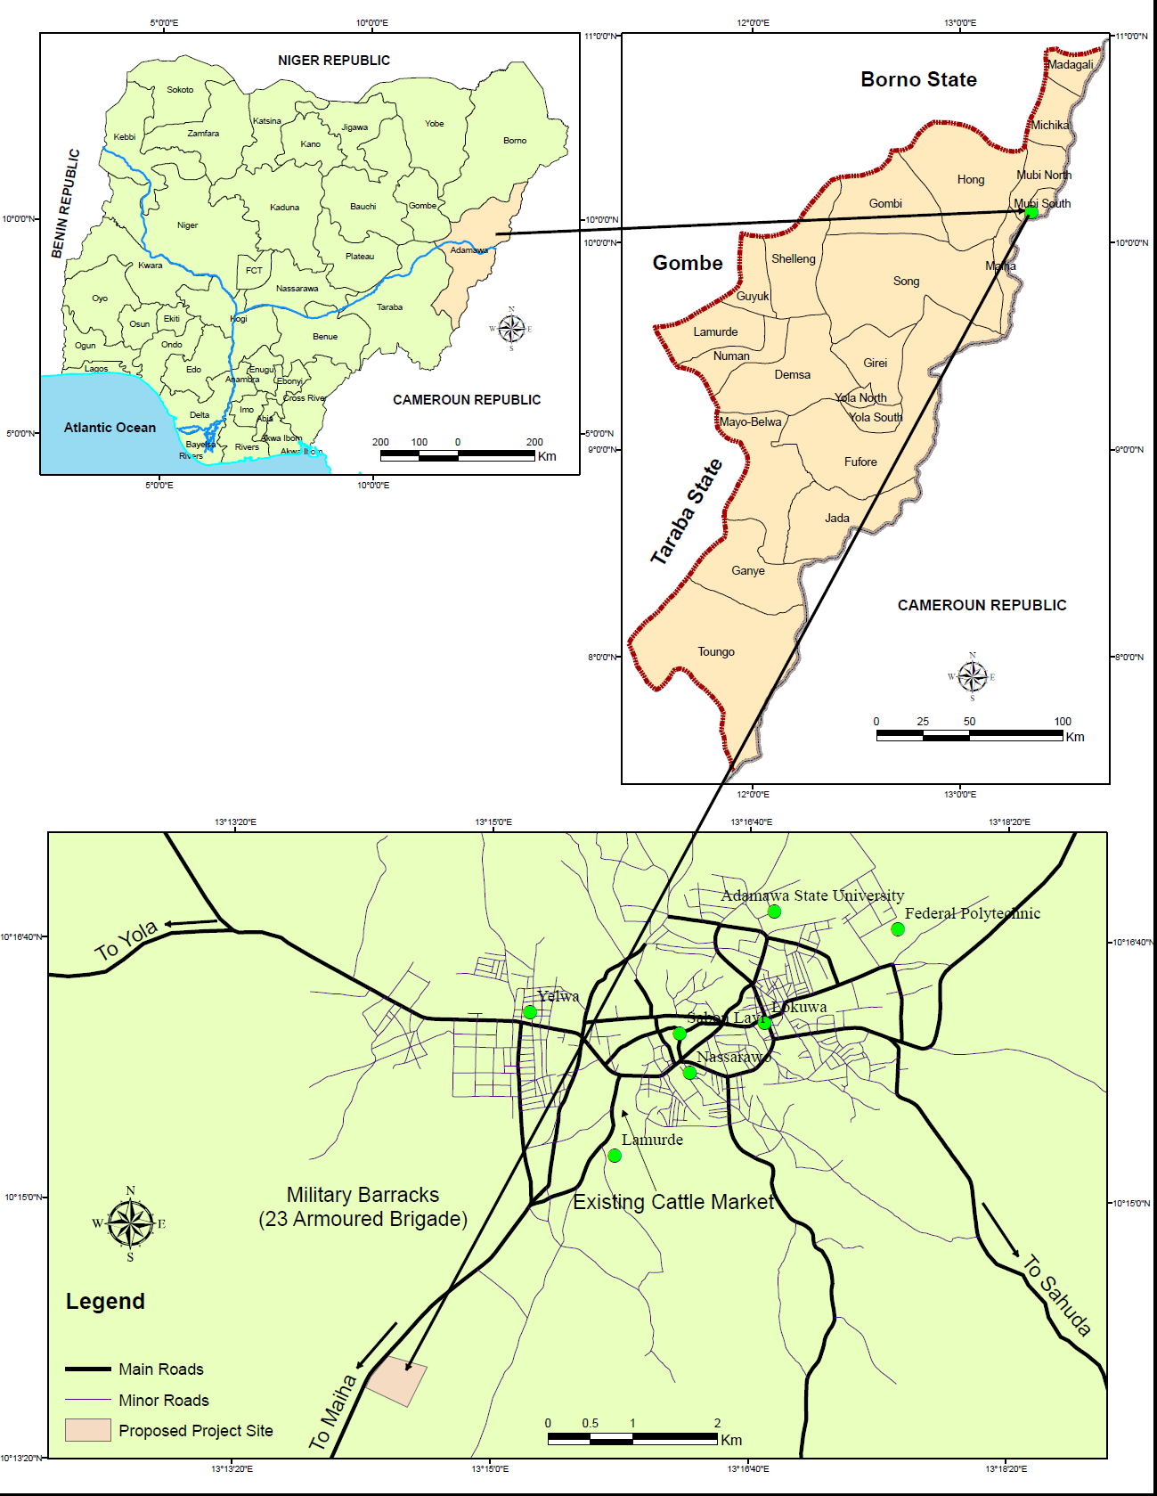
Figure 1. Location of Proposed Mubi International Cattle Market.
Figure 2. Location of the Proposed Project Site overlayed on Google Earth image.
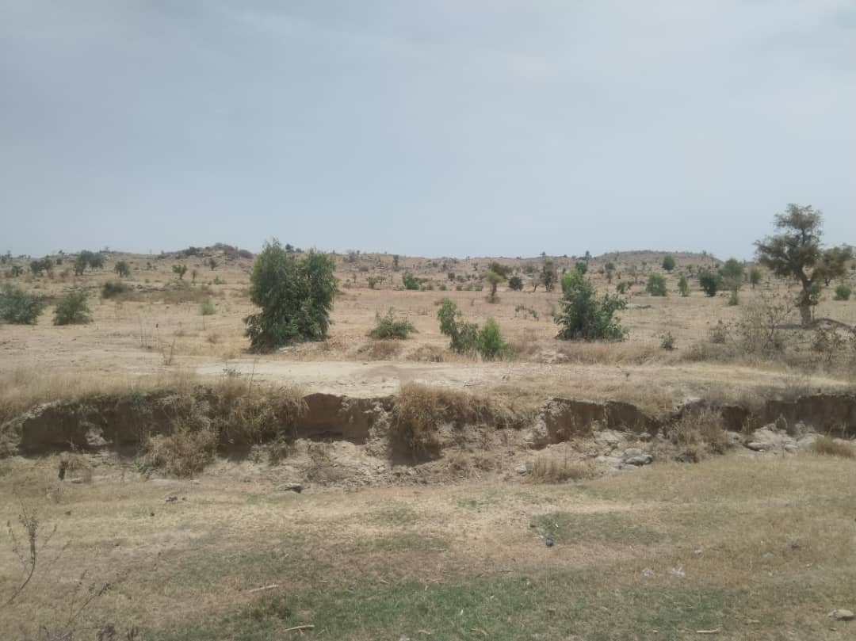
Plate 1. The site of the project (Field Survey, 2022).

Table 2. Coordinates of the site.
Beacons | Easting (m) | Northing (m)
TP01 | 240729.596 | 1021938.700
TP02 | 240956.703 | 1022013.563
TP03 | 241305.138 | 1022099.243
TP04 | 241350.258 | 1021929.771
TP05 | 241144.253 | 1021883.849
TP06 | 240764.805 | 1021773.453
Note: Coordinate System/Datum: WGS 1984, UTM Zone 33 N

3.4 Existing Land use
The existing land uses around the project site include; filling station, grave yard, disperse residential buildings, military barracks, among others (Figure 5).

3.5 Land Use Plan for the Proposed Project
The Land use plan of the Proposed Mubi International Cattle Market is well designed and it is a multi-purpose commercial complex of cattle and other livestock products facility, which comprises public sale areas, water, power, drainage, waste disposal areas and other ancillary/supporting facilities such as parking spaces, loading and offloading areas, office spaces, hostel like accommodation, etc. All these facilities are put in place to ensure a safe and serene living environment for proposed development. Refer to Figures 6, 7 & Table 3.

Figure 3. Survey Plan of the Proposed Project Site.

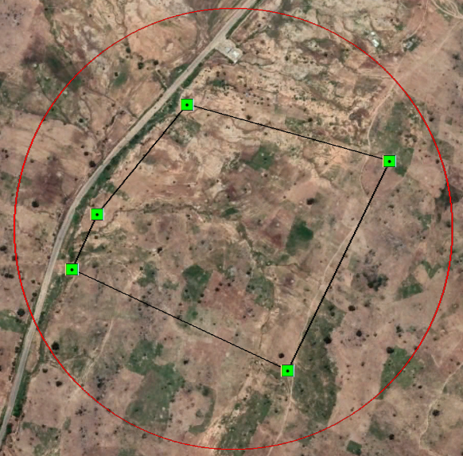 | 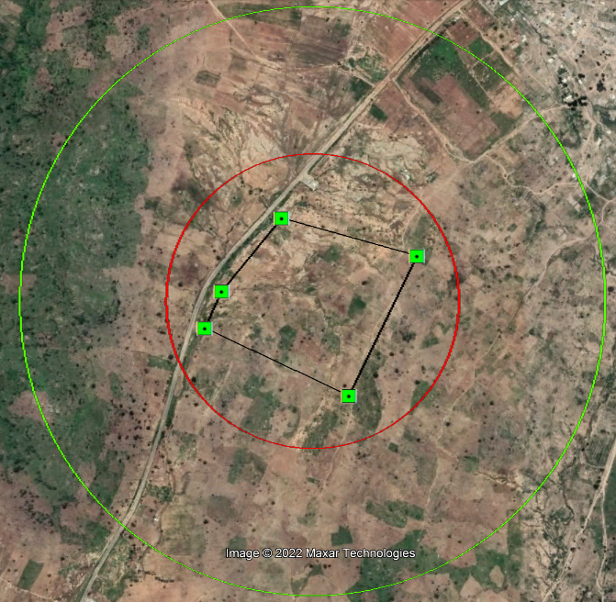 | 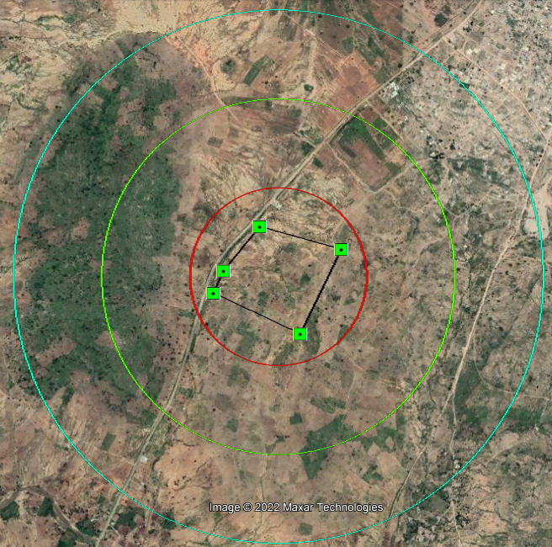
500 m buffer: filing station (North) | 1 km buffer: grave yard, disperse residential buildings (Northeast) | 1.5 km buffer: grave yard, residential area, part of army barracks virgin land (northeast), (filling station (south), part of a village (Southeast)
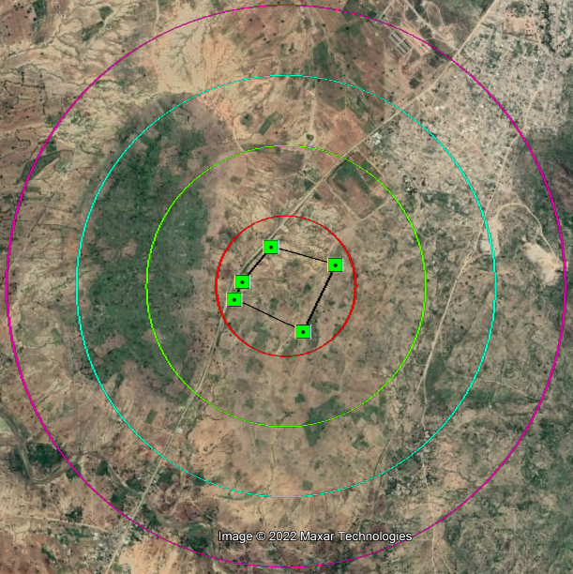 | 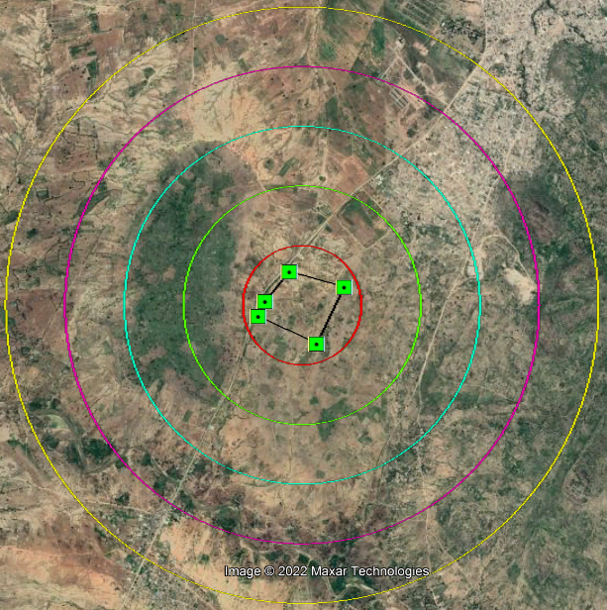 | 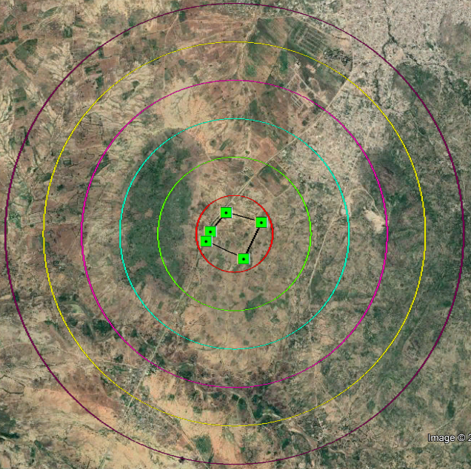
2 km buffer: residential area, part of army barracks built-up area (northeast), part of a village (Southeast and Southwest) | 2.5 km buffer: residential area residential area, school, part of army barracks built-up area (northeast), Buladega, primary school, 2 filling stations (southwest), part of a village (Southeast) | 3 km buffer: residential area (north), residential area, school, part of army barracks built-up area (northeast), Buladega (southwest), part of a village (Southeast)
Figure 4. Existing Land use around the Project Site.
Figure 5. Land use Plan of the Proposed Mubi International Cattle Market.
Figure 6. Detailed Site Plan of the Proposed Mubi International Cattle Market..
Table 3. Land Use Analysis of Proposed Development.
S/N | LAND USE | AREA (SQ.M) | (%)
1 | Loading Bay | 15,868.47 | 6.8
2 | Control Point | 11,752.82 | 5.0
3 | Masjid | 1,515.51 | 0.6
4 | Trailer Parking Zone | 12,344.56 | 5.3
5 | Parking Space | 6,626.69 | 2.8
6 | Motor Park | 9,622.97 | 4.1
7 | Administrative Block | 6,109.06 | 2.6
8 | Hotel | 3,269.80 | 1.4
9 | General Toilets | 3,480.83 | 1.5
10 | Waste Collection | 3,480.83 | 1.5
11 | Shops | 3,513.11 | 1.5
12 | Clinic | 3,498.59 | 1.5
13 | Restaurant | 3,502.15 | 1.5
14 | Toilets | 1,670.51 | 0.7
15 | Water Supply | 2,021.91 | 0.9
16 | Police Station | 2,348.47 | 1.0
17 | Fire Service | 2,369.50 | 1.0
18 | Shops for Livestock Feeds | 3,948.06 | 1.7
19 | Veterinary Clinic | 3,946.49 | 1.7
20 | Shops for Traditional Veterinary Dr. | 3,421.94 | 1.5
21 | Shopping Mall | 4,376.49 | 1.9
22 | Livestock Sick Bay | 8,565.00 | 3.6
23 | Livestock Inspection | 9,756.23 | 4.2
24 | Sheep/Goat Selling Ground | 8,964.22 | 3.8
25 | Cattle Selling Ground | 63,629.71 | 27.1
26 | Circulation | 35,396.08 | 15.1
 | TOTAL | 235,000.00 | 100.0

3.6 Building Plans
The complete building plans/working drawings of each proposed building is prepared. It include; floor plan, roof plan, elevations, sections, doors and windows schedule, electrical plan, mechanical plan, and structural plan (see Figures 8 to 17).

Figure 7. Floor Plan of Proposed Livestock Sic Bar and Veterinary Clinic.
Figure 8. Roof Plan of Proposed Livestock Sic Bar and Veterinary Clinic.
Figure 9. Elevations of Proposed Livestock Sic Bar and Veterinary Clinic.
Figure 10. Side Elevations of Proposed Livestock Sic Bar and Veterinary Clinic.
Figure 11. Floor Plan of Proposed Cattle Loading Bar.
Figure 12. Section of Proposed Cattle Loading Bar.
Figure 13. Floor Plan of Proposed Livestock Pens with 305 Tether/Iron Poles.
Figure 14. Elevation of Proposed Livestock Pens with 305 Tether/Iron Poles.
Figure 15. Section of Proposed Livestock Pens with 305 Tether/Iron Poles.
Figure 16. Floor Plan of Proposed Trucks Weighing Scale.

3.7 Accessibility to the Site
The site of the proposed project is accessed as follows:
- Main road linking to the site: Mubi – Maiha Trunk ‘A’ Federal Highway
- Status of the road: Untarred
- Width of the access road: 20m
The Mubi - Maiha Trunk ‘A’ Federal Highway is the only highway linking Mubi and Maiha Local Government Areas (LGA). It is also an international route linking Nigeria and Cameroun Republic (from Mubi to Demsa) (see Figure 18). Generally, it generates a high volume of traffic, with different types of vehicles plying it.

3.8 Plans on Cattle Routes
The planned cattle route to the market comprises the existing one in the area, including the Cameroun Republic - Maiha Cattle Route (Figure 19).

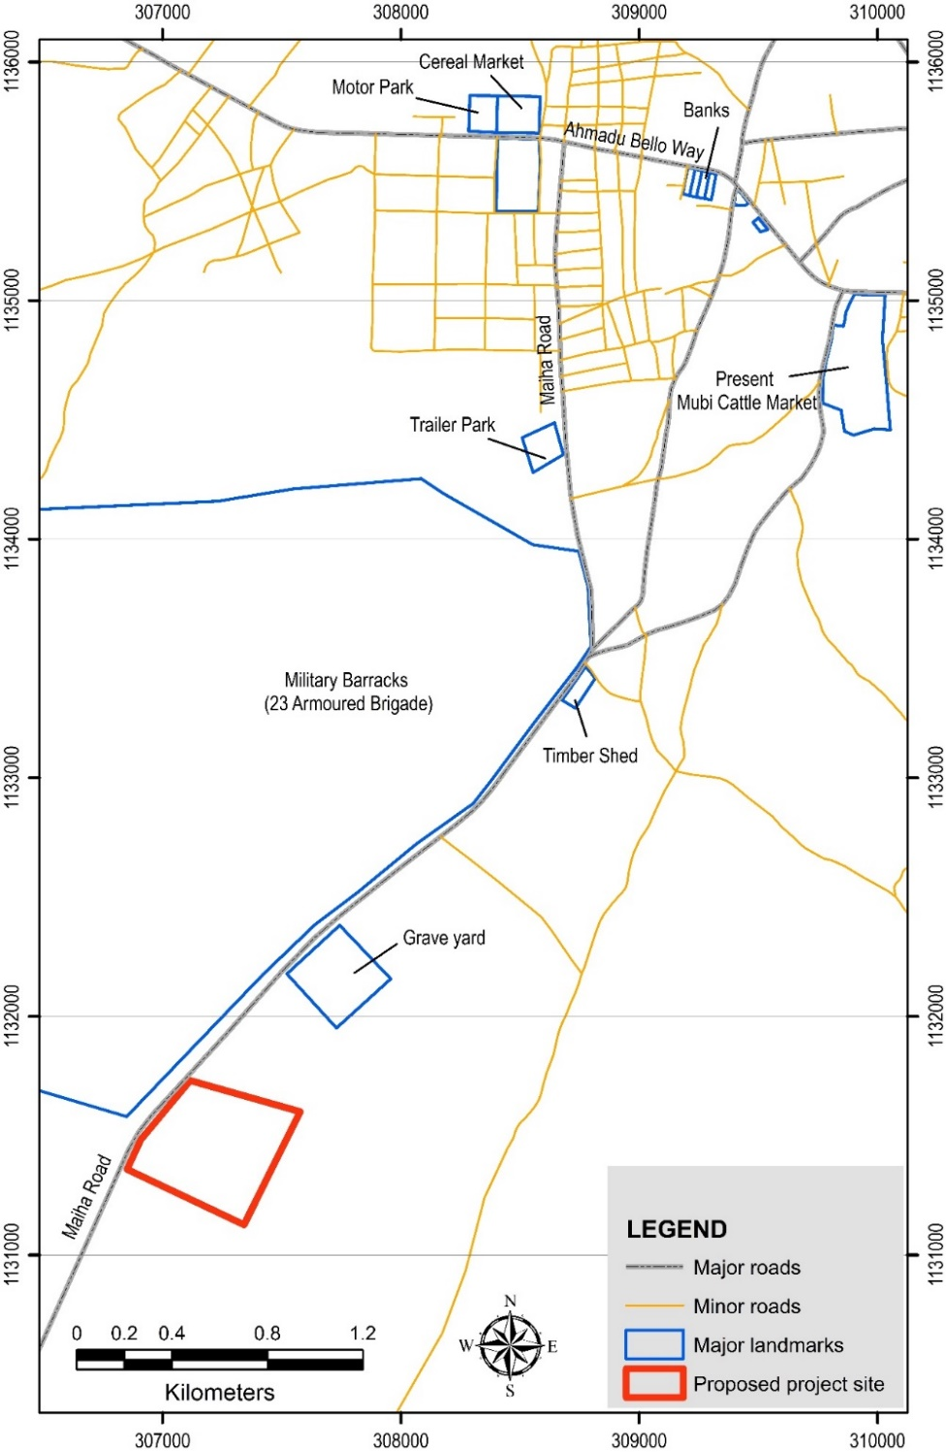
Figure 17. Accessibility to the Proposed Project Site.
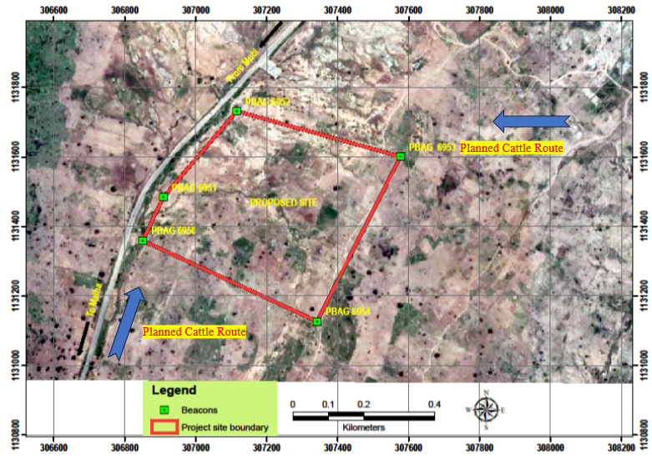
Figure 18. Plan of Cattle Routes in- and out to the Market.

3.9 Compliance with Planning Regulations
This section describes how the proposed development conforms to local planning standards and regulations (Development Control Manual, 2007). This is to ensure that the primary objectives of environmental protection which the manual seeks to achieve are given due consideration before approval is given for any development.
The design framework of the Proposed Mubi International Cattle Market has been prepared in conformity with the Development Control Manual (2007). Hence the proposed development complies with the following guidelines.

3.9.1 Setbacks
The proposed development has not compromised the standard for the required setback.
- The front setback is 10 meters
- The rear is 4 meters
- The right side is 4 meters
- The left side setback is 4 meters
All the dimensions and setbacks are subject to change as the site officer may recommend appropriate building lines and setbacks for the proposed buildings within the Market.

3.9.2 Plot Coverage and Accommodation Capacity
The percentage of the built-up area is in line with the Development Control Regulations.
Accommodation capacities of various sections of the projected are;
- Hostel - 1,000 persons/market day.
- Animals – an average of 7,000 herds on market day.
- Loading/Off-loading Bay – 7 Bays.
- Conveniences – 70 conveniences with ratio of 70/30% for male and female.
- Circulation – 20% of total land area
- Water Capacity – 20 litres/persons/day for humans, 25 litres/animal/day. Therefore, an average of 195,000 litres/day is required.
- Service Areas – 10% of the total area
- Parking space - Trailer Parking Zone (12,344.56 sq.m), Parking Space (6,626.69 sq.m), Motor Park (9,622.97 sq.m).

3.9.3 Airspace
The project development is oriented in a way that enhances adequate ventilation, light and scenic view of the general environment. Trees would be planted in the Market to filter the air and create a kind of buffer.

3.10 Workforce Requirement
The Proposed Mubi International Cattle Market construction requires approximately 400 personnel/labourers (unskilled, semi-skilled and skilled workers per day, who must converge at the project site before 7 a.m. and leave by 5 a.m. (Monday to Saturday).
Skilled labour will be sourced through advertisement and secondment from other Agencies, while the Unskilled will be sourced through various professionals/associations based on needs and competencies.

3.11 Construction Process
The building process is based on the procedures and standards of the Nigeria Building Code. The construction of the proposed development is to be carried out in the following stages:
- Pre-construction stage; involves site clearance, levelling and other earthworks.
- Foundation work involving setting out, excavation and re-enforcement.
- Superstructure comprising of framing, casting, block and mortar works.
- Roofing.
- Mechanicals- involving plumbing and electrical wiring.
- Fitting; comprising elements such as toiletries, POP/Ceiling, doors, and windows.
- Finishing; comprising painting, tiling, Air conditioning, fixtures and appliances, landscaping, etc.

3.12 Construction materials
Raw materials for the construction of the proposed project include the following:
- Sand, laterite, gravel and stones.
- Sandcrete blocks of various sizes (9” for external walls and 6” for internal walls) and curbs.
- Water, cement and paint
- Wood, iron rods, aluminium frames, roofing sheets and nails.

3.13 Construction equipment
Construction equipment such as an excavator, grader, vibrator, concrete mixer, tippers, etc. will be required for the construction of the proposed project.

3.14 Energy Consumption
The Project yard is proposed to have four (4) Nos, 1,275 kVa generators which supply electrical energy for its operations. Three of the generators are operational for 24 hrs while one is on standby. The generators will consume about 800 litres of diesel (Automotive Gas oil – (AGO) per day (i.e., 400 litres per generator per day).

3.15 Project Traffic Management Plan
This Traffic Management Plan describes procedures and protocols for site access, traffic routing and management, and contractor company guidelines with respect to vehicle and employee transportation in delivering their obligations on this intervention project. Public, employee and contractor safety is the primary goal of this plan. The Contractor must recognize that the traffic within the project area will be dynamic throughout the execution of this work and the safety of other road users is essential during this time.
- General Site Access: In the interest of site security and public safety, access to operational areas or locations where heavy-duty machinery would be operated in relation to the execution of this project will be restricted to authorized site personnel through the usage of signs and gates where appropriate. Facilities that potentially present danger to persons or wildlife such as the electrical substation, equipment staging area and workers camp will be barricaded as appropriate to prevent general access.
- Traffic Management: All traffic on routes to and from the site will be controlled. Where this is not possible, signs will be installed at appropriate locations to warn the public along the routes. If temporary closure occurs, access to the sites will be further restricted through the use of fences and gates as appropriate. Access to work areas such as temporary excavated places, or confined spaces where work is ongoing will be securely blocked using a temporary but robust barrier or barricade. Buildings and ancillary facilities will be locked and secured. Several additional general measures related to site access, road management public safety and construction events notification are presented here:
- Private employee off-road vehicles or private transport buses will be prohibited from entry into the site.
- Signage will be posted near all construction sites.
- Notifications will be provided for activities that will be carried out over the weekend or public holiday periods. These would be disseminated through existing social institutions such as the communities and Local Government leaders. Install reverse alarms fitted on all trucks, heavy-duty equipment and off-road vehicles.
- Employ or engage the use of a minimum of two flagmen around excavated areas, one for traffic approach and one to direct traffic away from the sites
- In accordance with the Occupational Health and Safety Regulations for public roads, use of flashing devices/trafficators on all vehicles/machinery and equipment that will cross, travel on or may otherwise pose a risk to users of public roads.
- Employee Transportation: To the extent possible employees will use buses provided by the contractor as transportation to and from the site, thereby reducing overall vehicle traffic. Project vehicles will be utilised by staff, only when necessary.
- Speed Limits: Speed limits will be enforced to and from the site and signage(s) shall be posted along the access and site roads (maximum 40 km/hr, reduced to 20 km/hr at blind corners and bridge crossings. Traffic along other access roads will be radio-controlled for safety and speed control. Furthermore, employees and contractors will be educated on safety including traffic protocols and speed limits during mandatory orientation. Routine traffic inspections and/or speed indicator signs will be used to encourage safe and responsible driving.
- Communications and Notification Protocols: It is anticipated that the intervention project will require only single-lane temporary closures. Signage warnings of construction activities on the roads will be placed at appropriate distances from the construction site, in consultation with SPIU, the Ministry of Transports, Department of Highways & Public Works. For significant work activity (those requiring more than one day to complete), written notification will be distributed to residents and the SPIU, Ministry of Transport, department of Highways & Public Works will be notified. A public notice would be posted at multiple locations in the metropolis to communicate to residents any new activities that may be occurring or scheduled. Contact information for the contractor senior management will be included in this notice and any concerns regarding the intervention work/project or traffic management can be forwarded through this notification system.
- Traffic Routing and Volumes: Alternative traffic routing shall be mapped out and provided in the event that there will be a complete closure of the road due to this intervention work activity. Traffic officers and appropriate road diversion signage(s) shall be deployed to ensure diversion routes are properly identified and traffic is directed along the mapped route. The flagmen shall be properly kitted in their Personal Protective Equipment (PPE), such as reflector vests and safety boots, to ensure that safety on the job is given due priority.

3.16 Waste Management
IBSDLEIP has put in place detailed waste management plans covering a comprehensive description of activities and waste handling at pre-construction, construction, operational and abandonment phases of this project.

3.16.1 Waste Generation and Sources
The wide range of waste that will be generated by the proposed project during construction and operation phases are classified into solid waste, liquid waste and gaseous emissions. The waste profile is presented in Table 4.
Table 4. Waste Profile of the Proposed Mubi International Cattle Market.
Project Phase | Waste Class
 | Solid | Liquid | Gaseous
Construction | - Soil and vegetation  - Cement bags  - Wood scraps  - Steel Scraps  - Rubble  - Food Waste  - Glass and Plastic Bottles  - Dust | - Wastewater  - Engine oil  - Spent oil | - Fugitive Dust  - Suspended Particulate  - Carbon dioxide  - Carbon monoxide  - Greenhouse Gases

3.16.2 Overall Waste Management
No waste shall be discharged into any surface river or wetland without adequate treatment. Table 5 shows the proposed waste management plan to be put in place.
Table 5. Summary of Mubi International Cattle Market Waste Management Plan.
Type of Waste | Waste From | Waste Management Option |  |  | Disposal
 |  | Reduce | Re-use | Recycle | Forest | Land
Gaseous | Heavy-duty machines (Land preparation), Methane | Installation of appropriate filters to the exhaust pipe |  |  | - | -
Noise | Machinery and Generators | Installation of appropriate noise reduction devices |  |  | - | -
Liquid | Office Areas (Waste water) | - | - | - | None | Soak-away pits attached to buildings
 | Sanitary from Toilets | - | Used in the field | - | None | Appropriately designed Septic tanks
 | Oil traps |  |  |  | None | Trapping of oil using retention trays
Solid | Domestic waste, workshop | Collected and taken to the dumpsite |  |  | - | -
 | Hazardous wastes such as empty agrochemical  containers | Taken away by the manufacturers and/or suppliers as part of an agreement deal. |  |  | - | -
None: Not discharged into/disposed-off in the habitat ̶ Not Applicable

3.16.2.1 Solid Waste Handling
Storage: At all the points of waste generation, waste bins will be provided for the immediate storage of solid waste. Provision would also be made for sorting and segregation of all solid waste at the point of generation. There are waste management plans where wealth shall be generated from wastes as much as practicable.
Collection and Transfer: Waste collection and transfer would include the provision of a truck to collect and transport the collected waste to a designated dumpsite.
Disposal: The solid waste collected would be transported and disposed of at the solid waste dumpsite within the plantation.

3.16.2.2 Liquid Waste Handling
Wastewater: Wastewater will be channelled into soak-away pits of varying dimensions attached to the mill facilities.
Storm water: Rainstorm water will be collected in channels and led into natural drainage lines and vegetation.

3.16.2.3 Waste Re-use/Re-cycling
As much as possible, waste will be minimized. There is an existing yard already designated for keeping all reusable waste.

3.16.2.4 Waste Manifest and Tracking
A manifest system will be established and record kept appropriately ensuring that the mill waste is tracked from “cradle to grave”.

3.17 Project Implementation Schedule
The proposed development is expected to be completed within a period of Twenty-Four (24) months of mobilization (Figure 20) and will have a life span of 99 years.
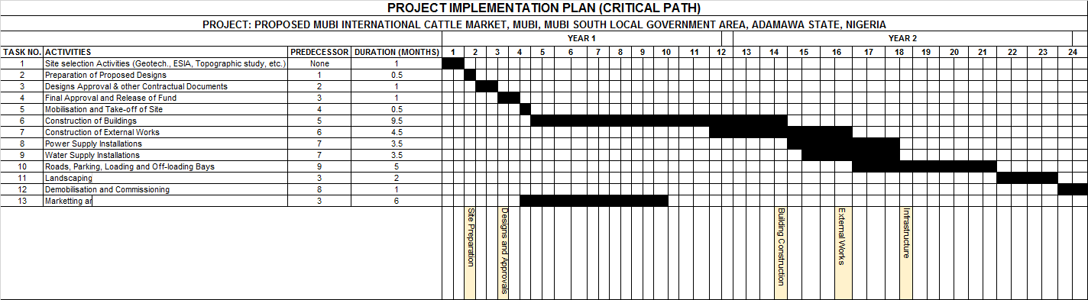
Figure 19. Project Implementation Plan.

CHAPTER FOUR

DESCRIPTION OF THE PROJECT ENVIRONMENT

4.1 Introduction
This Chapter presents the methodology of the study and environmental baseline studies of the proposed project area. This includes the climate, vegetation, land use, soil, water, air, noise and socio-economic study. The study was conducted to describe the existing environment of the project area and assess the probable environmental impact of building construction on the environment. Information obtained formed a baseline on which future data and assessments will be based. The quality and reliability of environmental baseline data is of great importance, as this can influence the use of such data in the assessment of impacts.

4.2 Methodological Approach to the study
This highlights how the outlined objectives were achieved.
- Reconnaissance Survey - A reconnaissance survey of the proposed project was carried out. The aim was to obtain a primary/baseline visual impression of the area and determine the relevant information/data for the work. The accuracy of this report owes much to this strategy.
- Site Inspection/Investigation- An initial site inspection was carried out to acquaint the consultant with the site (Plate 2). This is always required in executing any engineering structure. The investigation was a simple examination of the surface soils. Other information obtained from the site investigation includes:
  - The general topography of the site as it affects foundation designs and construction.
  - The location of buried services such as electric power and telephone cables water mains, etc.
  - Pre-vision history and use of the site including information on any effects or failure on existing project or structure around the proposed site and other information about the geology of the area, such as the presence of rock out-crops, flooding, etc.
- Interview - Interviews were held with a cross-section of the population of the area, who are the potential beneficiaries and/or those to be affected by the proposed development project. In addition, interviews were held with the management of the proposed project. The main instruments of the interview are questionnaire administration, through purposive sampling, focus group discussion with the stakeholders such as Sarki Tike (officials of the market), Miyetti Allah Cattle Breeders Association, Amalgamated Traders Union, Road Transport Employers Association, Shuwa Cattle Sellers Association, among others. Consultation with proponents, government officials, various Professionals, etc.
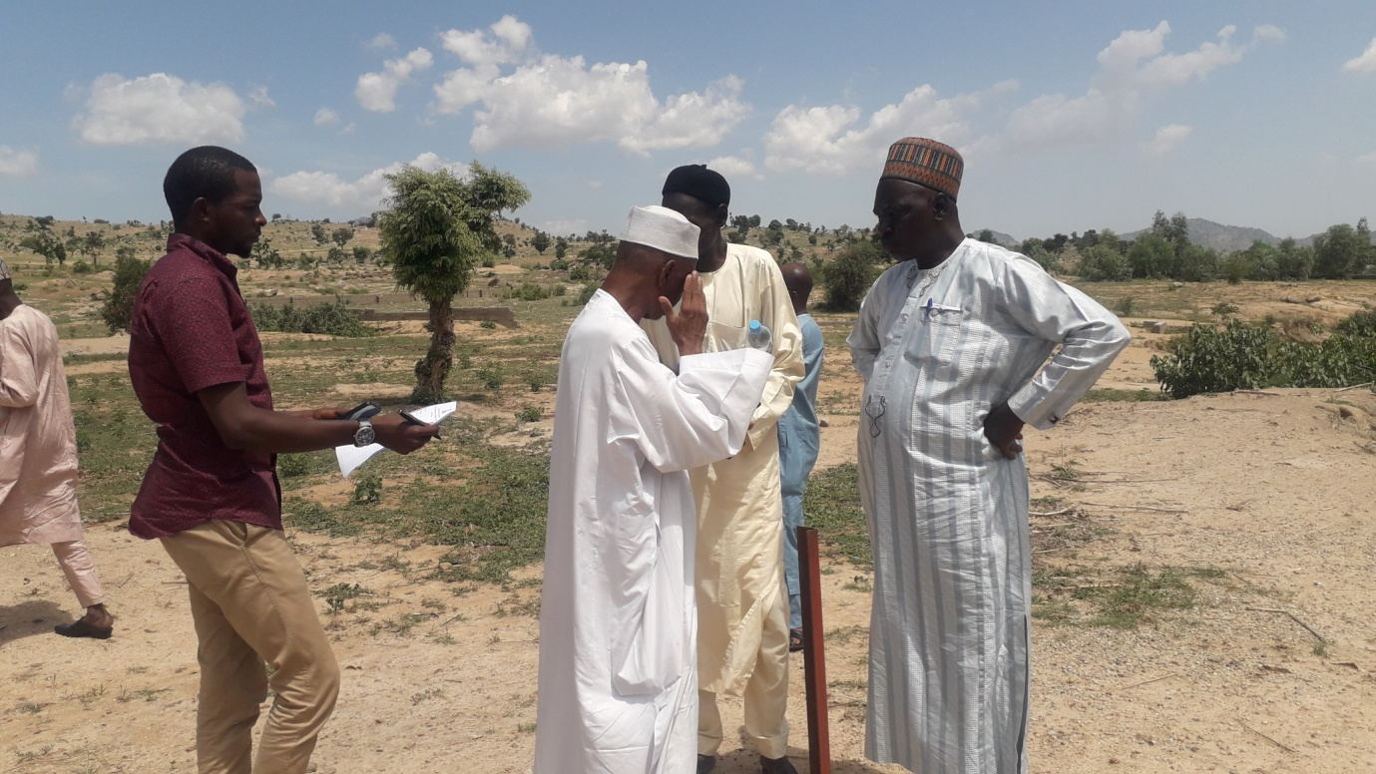
Plate 2. Inspection of Project Site with Staff of FMEnv, Adamawa State Ministry of Environment, Mubi South LGA and IBSDLEIP (Field Survey, 2022).
- Field Data Collection - The field data collection started on 5th February to 25th September 2022.
- Sampling Points - Sampling and observation points were established around the Proposed Mubi International Cattle Market project area. At each sampling location, the GPS location was taken and all the relevant environmental parameters including water quality (underground and surface), air quality, noise level, soil, temperature, and vegetation type were sampled or observed (Table 6 and Figure 21).
- Traffic Survey- Traffic volume on Tike Road leading to the existing Mubi Cattle market was carried out to determine the volume of traffic the existing site generates. This will help in assessing the capacity of the Mubi - Maiha Trunk ‘A’ Federal Highway to accommodate the expected increase in traffic volume to the site of the proposed development. Two locations at the entry from Ahmadu Bello Way and the exit of Tike Road to Lamurde were selected (Table 6 and Figure 21). All types of vehicles and motorcycles passing through the survey locations were counted by direction. The Research Assistance recorded vehicles manually and filled in a survey form.
Table 6. Sampling Points
Sample Location | Coordinates (UTM Zone 33 N, WGS 1984) |  |  | Environmental Component
 | Northing (m) | Easting (m) | Elevation (m)
TF1 | 309813 | 1134995 | 583 | Traffic
TF2 | 309728 | 1134369 | 600 | Traffic
GW1 | 1131877.82 | 307213.97 | 607 | Ground Water
SW1 | 1131683.67 | 307040.16 | 603 | Surface Water
AN01 | 1131608.34 | 307310.19 | 628 | Air Quality and Noise Measurement
AN02 | 1131219.86 | 306960.87 | 628 | Air Quality and Noise Measurement
SS01 | 306896 | 1131711 | 605 | Soil
SS02 | 307109 | 1131718 | 605 | Soil
SS03 | 307309 | 1131718 | 614 | Soil
SS04 | 307507 | 1131721 | 620 | Soil
SS05 | 307698 | 1131710 | 635 | Soil
SS06 | 306896 | 1131501 | 602 | Soil
SS07 | 307110 | 1131501 | 611 | Soil
SS08 | 307306 | 1131501 | 619 | Soil
SS09 | 307504 | 1131501 | 625 | Soil
SS10 | 307691 | 1131490 | 642 | Soil
SS11 | 306696 | 1131311 | 607 | Soil
SS12 | 306904 | 1131300 | 607 | Soil
SS13 | 307107 | 1131301 | 615 | Soil
SS14 | 307304 | 1131299 | 617 | Soil
SS15 | 307502 | 1131300 | 636 | Soil
SS16 | 307313 | 1131110 | 628 | Soil
SS17 | 307095 | 1131110 | 632 | Soil
- Baseline parameter survey- This was conducted by taking the dimensions of the site and observing the immediate environment, noting all the socio-economic, residential and industrial activities going on. This will enable the consultant to predict the potential impacts of the proposed project on the immediate environment.
  - Photographs were taken of the proposed site and other places of interest mentioned earlier within the immediate environment.

4.3 Climate
The climate of Nigeria is classified into dry and wet seasons which run from early November to the end of March and from April to October, respectively. Climate determines the seasonal cycles of food availability and type; the existence of diseases and controls the range of ecological habitat.
The most prevalent winds in the study are the north-easterly and south-westerly winds. The former is dominant in January, while the latter is dominant in July. These are due to the advancement of the maritime tropical air mass, an extension of the St. Helena Anticyclone, and the retreat/replacement of air mass by the continental air mass (Sahara) from the North African anticyclone, with the onset of the dry season. The data on climatic parameters considered for analysis in this study are recorded at Adamawa State University (ADSU), Mubi which is the closest Weather Station to the Proposed Mubi International Cattle Market.
Figure 20. Spatial Distribution of Sampling points for various parameters.

4.3.1 Rainfall
Rainfall from Table 7 shows that the mean rainfall is highest between the months of July and September and reduces drastically in October. There is little or no rainfall between November and March.

Table 7. Average Rainfalls (mm) in Mubi.
Year | Jan | Feb | Mar | Apr | May | Jun | Jul | Aug | Sep | Oct | Nov | Dec | Total (mm)
2004 | - | - | - | 5.2 | 99.9 | 96.5 | 274.5 | 235.9 | 146.5 | 73.6 | 5.1 | - | 937.2
2005 | - | - | - | 47.2 | 75.3 | 154.7 | 207.0 | 329.5 | 245.7 | 41.8 | - | - | 1,101.2
2006 | - | - | - | 2.5 | 92.7 | 96.6 | 229.6 | 216.2 | 243.2 | 52.5 | - | - | 933.3
2007 | - | - | - | - | 46.5 | 132.1 | 183.0 | 246.6 | 85.5 | 25.5 | - | - | 719.2
2008 | - | - | - | - | 74.5 | 133.7 | 212.5 | 295.2 | 103.7 | 18.7 | - | - | 838.3
2009 | - | - | 6.5 | - | 46.3 | 80.3 | 174.4 | 282.5 | 109.0 | 167.0 | - | - | 866.0
2010 | - | - | - | 74.5 | 141.4 | 124.0 | 125.8 | 61.2 | 252.6 | - | - | - | 779.5
2011 | - | - | - | 7.5 | 61.0 | 93.9 | 140.0 | 195.0 | 182.3 | 83.7 | - | - | 763.4
2012 | - | - | - | 65.4 | 133.0 | 187.0 | 201.8 | 331.5 | 314.5 | 109.7 | - | - | 1,342.9
2013 | - | - | - | 15.2 | 111.5 | 148.3 | 165.2 | 360.8 | 111.5 | 36.3 | - | - | 948.8
2014 | - | - | 3.0 | 81.8 | 318.0 | 125.0 | 170.9 | 264.4 | 47.3 | - | - | - | 1,010.4
2015 | - | - | - | - | 25.5 | 158.6 | 108.0 | 365.9 | 224.0 | 115.1 | 7.5 | - | 1,004.6
2016 | - | - | 17.0 | 61.0 | 120.6 | 190.8 | 264.1 | 320.3 | 144.3 | 32.3 | - | - | 1,150.4
2017 | - | - | - | 4.6 | 81.8 | 111.0 | 67.6 | - | - | - | - | - | 265.0
2018 | - | - | 51.0 | 18.1 | 129.9 | 103.4 | 170.4 | 198.8 | 144.0 | 107.5 | - | - | 923.1
2019 | - | 16.0 | 115.4 | 218.4 | 264.8 | 257.4 | 96.3 | 63.2 | 183.4 | 128.4 | - | - | 1,343.3
2020 | - | - | - | - | - | - | - | 86.6 | 35.2 | - | - | - | 121.8
2021 | - | - | - | - | 13.0 | 143.4 | 39.7 | 322.1 | 152.4 | - | - | - | 670.6
Source: Adamawa State University, Mubi.

4.3.2 Temperature
The months of January (19.9 ºC) and June (27.2 ºC) have seen the minimum and highest average temperature in Mubi, respectively (Table 8).
Table 8. Monthly Mean Temperature (ºC) in Mubi.
Year | Jan | Feb | Mar | Apr | May | Jun | Jul | Aug | Sep | Oct | Nov | Dec
2004 | 27.4 | 29.6 | 25.1 | 23.7 | 23.6 | 23.9 | 24.3 | 24.9 | 21.5 | - | - | -
2005 | 23.6 | 26.0 | 29.3 | 28.8 | 26.8 | 24.0 | 24.0 | 28.0 | 28.7 | 24.8 | 24.0 | 23.7
2006 | 24.0 | 24.6 | 27.0 | 28.0 | 28.4 | 24.3 | 23.7 | 22.8 | 23.1 | 24.5 | 23.7 | 28.8
2007 | 19.8 | 23.5 | 21.7 | 29.0 | 27.7 | 26.6 | 28.3 | 20.5 | 21.9 | 23.8 | 25.3 | 24.2
2008 | 22.6 | 20.1 | 24.9 | 27.6 | 26.0 | 24.5 | 23.2 | 23.4 | 23.5 | 23.8 | 26.3 | 23.5
2009 | 19.4 | 16.1 | 17.2 | 21.5 | 23.8 | 22.8 | 27.8 | 22.0 | 25.8 | 23.7 | 27.5 | 33.0
2010 | 17.2 | 18.6 | 20.7 | 22.4 | 22.4 | 30.2 | 27.0 | 23.8 | 23.6 | 24.4 | 20.8 | 17.5
2011 | 20.4 | 16.3 | 19.4 | 23.8 | 27.7 | 30.9 | 24.7 | 21.4 | 24.9 | 24.3 | 20.5 | 17.5
2012 | 18.5 | 18.2 | 19.3 | 21.0 | 27.6 | 26.2 | 25.8 | 23.9 | 24.9 | 25.5 | 20.7 | 13.9
2013 | 17.9 | 20.0 | 20.7 | 21.5 | 23.7 | 31.4 | 27.3 | 23.9 | 24.5 | 25.0 | 21.9 | 16.1
2014 | 19.4 | 18.3 | 20.9 | 23.5 | 22.6 | 29.4 | 26.6 | 24.5 | - | - | - | -
2015 | 18.6 | 18.8 | 18.0 | 22.7 | 29.1 | 30.7 | 26.5 | 22.6 | 23.3 | 25.4 | 19.4 | 16.2
2016 | 16.8 | 19.9 | 21.4 | 21.8 | 23.6 | 31.0 | 26.7 | 25.5 | 24.8 | 25.3 | 21.4 | 15.0
2017 | 13.6 | 20.7 | 29.9 | 26.8 | 24.4 | 25.5 | 22.8 | 23.9 | 23.6 | 24.0 | 26.1 | 25.3
2018 | 19.0 | 16.0 | 18.9 | - | - | - | - | - | - | - | - | -
Total | 298.2 | 306.7 | 334.4 | 342.1 | 357.4 | 381.4 | 358.7 | 331.1 | 314.1 | 294.5 | 277.6 | 254.7
Mean | 19.9 | 20.4 | 22.3 | 24.4 | 25.5 | 27.2 | 25.6 | 23.7 | 24.2 | 24.5 | 23.1 | 21.2
Source: Adamawa State University, Mubi.

4.3.3 Relative Humidity
The month of December experienced 41.4% mean relative humidity while September recorded the highest value of 62.8% (Table 9).
Table 9. Relative Humidity (%) in Mubi.
Year | Jan | Feb | Mar | Apr | May | Jun | Jul | Aug | Sep | Oct | Nov | Dec
2004 | 72.0 | 55.5 | 81.2 | 89.2 | 89.1 | 89.0 | 89.0 | 89.3 | 88.0
2005 | 87.6 | 88.1 | 80.7 | 87.4 | 89.9 | 90.0 | 89.0 | 89.0 | 89.0 | 89.0 | 80.0 | 89.0
2006 | 89.0 | 80.0 | 89.0 | 89.0 | 90.0 | 90.0 | 89.0 | 89.0 | 88.0 | 89.0 | 87.7 | 85.4
2007 | 67.6 | 68.5 | 79.6 | 84.7 | 71.6 | 84.2 | 82.5 | 88.0 | 84.9 | 81.2 | 78.3 | 56.5
2008 | 78.0 | 50.5 | 49.0 | 48.4 | 50.7 | 18.3 | 71.7 | 64.5 | 70.3 | 65.7 | 76.9 | 68.5
2009 | 60.6 | 65.1 | 72.2 | 82.5 | 60.9 | 84.0 | 83.8 | 88.7 | 90.0 | 84.0 | 97.2 | 59.7
2010 | 21.0 | 24.8 | 26.6 | 26.3 | 29.3 | 37.3 | 44.6 | 43.0 | 43.1 | 44.0 | 25.6 | 15.8
2011 | 20.0 | 22.5 | 25.7 | 28.3 | 31.5 | 42.4 | 45.0 | 48.4 | 46.0 | 44.3 | 26.8 | 18.6
2012 | 17.3 | 26.1 | 25.6 | 90.0 | 45.3 | 58.0 | 41.6 | 40.1 | 43.0 | 43.5 | 24.8 | 17.0
2013 | 17.7 | 25.7 | 25.6 | 26.0 | 31.0 | 39.3 | 45.0 | 43.2 | 42.7 | 41.1 | 25.9 | 16.2
2014 | 22.6 | 24.8 | 26.5 | 28.9 | 28.5 | 36.8 | 41.9 | 42.7
2015 | 19.9 | 25.9 | 26.9 | 24.3 | 29.1 | 37.4 | 44.2 | 39.0 | 43.0 | 42.1 | 26.2 | 11.1
2016 | 16.4 | 19.8 | 24.7 | 25.3 | 29.5 | 46.2 | 47.7 | 41.2 | 40.9 | 42.0 | 23.2 | 15.6
2017 | 76.8 | 51.2 | 52.2 | 54.9 | 65.0 | 73.9 | 71.9 | 63.6 | 68.2 | 67.4 | 87.3 | 67.8
2018 | 16.9 | 28.1 | 26.7 | 27.0 | 45.2 | 58.6 | 43.8 | 41.4 | 42.6 | 46.2 | 27.4 | 16.7
Total | 683.4 | 656.6 | 712.2 | 812.2 | 786.6 | 885.4 | 930.7 | 911.1 | 879.7 | 779.5 | 687.3 | 537.9
Mean | 45.6 | 43.8 | 47.5 | 54.1 | 52.4 | 59.0 | 62.0 | 60.7 | 62.8 | 60.0 | 52.9 | 41.4
Source: Adamawa State University, Mubi.

4.3.4 Wind
Figure 22 shows the mean wind speed in Mubi. The windiest months (with the highest average wind speed) are February and March (8.9 km/h). The calmest month (with the lowest average wind speed) is September (5.2 km/h).
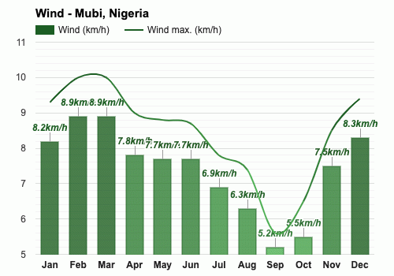
Figure 21. Average Wind Speed (km/h) in Mubi (Source: https://www.weather-atlas.com/en/nigeria/mubi-climate).

4.4 Vegetation Study
The project site is a brown field that is currently being used for farming. As a result, the vegetation cover of the site is sparsely distributed shrubs, grasses, and trees such as Eucalyptus tereticomis, Tamarin and Neem, among others. The land has been cultivated in previous years (Plate 4.2).

4.5 Air Quality
Air quality was measured using GC210 Portable gas detector which is designed to monitor the presence of combustible, flammable and toxic gases, and oxygen depletion.The equipment was placed at each of the two (2) sampling points (Figure 21); the switch was turned on and concentration of selected gases is displayed.
The major pollutant gases and particles considered in this study are; carbon monoxide (CO), sulphur dioxide (SO₂), and nitrogen dioxide (NO₂).

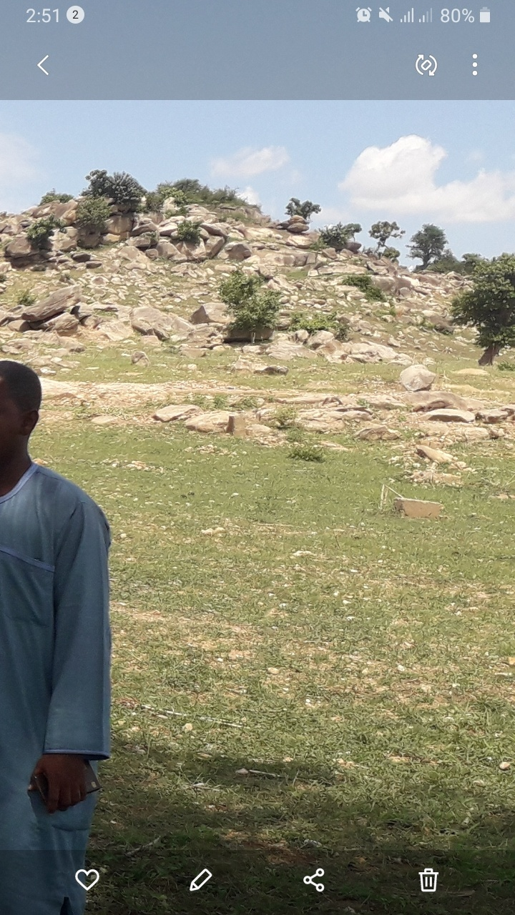
Plate 3. Nature of Vegetation Cover of the Proposed Site (Source: Field Survey, 2022).

4.5.1 Carbon monoxide (CO)
CO concentrations in all sampling locations (AN01 = 0.045 and AN02 = 0.002) mg/m³ are less than the FMEnv limit of 10mg/m³ (Table 10). Carbon monoxide occurs in the air due to the incomplete combustion of carbon produced by machines and automobiles that work on hydrocarbon as fuel source. At low concentrations, it causes fatigue and chest pain. At high concentrations, it results in headache, dizziness and impaired coordination. It results in death when it combines with oxygen in the blood thereby competing with the blood haemoglobin to form carboxylhaemoglobin.
Table 10. Air Quality Measurements at the Proposed Site.
Sampling Locations | Concentrations (mg/m³)
 | CO | SO₂ | NO₂
AN01 | 0.045 | 0.0002 | 0.00004
AN02 | 0.002 | 0.0001 | 0.00002
FMEnv Limit* | 0.41 | 0.0004 | 0.001 – 0.0025
World Bank Limitª | 1.06 | 0.0025 | 0.003
*Source: FEPA (1991) and ªWorld Bank (1998).

4.5.2 Sulphur Dioxide (SO₂)
Sulphur dioxide (SO₂) levels are 0.0002 (AN01) mg/m³ and 0.0001 (AN02) mg/m³, both of which are within acceptable healthy limits (Table 10). Sulphur Dioxide is formed when sulphur containing compounds combine with oxygen. Sources of sulphur dioxide include fossil fuel combustion, bush burning and industrial activities. High level of exposure to Sulphur IV Oxide is linked to several adverse effects on respiratory systems and cause breathing problems in asthmatic patients.

4.5.3 Nitrogen Dioxide (NO₂)
Nitrogen dioxide (NO₂) levels are below the acceptable limit at AN01 = 0.00004 and AN02 = 0.00002 mg/m³ (Table 10). Nitrogen Dioxide pollution results mainly from energy production from automobiles and other fuel combustion processes. Long-term exposure to nitrogen dioxide may decrease lung function and increase the risk of respiratory diseases. Nitrogen dioxide contributes to the rise in acid rain and the formation of other pollutants such as ozone.

4.6 Noise
All existing and planned noise-sensitive receivers in the Study Area have been identified from base maps, the Recommended Development Plan and the approved planning application, as appropriate, and were verified on site. Noise impacts due to the construction of the Project and traffic induced by its operation have been assessed. As the Project would encompass commercial livestock market on the site and human activities from crowd dispersion after major commercial and market events, these activities and the induced road traffic before and after market days are potential noise sources and their potential noise impacts have been assessed. Furthermore, potential impacts arising from fixed noise sources such as building services systems and ventilation systems have also been assessed in this Report.
The noise level was measured using Protmex Sound Level Meter Digital Reader Measurement Range 30-130 dB. The equipment was placed at each of the two (2) sampling points (Figure 21); the switch was turned on and sound levels were recorded.
The noise level in the sample locations AN01 (20dB), and AN02 (14dB) is less than the National Environmental Regulations (2009) maximum permissible noise level for commercial areas of 75dB.

4.7 Water Quality
Water samples for physico-chemical parameters and bacteriological examinations were collected in plastic containers and sterile bottles, respectively, stored and transported for analysis. The samples comprised surface and well water. The surface water sample was collected inside the major stream by the Mubi-Maiha Trunk ‘A’ Federal Highway, while the well water was collected from a Filling Station (Arsahamun & Co. Nigeria Ltd.) 173 m away from the Project Site (Figure 21).
The analysis revealed that the well water is fit for human and animal consumption but needs chlorination, while the surface water is also fit for human and animal consumption, contamination may be due to animal faeces (see Appendices I and II).

4.8 Soil
Seventeen (17) soil samples were collected from the project site and its surroundings. A systematic pattern in which grids of 200 x 200 m are created on the site's satellite imagery. Samples were collected in the center of each grid, which was traced using Etrex 10 Garmin global positioning systems (GPS). A depth of 0-30cm was used.
Heavy metal concentrations such as Arsenic (As), Lead (Pb), Cadmium (Cd), Zinc (Zn), Chromium (Cr), Nickel (Ni), Copper (Cu), Iron (Fe), and Mercury (Hg) were determined spectrophotometrically while Potentials of Hydrogen (pH), Sulphate (SO4-2), Nitrogen (Total N), Phosphorus (Av. P), Phosphate (PO4-2), Nitrate-nitrogen (NO3-N), Nitrite-nitrogen (NO2-N), Magnesium (Mg), Potassium (K), and Organic Carbon (OC) were determined titrimetrically.

4.8.1 Heavy Metals Concentration
Table 11 shows the concentration of the heavy metals in the soil samples collected from the 17 sample locations.

4.8.1.1 Arsenic (As)
Sample SS11 (0.022 mg/kg⁻¹) has the lowest concentration of As, while, SS03 (0.137 mg/kg⁻¹) constitute the highest concentration. Comparing the results of As with the maximum allowable limit which is FMEnv limit of 0.05 mg/kg.

Table 11. Heavy Metal Concentrations at the Proposed Site of Mubi International Cattle Market and Environs.
Sample ID | X_Coord | Y_Coord | Elev(m) | As | Pb | Cd | Zn | Cr | Ni | Cu | Fe | Hg
 |  |  |  | Mg/kg⁻¹ | Mg/kg⁻¹ | Mg/kg⁻¹ | Mg/kg⁻¹ | Mg/kg⁻¹ | Mg/kg⁻¹ | Mg/kg⁻¹ | Mg/kg⁻¹ | Mg/kg⁻¹
SS01 | 306896 | 1131711 | 605 | 0.116 | 0.006 | 0.018 | 2.89 | 0.003 | 0.175 | 0.38 | 18.93 | 0.001
SS02 | 307109 | 1131718 | 605 | 0.074 | 0.012 | 0.034 | 1.25 | 0.013 | 0.282 | 0.49 | 11.29 | 0.001
SS03 | 307309 | 1131718 | 614 | 0.137 | 0.021 | 0.035 | 1.39 | 0.016 | 0.505 | 0.58 | 9.19 | 0.003
SS04 | 307507 | 1131721 | 620 | 0.087 | 0.026 | 0.097 | 0.98 | 0.004 | 0.064 | 0.61 | 12.18 | 0.006
SS05 | 307698 | 1131710 | 635 | 0.069 | 0.035 | 0.055 | 0.75 | 0.01 | 0.202 | 0.37 | 6.16 | 0.004
SS06 | 306896 | 1131501 | 602 | 0.049 | 0.05 | 0.07 | 0.43 | 0.011 | 0.047 | 0.19 | 4.87 | 0.002
SS07 | 307110 | 1131501 | 611 | 0.038 | 0.043 | 0.082 | 0.41 | 0.015 | 0.041 | 0.13 | 15.93 | 0.003
SS08 | 307306 | 1131501 | 619 | 0.121 | 0.008 | 0.04 | 0.31 | 0.009 | 0.07 | 0.12 | 4.11 | 0.004
SS09 | 307504 | 1131501 | 625 | 0.073 | 0.023 | 0.044 | 0.52 | 0.023 | 0.132 | 0.16 | 8.95 | 0.004
SS10 | 307691 | 1131490 | 642 | 0.023 | 0.053 | 0.045 | 0.63 | 0.013 | 0.26 | 0.18 | 3.92 | 0.002
SS11 | 306696 | 1131311 | 607 | 0.022 | 0.018 | 0.021 | 3.71 | 0.004 | 0.211 | 1.18 | 4.44 | 0.001
SS12 | 306904 | 1131300 | 607 | 0.047 | 0.025 | 0.022 | 4.75 | 0.005 | 0.193 | 1.06 | 2.28 | 0.001
SS13 | 307107 | 1131301 | 615 | 0.051 | 0.011 | 0.011 | 0.44 | 0.002 | 0.147 | 0.28 | 5.29 | 0.002
SS14 | 307304 | 1131299 | 617 | 0.033 | 0.031 | 0.027 | 2.97 | 0.004 | 0.211 | 1.34 | 2.75 | 0.001
SS15 | 307502 | 1131300 | 636 | 0.041 | 0.02 | 0.009 | 1.35 | 0.008 | 0.188 | 0.75 | 6.13 | 0.002
SS16 | 307313 | 1131110 | 628 | 0.107 | 0.019 | 0.051 | 2.11 | 0.07 | 0.07 | 0.68 | 3.52 | 0.005
SS17 | 307095 | 1131110 | 632 | 0.037 | 0.011 | 0.021 | 2.09 | 0.003 | 0.033 | 0.83 | 2.81 | 0.001
 |  |  | Min | 0.022 | 0.006 | 0.009 | 0.310 | 0.002 | 0.033 | 0.120 | 2.280 | 0.001
 |  |  | Max | 0.137 | 0.053 | 0.097 | 4.750 | 0.070 | 0.505 | 1.340 | 18.930 | 0.006
 |  |  | Mean | 0.066 | 0.024 | 0.040 | 1.587 | 0.013 | 0.167 | 0.549 | 7.221 | 0.003
 |  |  | Std Dev | 0.0361 | 0.0141 | 0.0248 | 1.3146 | 0.0159 | 0.1177 | 0.3823 | 4.8631 | 0.0016
Source: Field Survey (2022).

4.8.1.2 Lead (Pb)
The lowest and highest Pb levels of 0.006 mg/kg⁻¹ and 0.053 mg/kg⁻¹ were recorded from samples SS01 and SS10, respectively. It was observed that all the samples are below FMEnv maximum allowable limit of 0.05mg/kg⁻¹.

4.8.1.3 Cadmium (Cd)
Cd levels of 0.009 mg/kg⁻¹ and 0.097 mg/kg⁻¹ were recorded for the samples SS15 and SS04, representing the lowest and highest concentrations of Cd in and around the project site. Thus, all of the samples are less than the FMEnv maximum allowable limit of 0.01 mg/kg⁻¹. A natural source of cadmium in the environment is through weathering of rocks. Cadmium is found in manures and pesticides. It enters the environment mainly through the ground, contaminated water seeping into the soil, through the atmosphere from gaseous industrial emissions and fumes from cigarette and forest fires

4.8.1.4 Zinc (Zn)
The concentration of Zn in the soil sample ranged between 0.31 to 4.75 mg/kg⁻¹. Comparing the results for Zn with WHO maximum allowable limit of 300 mg/kg, all the samples are below the limit.

4.8.1.5 Chromium (Cr)
Chromium concentration in the area falls between 0.002 to 0.07 mg/kg⁻¹. Apart from SS16 (0.07 mg/kg⁻¹), all the remaining samples are less than the FMEnv maximum allowable limit of 0.05 mg/kg⁻¹.

4.8.1.6 Nikel (Ni)
The concentration of Ni ranges from (0.033-0.505) mg/kg⁻¹ which indicates that all the samples are within the WHO maximum allowable limit of 50 mg/kg⁻¹.

4.8.1.7 Copper (Cu)
Among the samples collected, samples SS11 (1.18 mg/kg⁻¹), SS12 (1.06 mg/kg⁻¹), and SS14 (1.34 mg/kg⁻¹) were above the limit of <1 mg/kg⁻¹ for Cu. Copper can be found naturally in the environment. Toxic levels of copper (Cu) rarely occur naturally in soils. However, copper may accumulate through the application of sewage sludge, mine slag or through persistent use of copper-containing fungicides or fertilizers. Moderate levels of copper toxicity may be accompanied by a pale green to white chlorosis on mature leaves.

4.8.1.8 Iron (Fe)
The Fe concentration in the area ranges between 2.28 to 18.93 mg/kg⁻¹ indicating within WHO maximum allowable limit of 50,000 mg/kg.

4.8.1.9 Mercury (Hg)
The concentration of Hg in the soil sample ranges between (0.003 and 0.006) mg/kg⁻¹ indicating that all the samples are slightly above the FMEnv limit of 0.002 mg/kg⁻¹ allowable limit.

4.8.2 Soil Quality
Soil is the topmost layer of the earth's crust. Soil is a thin covering over land consisting of a mixture of minerals, organic material, living organisms, air and water that support the growth of plant life. The quality of soil depends on its parent material from which it is formed. Soil is essential for agricultural purposes, and recreation and serves as a habitat for other organisms. It is therefore important to prevent contamination of soil as it poses danger to the availability of food and affects the quality of air and water. The results of the soil quality parameters are shown in Table 12.

4.8.2.1 Soil pH
Soil pH is a measure of how acidic/basic water is. The range goes from 0 - 14, with 7 being neutral. pHs of less than 7 indicate acidity, whereas a pH of greater than 7 indicates a base.
However, for practical purposes, soil is neutral when pH is between 6 and 8, depending on plant requirements, and it is acidic when pH is less than 6 and alkaline when it is greater than 8. The soil pH in the area ranged between 3.21 and 6.77 indicating acidity. Most of the samples show neutrality except samples SS09 (3.21), SS10 (3.34), and SS16 (5.82). Soil acidity is a potentially serious land degradation issue.

4.8.2.2 Sulphate (SO4-2)
Values of sulphate range from 89.97 to 186.52 mg/kg⁻¹ and are within the FMEnv limit of 250 mg/kg⁻¹. Sulphate in the soil occurs naturally as sediments or organic substrates that are formed under water-logged conditions.

Table 12. Soil Properties in the Proposed Mubi International Cattle Market and Environs.
Sample ID | X_Coord | Y_Coord | Elev(m) | pH | SO4-2 | Total N | Av-P | PO4-2 | NO3-N | NO2-N | Mg | K | Org.C
 |  |  |  |  | mgkg-1 | % | mgkg-1 | mgkg-1 | mgkg-1 | mgkg-1 | mgkg-1 | mgkg-1 | %
SS01 | 306896 | 1131711 | 605 | 6.76 | 121.93 | 0.044 | 8.11 | 7.21 | 12.86 | 2.86 | 10.23 | 9.75 | 0.63
SS02 | 307109 | 1131718 | 605 | 6.33 | 167.59 | 0.013 | 5.29 | 14.33 | 6.33 | 1.73 | 6.04 | 6.63 | 0.18
SS03 | 307309 | 1131718 | 614 | 6.47 | 147.83 | 0.015 | 4.87 | 12.45 | 7.36 | 1.13 | 6.72 | 7.02 | 0.21
SS04 | 307507 | 1131721 | 620 | 6.51 | 155.93 | 0.017 | 5.39 | 15.37 | 9.44 | 1.88 | 5.28 | 5.07 | 0.24
SS05 | 307698 | 1131710 | 635 | 6.22 | 143.9 | 0.02 | 4.98 | 13.66 | 8.26 | 1.09 | 7.08 | 8.58 | 0.28
SS06 | 306896 | 1131501 | 602 | 6.53 | 130.1 | 0.015 | 6.13 | 16.62 | 5.93 | 0.92 | 8.88 | 7.41 | 0.24
SS07 | 307110 | 1131501 | 611 | 6.72 | 121 | 0.014 | 4.54 | 17.00 | 6.74 | 0.48 | 5.41 | 5.85 | 0.2
SS08 | 307306 | 1131501 | 619 | 6.77 | 140.56 | 0.013 | 5.44 | 14.44 | 6.84 | 0.75 | 10.68 | 6.63 | 0.19
SS09 | 307504 | 1131501 | 625 | 3.21 | 125.32 | 0.015 | 6.22 | 13.36 | 9.25 | 1.39 | 6.02 | 7.41 | 0.22
SS10 | 307691 | 1131490 | 642 | 3.34 | 186.52 | 0.022 | 5.77 | 17.11 | 11.84 | 2.63 | 6.24 | 6.75 | 0.38
SS11 | 306696 | 1131311 | 607 | 6.66 | 98.65 | 0.062 | 8.92 | 9.25 | 13.83 | 2.52 | 8.76 | 9.75 | 0.88
SS12 | 306904 | 1131300 | 607 | 6.32 | 113.9 | 0.076 | 13.52 | 8.64 | 14.28 | 1.99 | 9.36 | 14.43 | 1.09
SS13 | 307107 | 1131301 | 615 | 6.67 | 121.11 | 0.025 | 6.83 | 10.09 | 10.75 | 1.25 | 7.56 | 7.02 | 0.36
SS14 | 307304 | 1131299 | 617 | 6.29 | 89.97 | 0.068 | 11.29 | 7.29 | 19.86 | 1.86 | 10.08 | 12.09 | 0.97
SS15 | 307502 | 1131300 | 636 | 6.49 | 97.63 | 0.034 | 7.88 | 6.95 | 3.16 | 1.11 | 8.16 | 8.19 | 0.48
SS16 | 307313 | 1131110 | 628 | 5.82 | 137.92 | 0.036 | 5.97 | 18.1 | 5.22 | 0.99 | 8.52 | 8.97 | 0.51
SS17 | 307095 | 1131110 | 632 | 6.44 | 92.54 | 0.054 | 8.13 | 11.09 | 10.95 | 1.08 | 8.64 | 10.92 | 0.76
 |  |  | Min | 3.21 | 89.97 | 0.013 | 4.54 | 6.95 | 3.16 | 0.48 | 5.28 | 5.07 | 0.18
 |  |  | Max | 6.77 | 186.52 | 0.076 | 13.52 | 18.1 | 19.86 | 2.86 | 10.68 | 14.43 | 1.09
 |  |  | Mean | 6.09 | 128.96 | 0.03 | 7.02 | 12.53 | 9.58 | 1.51 | 7.86 | 8.38 | 0.46
 |  |  | Std Dev | 1.09 | 26.80 | 0.02 | 2.43 | 3.76 | 4.12 | 0.69 | 1.73 | 2.41 | 0.30
Source: Field Survey (2022).

4.8.2.3 Nitrogen (Total N)
Nitrogen concentrations ranged from 0.013 to 0.076 mg/kg⁻¹, well below healthy levels of Total N in soil of 40 mg/kg⁻¹.

4.8.2.4 Phosphorus (Av. P)
Phosphorus (Av. P) concentration ranged from 4.54 to 13.52 mg/kg⁻¹, which was lower than the minimum requirements for healthy FMEnv levels of 25 to 50 mg/kg⁻¹. Phosphorus is an essential element classified as a macronutrient because of its relatively large amount. It is one of the key nutrients added to soil in fertilizers for energy, early plant growth and maturity. In natural systems like soil, phosphorus will exist as phosphate. Phosphates are taken up by plants from the soil, utilized by animals that consume the plants and returned to the soil as organic phosphates.

4.8.2.5 Phosphate (PO4-2)
Phosphate (PO4-2) concentration (6.95 – 18.10 mg/kg⁻¹) is also below FMEnv's recommended healthy levels of 25 to 50 mg/kg⁻¹.

4.8.2.6 Nitrate-nitrogen (NO3-N)
Nitrate-nitrogen (NO3-N) measures the amount of available nitrogen in the soil that can be absorbed immediately by plants. The amount required in the soil for specific crops varies from crop to crop, but in general, the levels should not fall below 10 mg/kg⁻¹ and should not exceed 50 mg/kg⁻¹. However, nitrate varies with soil-water so levels can fluctuate widely depending on soil water movement. Values of NO3-N for this study fall between 3.16 and 19.86 mg/kg⁻¹. Nitrates in the air may act as respiratory irritants.

4.8.2.7 Nitrites (NO2-N)
The NO2-N concentration in the area ranges from 0.48 to 2.86 mg/kg⁻¹. Only samples SS06 (0.92), SS07 (0.48), SS08 (0.75), and SS16 (0.99) fall within the FMEnv limit of 1mg/kg⁻¹. Nitrites are harmful to human health. Both nitrates and nitrites occur naturally in the soil, through dead leaves, and plant and animal wastes. In the natural nitrogen cycle, bacteria convert nitrogen to nitrates which are further converted to nitrites. This reaction occurs in the environment and prevents the excessive deposits of nitrites accumulation. However, human activities may increase nitrite concentration through agriculture. This includes the use of nitrogen–containing fertilizer. Nitrates are non-toxic to human health. However, when swallowed, they are converted to nitrites, creating a decrease in oxygen transportation in the blood.

4.8.2.8 Magnesium (Mg)
All soil samples contained acceptable levels of Mg (ranging from 5.28 to 10.68 mg/kg⁻¹) and were within the FMEnv (50mg/kg⁻¹) limit. Mg is among the macronutrient and secondary nutrients required by plants in moderate amounts. Magnesium deficiencies are rare when the soil pH is adequate. The level of magnesium found in soil is primarily affected by soil type, drainage, liming and cropping practices.

4.8.2.9 Potassium (K)
Potassium concentrations ranged from 5.07 to 14.43 mg/kg⁻¹, well below healthy levels of K in soil, which range from 40 to 80 mg/kg⁻¹.

4.8.2.10 Organic carbon (OC)
It is widely assumed that the soil organic carbon threshold for sustaining soil quality is around 2%, below which deterioration may occur. The OC concentrations ranged from 0.18 to 1.09 percent, which is well below the healthy OC levels in soil.

4.9 Traffic Volume
The total number of vehicle trips counted at the locations on Tike Road (Plate 4) was summarised and presented in Table 13 and Figures 23 to 30.
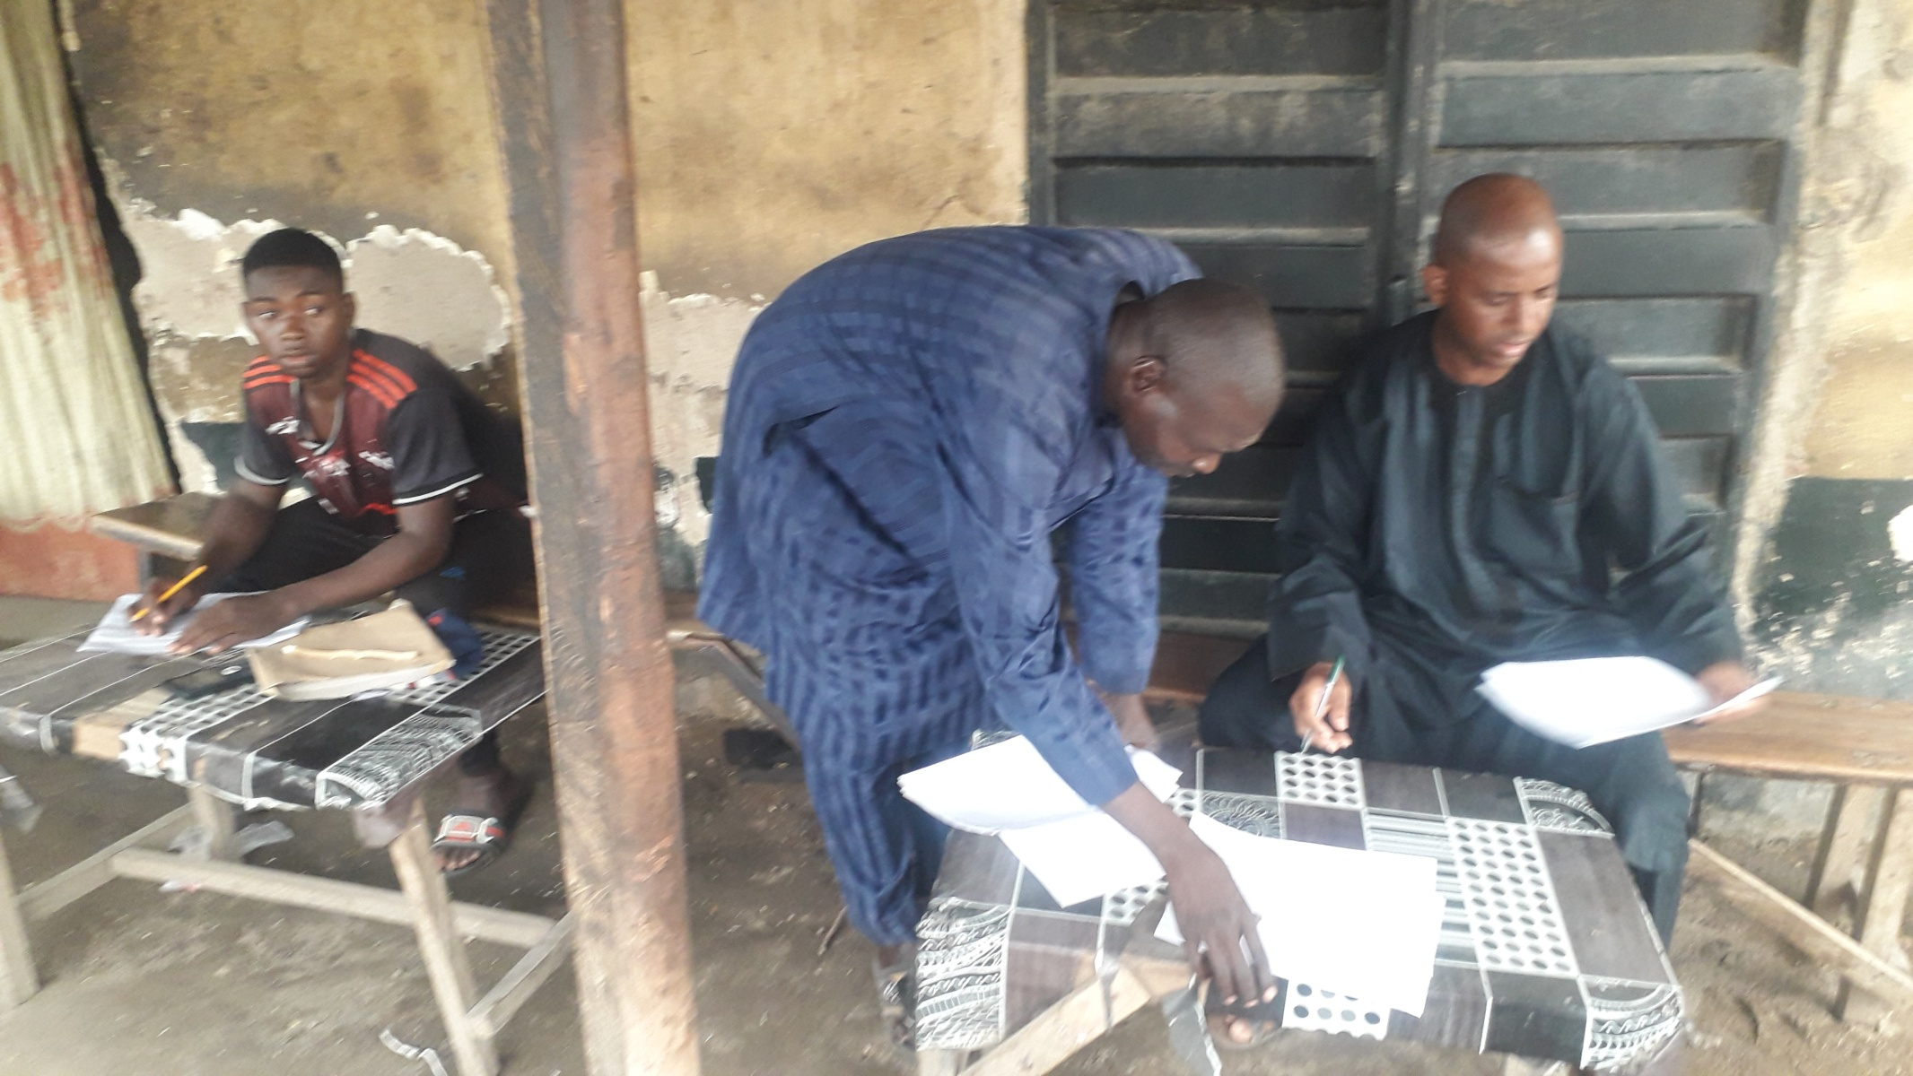
Plate 4. Conducting Traffic Survey (Field Survey, 2022).

Table 13. Traffic Volume along Tike Road on Tuesday and Wednesday.
Days |  | Tuesday |  |  |  | Wednesday
Location | Trailers/Tankers | Cars (Saloon/Pick-up Vans) | Keke Napep/Motor Cycle | Total | Trailers/Tankers | Cars (Saloon/Pick-up Vans) | Keke Napep/Motor Cycle | Total
Ahmadu Bello Way to Cattle Market | 233 (2.6%) | 656  (7.3%) | 8,095  (90.1%) | 8,984 | 170 (2.1%) | 810  (9.8%) | 7,310  (88.2%) | 8,290
Cattle Market to Ahmadu Bello Way | 237 (2.8%) | 786  (9.2%) | 7,524  (88.0%) | 8,547 | 332  (3.9%) | 867  (10.1%) | 7,396  (86.1%) | 8,595
Lamurde to Cattle Market | 170  (4.1%) | 572  (13.7%) | 3,448  (82.3%) | 4,190 | 167  (3.7%) | 576  (12.6%) | 3,829  (83.7%) | 4,572
Cattle Market to Lamurde | 124  (3.0%) | 518  (12.4%) | 3,537  (84.6%) | 4,179 | 144  (3.2%) | 573  (12.6%) | 3,830  (84.2%) | 4,547
Source: Field Survey (2022).

Figure 22. Ahmadu Bello Way to Cattle Market on Tuesday (Field Survey, 2022).

Figure 23. Cattle Market to Ahmadu Bello Way on Tuesday (Field Survey, 2022).

Figure 24. Lamurde to Cattle Market on Tuesday (Field Survey, 2022).

Figure 25. Cattle Market to Lamurde on Tuesday (Field Survey, 2022).

Figure 26. Ahmadu Bello Way to Cattle Market on Wednesday (Field Survey, 2022).

Figure 27. Cattle Market to Ahmadu Bello Way on Wednesday (Field Survey, 2022).

Figure 28. Lamurde to Cattle Market on Wednesday (Field Survey, 2022).

Figure 29. Cattle Market to Lamurde on Wednesday (Field Survey, 2022).

4.10 Social and Economic Baseline Conditions of the Area
The study examines and assesses the social, cultural and economic characteristics as well as conditions of the project environment. This part therefore presents the report of the social impact assessment of the project in the area. The major issues discussed are part of the terms of reference of the Environmental and Social Impact Assessment. The report also attempts to explain the probable impact of the project on human activities within and around the project site.

4.10.1 The Demographic Conditions
Mubi is the second largest town in Adamawa State after Yola, the state capital; it is the headquarters of Mubi South Local Government council. The town is cosmopolitan in character with different ethnic, religious and cultural norms. Mubi is growing rapidly due influx of migrants and high birth rates. The growth rate is projected at 2.9% per annum (NPC, 2016).

4.10.2 Communities and People of Mubi
The people of Mubi are dominantly, Fulani, Gude and Fali, with other significant number of Margi, Higgi, Njai, Hausa among many others. The people are mainly Muslims and Christians, with traditional religion among some of the people.
Administratively Mubi town is organized along both traditional and political units. These units are recognized as traditional wards (Anguwa) and political wards. The administrative units varies in terms of both geographical and population sizes. These units form the communities of Mubi with common attribute. The major wards are Lokuwa, Lamorde, Gude, Nassarawo, Sabon Layi, among others. Each unit has leaders ward heads (Mai Anguwa) and political leaders’ councilor
No residential properties or houses were recorded on the site and even at 800 m buffer. However, on the positive side, local economic and social resources will be positively affected due to construction activities in the area. For instance, employment will be provided to the populace of Mubi and villages around thereby enhancing their economic and social status. Also commercial activities, particularly small scale business will likely be enhanced.
Fiver (5) wards have been selected for data collection to analysed social and economic characteristics of the people within and around the project site at Mubi. The wards selected are Gude, Lamorde, Sabon Layi, Yelwa and Nassarawo wards. A total of four hundred (400) copies of questionnaires were distributed in the wards base on their population. Thus, Lamorde ward 120 questionnaires, Yelwa ward 90 questionnaires, Nassarawo ward 80 questionnaires, Sabon Layi ward 60 Questionnaires and finally Gude ward 50 questionnaires. Simple Sampling Technique was adopted in administering the questionnaires.

4.10.3 Bio-Data Analysis
Table 14 shows that out of the four hundred (400) total respondents 78.7 % are males while female are 21.3%. Marital status among the respondents indicates that 52% are single while 48% are married. The educational status of the people shows that None formal education constitute 18%, those with first school leaving certificate amount to 26.2% while those with advanced level certificate account for about 31.2%. 34.5% of respondents have either first degree or higher degree in the area.
Table 14. Summary of Respondents on Gender, Marital status and Qualification.
 | PARAMETERS
Summary | GENDER |  |  | Marital status |  |  | Educational Qualification
 | Male | Female | Total | Single | Married | Total | None | 1st SCL | A’level | Degree | Total
Total | 315 | 85 | 400 | 208 | 195 | 400 | 72 | 105 | 125 | 98 | 400
% | 78.7 | 21.3 | 100 | 52 | 48 | 100 | 18 | 26.2 | 31.2 | 24.5 | 100
Source: Field Survey (2022).
Table 15 is the summary of respondents based on employment status, average income and the profession or occupation of the people in the area. The summary indicates that 46.3$ of respondents are employed while 51.7 are not formally employed. Average income of respondents shows that those earning below fifty thousand Naira per month is 50.5% while those with income above fifty thousand constitute about 49.5%. Profession or occupation of respondents shows that the majority of the people of Mubi 54.5% are in one form of business or another, while farmers account for about 21.7% of respondents. Civil servants are only 16% of respondents.
Table 15. Summary of Respondents on Employment, Income and Occupation.
Summary | Employment Status |  |  | Average Income |  |  | Profession/Occupation
 | Employed | Unemployed | Total | >50k | <50k | Total | C/S | Business | farmers | Artisan | Total
Total | 185 | 207 | 400 | 202 | 198 | 400 | 64 | 218 | 87 | 33 | 400
% | 46.3 | 51.7 | 100 | 50.5 | 49.5 | 100 | 16 | 54.5 | 21.7 | 8.2 | 100
Source: Field Survey (2022).

4.11 Health Survey/Analysis

4.11.1 Knowledge of Environmental Threats Associated With the Proposed Project
Sixty three (63%) of the respondents could not demonstrate any knowledge of environmental threat associated with the project. Of the remaining 37% who responded, 33% were of the belief that there is no form of environmental threat whatsoever, if the proponent of the project monitors the projects activity well.
95% of the respondents were of the view that the proposed project would bring development to the area which would eventually boost the standard of living of the people. 5% directly linked the operations of the project from the construction stage with employment opportunities for the people, they based their reasoning on the fact that, the project activities would require labour of all categories for its successful completion and it is those people that live around the project area that would benefit more.

4.11.2 Health Status Assessment
The Construction Stage of the project development will involve a lot of digging and excavation works. These operations may have the tendency of creating standing pools of water if the activity is carried out during the wet season which may become breeding grounds for vectors such as mosquitoes and flies. This may increase the incidences of malaria and other diseases associated with such stagnant water bodies.
The construction works of the project will attract immigrant workers from within and outside the study area. Most of them will be young men in their sexually active ages. There is the tendency that there will be a high degree of interaction between the young immigrants and the young ladies of the host communities. This will present a similar high risk of the incidences of Sexually Transmitted Diseases (STDs).

4.11.3 The Current Health Status in the Study Area
The data presented here relies heavily on focus group discussion and perceived knowledge by the community as noted during group discussion As much as 83% of those interacted with indicated malaria as the most common health problem occurring in the study area. This was followed by Typhoid fever, Tuberculosis/Cough related illness and Yellow fever accounting for 10%, 3% and 5% respectively.

4.11.4 Lifestyle and Wellness in Mubi Community
Lifestyle is generally considered a personal issue. However, lifestyles and social practices or ways of living adopted by individuals often reflect personal or group and social-economic identities.
The results revealed that urban people of Mubi LGA engaged in sedentary lifestyle more than their rural counterparts hence, health problems suffered by the people of Mubi Community is significantly related to their sedentary lifestyle. Thus, the main observations are
Urban people in the study area engage more in sedentary lifestyle than their rural counterparts.
Health problems suffered by the people of Mubi community are significantly related to their sedentary lifestyle or physical inactivity.

4.11.5 Cause of Health Problems in the area
These were noticed to occur as a result of poor sanitary conditions/mosquitoes (62%), lack of potable water supply (28%) lack of basic infrastructures e.g. good roads, electricity etc. (10%), as actors responsible for the illnesses experienced in the study area.
This is further corroborated by the response of about 94% who agree that these health problems are preventable.

4.11.6 Health Care Facilities
Adamawa State Government has always prioritized healthcare to its people, for that purpose the State has well over 1,000 primary healthcare centres and a considerable healthcare facilities. However, due to economic recession the nation had faced in the past few years, accessibility to quality and affordable health care services was a serious challenge, especially to rural dwellers.
Another major challenge is that there are not enough drugs and other medical consumables in most of the healthcare centres including the General Hospitals.
Infrastructural decay also pervades most of the healthcare centres especially those located in remote areas where the buildings and other facilities are almost abandoned.

4.11.7 Types of HCFs
A health care facility (HCF) is any place where medicine is practiced regularly. Overall, the types of HCFs ranges from small and relatively simple medical clinics (such as dispensaries, dental offices, out-patient surgery centres, birthing or delivery centres, and nursing homes and personal care facilities) to large, complex, and costly hospitals (General, Specialist, Teaching and Research). In between the two extremes are the Comprehensive Health Centres (CHC), Maternity Centres and Homes (MCH), and Primary Health Care Centres (PHCs).
The MCH, CHCs and PHCs were the primary facilities that are the closest to the grassroots population in the rural communities while the General and Rural Hospitals constituted the secondary Facilities that usually represent referral centres to the primary facilities in the third tier of health care in the country.

4.11.8 Physical Status of HCFs
Interviews were conducted to observe the physical status of the selected HCFs in the State with respect to general cleanliness, availability of curtains in the Maternity/Delivery Rooms, and the status of the floor of the labour room.
Findings show that majority (50.6%) of the supported facilities in the State was clean and 10.5% were very clean. However, the balance of 30.1% was under renovation, while 8.8% did not indicate status of facility cleanliness. This finding should be validated for appropriate strengthening.

4.11.9 Availability of Amenities
Amenities are any provisions in the HCFs that enhance its benefits including access, patronage and performance of service delivery, as well as the sanitary conditions.
Amenities in this context are toilets, water, light, bathroom, waste disposal system, and sterilization system, wards, and labour or delivery rooms.

4.12 Public participation
Members of the public are supposed to participate and get involved in decision making concerning development projects because they affect them. Reference is made to Section 17 of the Environmental (Impact Assessment and Audit) Regulations, 1992, which states that the proponent shall in consultation with the authority, seek the views of persons who may be affected by the projects. The role of public consultation and involvement in EIA process is to assure the quality, comprehensiveness and effectiveness of the assessment and ensure that the public views are adequately taken into consideration in decision making process. This public participation was conducted through a public meeting organized at the site. The meeting was attended by the Proponent representatives, EIA/EA expert, the area leaders including the Sarki Tike, Miyetti Allah Cattle Breeders Association, Amalgamated Traders Union, the elders and the area residents including immediate neighbours of the proposed site (Plate 4).
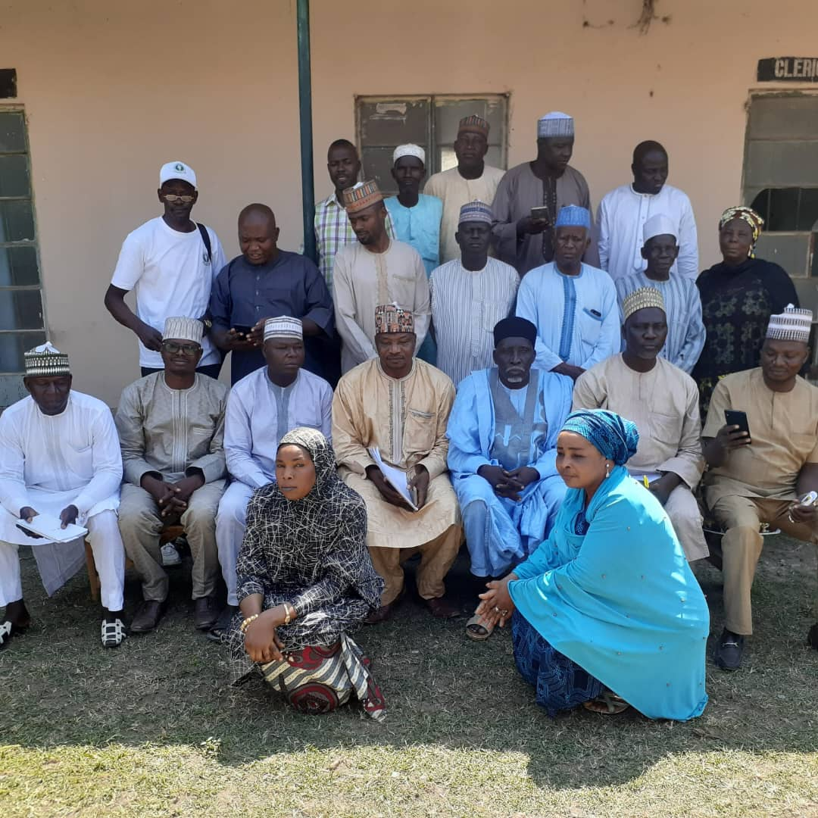
Plate 5. Photo after Stakeholder’s Meeting (Field Survey, 2022).
The findings from the stakeholder's meeting are;
- During the meeting, the locals appreciated that the Proponent had given them a chance to participate in the decision-making process concerning the proposed project.
- The Proponent explained that the site was chosen for a new Cattle Market to be constructed by the state Government.
- The members of the public were concerned about the insecurity of the new site.
- After a lengthy discussion on the outcome of the proposed new cattle market, the Locals allowed the Proponent to carry on the proposed project.

CHAPTER FIVE

POTENTIAL AND ASSOCIATED IMPACTS

5.1 Introduction
This Chapter seeks to report on the likely impacts of the proposed project identified and evaluated with due consideration to the construction and operation of the proposed Mubi International Cattle Market in relation to the current status of the project site environment. The environmental impacts associated with the project have been identified by examining how the activities associated with the different components interact with the environment.
The key components associated with the project are environment, health, safety, and social management; construction activities; labour and working conditions (including employee and contractor occupational health and safety); pollution prevention and abatement; and biodiversity conservation. The two basic components associated with the project, namely; construction and operations have several activities which can either directly or indirectly interact with different components of the environment leading to environmental impacts.
For instance, during construction, the site is likely to be vulnerable to environmental disturbance. The construction/installation would be rapid and could be disorderly with a strong emphasis on completing the project and not on protecting the environment. Nevertheless, during construction and operation, irreversible impacts are not likely as the proposed Project is not envisaged to exacerbate the current environmental condition. The assessment of the identified impacts was based largely on field observations, baseline data and existing literature. In practice, many elements of the environment are inter-related and cannot be considered in isolation. However, for convenience, some of these elements discussed here are under separate headings.

5.2 Defining the Impact Scope and Indicators
Since all players within the structural construction developments sector have an influence on the environment and the impacts that are associated with the various players differ from one another in terms of the nature and magnitude, it was necessary to consider the scope of the proposed project dealt with in the identification and evaluation of relevant impacts.

5.3 Environmental Components and Impact Indicators
In Table 16, some of the environmental components and indicators that were identified based on the premise that they could engender some changes (impact) on the environment as a result of the proposed project's activities are outlined. It should be appreciated that the impact indicators associated with the activities of the proposed project on the environment were identified based on the combination of the existing literature, knowledge of the project activities and operational procedures, acquired and past experiences on the activities.
Table 16. Environmental Components and Impact Indicators.
S/No. | Environmental Components | Identified Impact Indicators | Source of Impact
1. | Air Quality | Particulate matters, CO, NO₂, SO₂, CO2 | Vehicular movements,  Construction, Electricity  Generators
2. | Noise | On-site &Off-site disturbance, noise related health problems, communication interference. | Electricity Generators
3. | Soil & Water  Quality | Solids, physico-chemical, turbidity, salinity, chemical toxicity, and microbiological characteristics etc. | Vehicles, Construction,  Electricity Generators, Waste
4. | Flora & Fauna | Changes in original types and deviation from normal characteristics | Removal during construction, etc.
5. | Socioeconomics | Traffic, Population, security, income, settlement, and infrastructure change.  Access to communication facilities, Sense of place/wellbeing /aesthetic value, Level of income and financial flows, Opportunities for contracting and procurement, Opportunities for local and national employment, Respect for human rights, Promoting equal opportunities | Vehicular movements,  Construction,  Communication facilities installed on towers (running networks)
6. | Health and Safety | Exposure to nuisance (dust, noise etc.), Level of disease vectors, Exposure to radiations, Mortality rate, Morbidity rate, Physical activity, Hygiene, Exposure to commercial sex workers, Access to primary health care, Access to secondary health care, Access to traditional medicine, Access to emergency services | Vehicular movements, Construction, facilities installations.
Source: Compiled by Authors from literature & Field work, 2022

5.4 Impact Identification and Evaluation
The identification and evaluation of impacts associated with the project activities were based on a risk management process which involved identification of project activities that may interact with the project environment, controls to reduce risk of impacts and monitoring the effectiveness of controls.
The key project activities of the proposed development were identified. The pathways (or events) that may cause impacts to the environment were determined, and their associated potential impacts listed. The risk of the impacts occurring was analyzed by determining the consequence severity of the impacts and the likelihood of consequences being realized. The severity of the consequences was determined using a Consequence Severity Table and the likelihood of an impact resulting from a pathway was determined with a Likelihood Ranking Table (Table 17) and then the level of risk was determined using a Risk Matrix (Table 18).
To prevent or minimize the impacts, controls were placed on the pathways in this order of priority:
- Elimination of the activity.
- Substitution with a lower risk activity.
- Engineering solutions to reduce the impact of the event.
- Implementation of administrative procedures to control the activity.
- Clean up or remediation measures to mitigate impacts after an event.
Table 17. Consequence Severity, Likelihood Ranking & Risk Matrix Tables.
Consequence Severity
Level | Consequence Hazard Effect
significant | No detectable impact to the existing environment, Minor Injury (e.g. bruising, abrasion)
Minor | Short term of localized impact, Injury requiring medical attention or first aid
Moderate | Prolonged but recoverable impact on the environment and commercial industries, Day Injury/Temporary Disability
Major | Prolonged impact to the environment which may not be recoverable and threatens an ecological community, the conservation of species, Major injury/Long-term absence
Catastrophic | Non-recoverable change to existing environment leading to loss of endangered Species or creation of human health risk, Fatality/Permanent Disability
Likelihood Ranking
Level | Likelihood Probability
Almost certain | The incident is expected to occur most of the time (i.e. every time), Will invariably happen - could occur repeatedly
Likely | The incident will probably occur in most circumstances (i.e. regularly, weekly), Highly probable - could occur several times
Moderate | The incident should occur at some time (i.e. quarterly), Possible: Feasible - could occur sometime
Unlikely | The incident could occur at some time during the life of the project, Possible: Might Happen - unlikely though conceivable
Rare | The incident may occur only in exceptional circumstances and may never happen, Remote Possibility/Negligible

Table 18. Risk Assessment Matrix Table.
Likelihood |  |  | Severity
 |  |  | Minor  Injury/ Not detectable |  | First Aid Injury/Short term | Injury Temporary Disability/Prolonged but recoverable impact | Major Injury  /Long Term  Absence/  Prolong impact | Fatality/  Catastrophic
Probability | Remote  Possibility /Rare |  | 7 |  | 5 | 6 | 9
 | Might  Have/Unlikely |  | 4 |  | 7 | 7 | 11 | 16
 | Feasible/Moderate |  | 5 |  | 5 | 10 | 13 | 17
 | Highly  Probable/Likely |  | 5 |  | 9 | 15 | 19 | 25
 | Invariably Happen/Almost certain |  | 7 |  | 10 | 10 | 21 | 23
Scale |  |  |  |  |  | Low | Moderate | High
Decisions and nature of Actions
Rating |  |  |  | Definition
11-25 |  | 11-25 |  | Unacceptable risk - immediate action required, Risk reduction required - hi priority, High impact - Senior management involvement and planning needed
6-10 |  | 6-10 |  | Medium risk - action required so far as is reasonably practical, Moder; Impact - Management responsibility must be specified.
1-5 |  | 1-5 |  | Low risk - no further action required, Low impact - Managed by routine procedures
0 |  | 0 |  | No Impact-neutral
 |  |  |  | Positive Impact
To ensure a comprehensive evaluation, a variety of measures to identify and weigh likely impacts, were considered. These include:
- Overlaying project components on maps of existing conditions to identify potential impact areas and issues;
- Consultation with experts;
- Experience from similar projects;
- Published and unpublished documents that guided performing impact analysis, and the EIA provisions of Nigerian's Environmental laws and regulations.
- The sensitivity/vulnerability of the ecosystem component;
- Knowledge of the possible interactions between the proposed project and the environment.
- Envisaged sustainability of the project environment;
- The economic value of the proposed project;
- Projected duration of the impact of each project activity on various environmental components.
- Knowledge of the proposed project activities, equipment types, layout of the project facilities; xi. Peculiar observations and results of baseline studies of the study area; xii. Checklist of project specific risks and hazards developed using professional judgment.
To objectively screen those issues warranting consideration as potential impacts and to determine the likely significance of those impacts, general consequence criteria covering natural (physical and biotic) and socio-economic as well as health and safety components were developed. The results of the rating of the various impacts are summarized in Table 5.3 and some briefly discussed below.

5.5 Summary of Impacts

5.5.1 Significant Positive Impacts
The potential beneficial impacts of the construction of Mubi International Market include among many others; improved access to commercial facilities, employment opportunities, improved land use, visual aesthetics and revenue to the government.

5.5.2 Significant Negative Impacts
The proposed development unfortunately is likely to exert negative impacts on the social and physical environment within which it is executed. These impacts can be divided into two, namely:
Short-term construction-related impacts such as; construction activities would be strictly restricted to the standard design of structures for the facility and where there would be removal of initial vegetation, soil and disturbance of the immediate environment as the case may be.
The construction phase also involves the movement of goods and materials by heavy trucks on roads that were originally not meant for such heavy weights. Consequently, the impacts on the road can be rated as low during the construction phase.
The construction phase would affect the air quality status of the host community, though the overall impact can be rated low since the construction phase will last for a period of about 14 months.
Construction activities are one-time activities (though they might come in phases) and are not permanent but only for a short period. Since the project does not envisage any large-scale construction activities at a time, impacts associated with the construction activities are rated "Low" on duration.
Nevertheless, unless good construction management practices are followed, construction activities can cause serious environmental pollution, ecological degradation and health and safety concerns to both workers and the public. The stakeholders that get impacted due to construction activities generally include the workers, the public and the environment. Although the proposed construction activity does not envisage any large-scale construction activities at a time, impacts associated with the activities are rated to be moderate in severity. These short-term construction-related impacts include impacts such as on-air quality, noise and vibration, drainage, flooding and solid wastes management and social impacts likely on land use, traffic and health and safety impacts.
Long-term operation-related unavoidable impacts such as; air quality degradation and noise. However, this impact would be managed with appropriate good management practices.
The social impacts identified during the operation phase were mostly beneficial.

5.5.3 Irreversible Changes
No long-term losses of significant resources are anticipated with this project. The project itself will neither consume nor engender significant land alterations, and environmental and socio-cultural resource changes. The project will not generate nor lead to other significant demands on natural resources of the immediate or surrounding area nor disturb archaeological sites.

5.5.4 Cumulative/Secondary Impacts
Cumulative impacts are changes to the environment that are caused by an activity in combination with other past, present and future human activities.
The concept of cumulative effects is an important one. It holds that while impacts may be small individually, the overall impact of all environmental changes affecting the receptors taken together can be significant. When a resource is nearing its tolerance threshold, a small change can push it over. The objective of the cumulative impact assessment is to identify the environmental and/or socio-economic aspects that may not on their own constitute a significant impact but when combined with impacts from past, present or reasonably foreseeable future activities associated with this and/or other projects result in larger and more significant impacts.
Secondary impacts of traffic as a result of trucks delivering some of the needed work materials are expected to be minimal since traffic volumes on adjoining/surrounding roads can absorb added traffic without degradation of operations.

CHAPTER SIX

MITIGATION MEASURES

6.1 Introduction
To enhance the effective implementation of the project and to reduce some of the negative impacts of the proposed project, the following are recommended.
- Mitigation measures as proposed in this report for the identified negative impacts should be strictly adhered to.
- Safety measures as prescribed by the existing binding regulations and codes must be observed to forestall the incidence of such associated hazards.
- Routine inspection and physical assessment of the set-out standards should be undertaken by the Adamawa State Urban Planning Development Authority, Ministry of Environment and Ministry of Works to ensure compliance.

6.2 Contingency Plan
Planning is helpful in the prevention of mistakes and the alleviation of consequences of accidents although under normal circumstances no one wishes for an accident to occur it is good to plan against the occurrence of the unexpected. The means and provisions to avoid unexpected accidents and to manage them effectively if they occur include proper awareness and the ability to implement an emergency plan.

6.2.1 Area of Emergency
Possible sources of fire outbreaks at the project site include but are not limited to the following: -
- Electric fuse.
- Shops.
- Generator House.
- Vehicles.

6.2.2 Emergency Response Procedure
The management of the Market will provide a well-defined procedure for dealing with an emergency thus:
- Activate the already installed emergency alarm.
- Evacuate all people from areas of danger.
- Deploy the fire extinguishers.
- Take note and record the source of the emergency.
- Record all losses.
- Take note of areas of flaws in the procedure and effect corrections against future occurrences.

6.2.3 Emergency Plan
The emergency plan must make assumptions on the nature of the emergency. In most cases the likely emergencies are fire outbreaks; therefore, the project proponents must do the following:
- Place appropriate fire extinguishers, fire hose reels, water sprinklers, and smoke detectors at strategic locations, along the vehicle service area.
- Train all workers and management staff on the deployment of emergency appliances, so that in case of an emergency any person can initiate the emergency response.
- The principal manager or his assistant must be on hand to give proper directives.
- Install a central emergency alarm system within the building with switches strategically located within easy reach. Place warning signs and emergency exits where practicable at strategic places and eye level.
- Project proponent to establish effective channels of communication with the relevant firefighting agencies as well as any other public agency from where support can be obtained in the case of emergency.
- Management must provide adequate funds for emergencies for the effective implementation of the emergency plan.

6.2.4 The Emergency Response
In responding to an emergency, the following must be taken into consideration.
- Lifesaving should take priority over all other aspects of the emergency.
- Initial response must address those basic requirement measures for:
  - Saving life.
  - Reducing or avoiding injuries.
  - Giving immediate warnings.
  - Mitigate initial consequences.
  - Call for additional resources as required.

6.3 Mitigation Measures
The following mitigation measures have been proffered towards ameliorating the negative impacts of the proposed project.

6.3.1 Traffic Impacts
To ameliorate this impact, the following measures are recommended:
- The Mubi – Maiha Road should be dualised to accommodate at least two vehicles on each lane.
- Other roads in the vicinity of the site should be expanded and well-graded to avoid cases of accidents or damaging vehicles.
- Install traffic lights.
- The project proponent should liaise with the Federal Road Safety Commission to forestall sanity on the right of way.
- Employ the services of traffic managers to manage traffic flows in and out of the building both at the construction and operational phases of the project.

6.3.2 Noise
The following measures have been recommended:
- Limit work hours during the construction phase between 08:00 a.m. and 6:00 p.m. during weekdays. No construction work should occur during weekends in order not to disturb the resting time of the neighbours.
- Work hours should conform with the national laws and local bylaws.
- Ensure that noise from the site does not negatively impact the surrounding properties.
- Adhere to the prescribed safety precautions in terms of the Occupational Health and Safety Act in the event of blasting required during excavations.
- Staff must regularly be informed of the necessary safety procedures and be competent in the work they are employed to do.
- All the necessary safety regulations must be abided by including noise level codes, building codes and fire practice requirements.
- Provide adequate facilities on site to treat emergencies to staff and/or the public.
- Ensure that the contact details of the police or Security Company, ambulance services and fire brigade are available on site.
- Construction workers should be adequately educated on the impact of noise in a built environment. Management approach should be used to reduce noise level. Workers in extremely noisy compartments should be provided with mufflers and headphones.
- The noise level at the site either during the construction or operational phase should not exceed 75 dB.

6.3.3 Decommissioning Impacts
- The decommissioning phase should be audited at least three times by an independent consultant. Auditing should coincide with mid-stage decommissioning and approximately one week before finalization.
- Ensure that the excavated and stockpiled soil material is stored and burnt on the higher laying areas of the site and not in stormwater run-off channels or any other areas where it is likely to cause or where would naturally accumulate.
- Cover materials such as sand and construction debris during transport to and from the site with a tarpaulin.
- The property must be graded and re-vegetated to ensure that rainwater drains gradually over the site without creating erosion gullies.
- Institute noise control measures throughout the decommissioning phase for applicable activities.
- No refuse wastes are to be burnt on the premises or surrounding premises and the property is litter-free at all times.
- No refuse or construction debris be placed, dumped or deposited on adjacent/surrounding properties including road verges, roads or public places and open spaces during or after the decommissioning period.
- Ensure that all refuse/construction waste during and after the decommissioning phase is contained and disposed of at an approved dumping site as approved by the local authority.

6.3.4 Solid Waste
This is an encompassing process and should be viewed from the point of collection, transportation and final disposal of wastes at government designated dump sites. To that end, the managers of the facility should ensure that:
- Waste disposal bins should be placed at strategic positions in and around the Residential building.
- The project proponent should consult a private waste disposal/management firm to ensure a daily collection of waste. They should ensure that waste is collected twice daily and cleaned up thoroughly, also solid and liquid waste mixed with stormwater should be drained from the septic tank at least twice a month.
- At no point in time should waste especially, trash papers or any used material be burnt on the premises of the building.
- The need for effluents from the building not to be released into open drains, open surfaces or any nearby stream, but treated properly before being discharged.
- Cleaners should be contracted to clean and fumigate the drainages in and around the facility, so as to avoid the breeding of parasites.
- Solid waste should be segregated based on the criteria of recycling/reuse of properties. Non-reusable wastes should be disposed of properly in the designated landfills, while materials that have no other useful properties and are toxic to the environment should be incinerated properly.
- No refuse or construction debris generated during the construction phase be placed, dumped or deposited in front of the site or on the adjoining site;
- No construction debris should be deposited outside the government-approved dump site
- Air conditioners and fans should be installed in all the bedrooms, restaurant etc. for better air quality, disinfectants should also be used to purify the air in and around the building
- Liquid effluents emitted from the facility should be stored in a special septic tank and conveyed from the facility using special tanks to designated dump sites, while other degradable waste materials could be sold to recycling companies for recycling.
- Air vents and filters should be cleaned regularly to ensure better air purification in all the facilities in the plot.
- Arrangements should be made between the project proponent and a private consultant specialised in the collection and even recycling of such wastes.

6.3.5 Soil and Ground Water Contamination
The following measures will need to be taken to ensure that no chemicals seep into the soil;
- Appropriate damp proofing precautions to be implemented beneath structures constructed on the site and in the vicinity of deep excavations for the sewerages.
- Construction vehicles and all heavy-duty trucks are to be maintained in good working condition, to reduce the probability of leakage of fuels and lubricants and breaking down of vehicles.
- The permeability of the soils at the site should be empirically determined to quantify the risk of groundwater contamination.
- The project proponents should make arrangements with private consultants for the treatment of all water pipes and mains installed in the building.
- All water tanks and installations should be filtered and purified at least twice a month.
- All sewages in and out of the facility should be cleaned thoroughly with disinfectants and chemicals to clear every trace of contaminated water that could slip out of the facility.

6.3.6 Impact on Electricity
To combat the negative issue of electricity, the following steps could be taken;
- Ensure that power is properly and judiciously utilized.
- Ensure that all electricity transformers and other facilities are sited in the designated locations to minimise indiscriminate digging across the roads.
- Solar electric panels or inverters could be installed to complement the erratic supply of power, this would not only enhance the power supply but also reduce the risk of fire outbreaks caused by continuous power surges.
- During electrical installations, all naked wires should be covered or coated properly with fireproof rubber materials and also fitted with fire alarm systems
- All heavy electrical installations should be fitted with up-to-date security gadgets and alarm systems to ensure the safety and security of lives and properties.
- All workers and members of staff should be given orientation on the usage of such electrical appliances and disaster management.
- Implement appropriate energy conservation measures.

6.3.7 Water Supply
Considering the importance of water in our daily lives, it is however imperative for us to take serious measures in order not to fall victim to the ills of mismanagement and treatment of such a relevant issue. The following measures are to be taken;
- Alternative sources of water such as wells or boreholes, and surface water should be adequately treated with chemicals and preservatives before consumption and usage. These treatments must be done at least twice a month in order to ensure water purity.
- The entire building should be educated on general water management.

6.3.8 Impact on Vegetation/Fauna/Flora
- All vegetation lost during the construction phase of the project, should be replanted in and around the vicinity to further re–balance the ecosystem lost initially.
- During the landscaping of the site, various economic trees should be planted to further enhance both the beauty and the economic values of the project.
- Vegetation outside the premises should be restored back to its original state to ensure a complete flow of the ecosystem.

6.3.9 Impact on Health
- The Project proponent should ensure the health of its workers and members of staff and be responsible for the wellbeing of all its subordinates in the vicinity.
- All workers in the building should be subjected to health checks and tests by the management of the facility at least once every month.
- Headphones, nose masks and mufflers should be issued to all workers of the Residential building before the commencement of the day’s job during construction.
- All the structures of the facilities should be cleaned thoroughly on a daily basis before and after the day's job in other to maintain a clean working environment.
- The air inside these facilities should be purified before and after every working day to combat any health-related risks.

6.3.10 Environmental Pollution
- In other to ensure an environment devoid of any evident pollution, pollutants from the facility like solid waste should be carried out from the building and either burnt or buried in the designated government dump sites.
- All wastage especially paper from the site could be recycled as the paper is easily recycled and could be turned into very relevant goods.
- The latest technologies that could be used to filter all air emissions from the site should be installed and made operational at all times.
- Soil samples should be tested and checked for any traces of a high percentage of corrosion in and around the vicinity in other to ensure that liquid waste those not sip into the soil from the facility.
- Lots of trees should be planted in, and outside of the facility to further ensure a buffer zone as these will further ensure the purification of the air in and around the area.
- All liquid wastes and water effluents obtained from the facility should be filtered with chemicals, in a way trying to recycle such effluents to be used back in the production of goods. While the rest could be carried off in a specially created tank and deposited in federal government-designated sites.
- Orientation and classes should be organized by the management on waste management.
- Arrangements should be made between the project proponent, private consultants and government agencies on how to combat any form of environmental pollution.

6.3.11 Fire Hazards
This is an issue that can never be overlooked and should always be treated with all seriousness and attention. The various measures are to be strictly adhered to:
- Give prompt attention to faulty electrical installations.
- Make provisions for firefighting equipment and gadgets like:
  - Fire extinguishers, smoke detectors, in-door water sprinklers, sand buckets, etc.
  - Provide enough 30m hose reels around major buildings in the Market.
  - Allow for a 5,000-litre fire reserve water tank attached with an automatic booster pump for the hose reel.
  - Provide enough 9 kg dry powder fire extinguisher for the property.
  - Provide enough 9 kg CO2 fire extinguisher for the property.
  - Provide appropriate Fire Hydrant Ring main with suitable outlet points.
  - Provide fire hydrants.
  - Clearly marked muster zone/area be demarcated.
  - Visible fire exit sign.
  - Provide no smoking signs.
- Serious awareness should be given to all workers and members of staff on Fire drills and fire hazard management.
- All contact details of the Adamawa State Fire Service, Federal Fire Service Commission (FFSC), Adamawa State University and Federal Polytechnic Fire Service Units should be made available everywhere in the Market and its environs in general.
- Arrangements should be made between the project Proponent, Adamawa State Fire Service and the private consultant contracted to install all electrical and security systems for an annual monthly check of all installations made in the building in other to monitor, effectively correct any impending problems, effect repairs and curb any future accidents.
- Storage of flammable materials shall be inappropriately bundled and secured containers and in compliance with standards of fire safety regulations.

CHAPTER SEVEN

ENVIRONMENTAL AND SOCIAL MANAGEMENT PLAN (ESMP)

7.1 Introduction
It has been proved that construction of this nature and similar projects do have significant environmental and social impacts. Therefore, it is important that adverse impacts are reduced/averted and positive ones maximized. In this regard, the EIA Expert developed an Environmental and Social Management Plan (ESMP) to aid the proponent in managing significant environmental impacts associated with the project.
The ESMP has been developed to provide a basis for an Environmental Management System for the project. It is noteworthy that key factors and processes may change throughout the life of the project and considerable provisions have been made. As such, the ESMP will be subject to a regular regime of periodic review.
Table 19 illustrates how ESMP shall operate during the construction, occupation and decommissioning phases of the project. The Table contains environmental impacts, mitigation measures, and responsibilities of the project cycle. Information in this ESMP will be used in future annual audits to verify if projected impacts were realized and the manner in which they were managed.

7.2 Scope of Monitoring
The project life span is supposed to be ninety- nine years (99 years) because the certificate of occupancy granted is for a period of 99 years by the Adamawa State Government. Although, there is the possibility for re-grant after the expiration of the title, ninety-nine years are therefore taken as the normal life span.
The scope of monitoring is at both construction and post-construction stages to determine the scale and nature of impact periodically.

Table 19. Environmental and Social Management Plan for Construction and Operation Phases.
Environmental  Impacts | Mitigation measures | Responsibility | Time frame
Vegetation  Disturbance | - Ensure proper demarcation and delineation of the project area to be affected by the construction work.  - Specify location for vehicles and equipment and areas of the site which shall be kept free of traffic equipment and storage.  - Designate access routes and parking within the site.  - Introduction of vegetation (trees, shrubs and grass) in open spaces and around the project site and their maintenance.  - Design and implement an appropriate landscaping program to help in the re-vegetation of part of the project area after construction | Contractor/Proponent | Continuous
Increased solid waste generation | - Use of an integrated solid waste management system i.e., through a hierarchy of options:  - Reduction at source,  - Recycling,  - Reusing,  - Incineration,  - Sanitary Landfilling.  - Through accurate estimation of the dimensions and quantities required.  - Use of durable, long-lasting materials that shall not need to be replaced as often as, thereby reducing the amount of waste generated over time.  - Provide facilities for proper handling and storage of construction materials to reduce the amount of waste caused by damage or exposure to the elements.  - Use building materials that have minimal or no packaging to avoid the generation of excessive packaging waste.  - Reuse packaging materials such as cartons, cement bags, and empty metal and plastic containers to reduce waste at the site.  - Dispose of waste more responsibly by contacting a waste registered handler who will dispose of the waste at designated sites only.  - Waste collection bins are to be provided at designated points only. | Contractor  Drivers | During  construction
Dust Emission | - Ensure strict enforcement of on-site speed limit regulations.  - Sprinkle water during excavation works by heavy machines.  - Sprinkle water on graded access routes when necessary to reduce dust generation by construction vehicles.  - Dust masks to be provided to employees and worn.  - Use environmentally friendly fuels.  - Minimize the period for machinery idling.  - Pursue good practices in energy use during operations and sensitize staff.  - Provide appropriate personnel protective equipment to site workers. | Contractor  Proponent | Continuous
Health and Safety | - Provide personnel and passers-by signage and warnings, traffic control signs and warnings.  - Develop a traffic management plan to ensure that site vehicles do not interfere with the regular traffic on the Project area.  - Provide for appropriate signage and warnings at work sites.  - Provide appropriate personnel Protective Equipment (PPE) to site workers.  - Provide for First Aid facilities within the facility.  - Provide for an appropriate traffic management plan to avoid congestion on road leading to the project area.  - Provide and clearly display emergency contacts.  - Develop and implement detailed and site-specific Emergency.  - Response Plans. | Contractor  Proponent | Continuous
Fire hazards | Ensure that the following appliances are provided in the building as follows:  - Provide Fire sign notice at visible locations at all the entrances,  - Hose reel on each floor with 1x 9 Liters Water, O2 fire extinguishers,  - 9Kg of fire extinguishers in each building,  - 4.5 Kg dry powder fire extinguisher on each floor,  - Alarm each floor,  - 4,500 Litre water storage tank reserved for fire fighting with booster pump,  - Security personnel, members of staff and production workers to be properly drilled in firefighting skills regularly,  - Install smoke-fire detectors, indoor water sprinklers and fire alarms on all the floors of the building. | Proponent | Servicing of fire  Extinguishers and fire drills  to be done every six (6) months
Energy Resources  Management | - Ensure machinery is regularly serviced to improve efficiency in the consumption of energy.  - Energy management through the use of sound/appropriate equipment.  - Application of rated equipment in welding and related works.  - Use of efficient mechanical plant and energy savers on sites | Contractor  Proponent | Continuous
Water and Energy  Management | - Provide adequate and appropriate drainage infrastructure where required.  - Ensure machinery is regularly serviced to avoid leakages and/or spillages.  - Oils, fuels and other materials to be stored in accordance with the manufacturer’s safety data sheets.  - Train staff on spill response.  - Implement erosion and sedimentation controls.  - Ensure Energy management through the use of sound equipment.  - Application of rated equipment in welding and related works.  - Use of efficient mechanical plant and energy savers on sites | Contractor  Proponent | Continuous
Noise and Vibrations | - Sensitize construction vehicle drivers and machinery operators to switch off engines or machinery not being used.  - Sensitize the construction vehicle drivers to avoid unnecessary hooting.  - Ensure that construction machinery is kept in good condition to reduce noise generation.  - Sound barriers to be erected around the construction site.  - Procure machines that are soundproof, during the operational stage.  - Works should be entirely planned to be during day time. | Contractor  Proponent | During  construction  and  transportation  of materials
Increased Storm Water, Run-off and Soil Erosion | - Surface run-off and roof water shall be harvested and stored in reservoirs so that they can be used for other purposes within the project site.  - A stormwater management plan that minimizes impervious area infiltration by use of recharge areas and use of retention with graduated outlet structures shall be designed.  - Apply soil erosion control measures such as levelling of the project site to reduce run-off velocity and increase infiltration of stormwater into the soil.  - Ensure that construction vehicles are restricted from using the graded roads.  - Ensure that compacted areas are ripped to reduce run-off. | Contractor  Proponent | Continuous
Oil Spills | - Install oil trapping equipment in areas where there is a likelihood of oil spillage such as during the maintenance of equipment.  - Soil in such an area should be well-protected from all kinds of contamination | Contractor | Continuous
Air Quality | The proponent shall ensure at all times that the quality of air in and around the vicinity should be free of all harmful chemicals by doing the following:  - Employ the services of credible environmental managers to annually check the quality of air in the site during both the construction and operational stages | Environmental Managers and Proponent | Annually
Social Impacts | Mitigation measures | Responsibility | Time frame
Insecurity | - The establishment should employ the services of a competent 24-hour security outfit to protect lives and property.  - Conflict resolutions in terms of the use of resources. | Contractor  Proponent  Market Managers | Daily on 24-  hour basis
Income and Employment | - Commercial and business activities be regulated for maximum advantage to all stakeholders within the project area  - Determining the scale, nature, and extent of commercial services in the area  - Fair creation and distribution of income opportunities | Proponent  Market Managers | Regularly
Skill Development | - Regular sensitisation and skill development  - Diversification of technical and labour practices | Contractor  Proponent  Market Managers | Regularly
Gender Inclusiveness | - Promote gender participation and involvement  - Protecting equal gender opportunities | Contractor  Proponent  Market Managers | Regularly
.

7.3 Remediation Measures
The recommendations for the prevention and mitigation of adverse impacts are as follows;
- It is important that warning/informative signs (billboards) be erected at the site. These should indicate the operation hours and when work is likely to be started and completed.
- All solid waste materials and debris resulting from construction activities must be disposed of at approved dumpsites. The wastes should be properly segregated and separated to encourage recycling of some useful waste materials, i.e. some excavated stone materials can be used as backfills.
- All construction materials especially sand, gravel, hardcore and wood must be sourced/procured from legalized dealers.
- Construction activities must be undertaken only during the day, i.e., between 8 am to 6 pm daily. This will minimize disturbance to the general public within the proximity of the site/project, especially the Residential areas.
- Traffic on the access road to the site should be controlled and informed during construction especially when heavy trucks are turning in and out of the site. This will ensure that no accidents are caused by the site’s activities.
- During construction, all loose soils must be compacted to prevent any erosion by wind or water. Other appropriate soil erosion control measures can be adapted. Any stockpiles of the earth should be enclosed, covered or sprinkled with water during dry or windy conditions to minimize the generation of rust particles into the air.
- Once earthworks have been done, restoration of the worked areas should be carried out immediately by backfilling, professional landscaping/levelling and planting of low grass in open areas), flowers and suitable tree species or economic trees.
- The Project Proponent should look into modalities aimed at enhancing water supply to the proposed scheme and also give a hand in upgrading water supply systems in the neighbourhood. Water supply and treatment systems should be adequate so as not to cause any water-related issues or health risks. Also, Rainwater harvesting systems should be provided as well as standard storage systems to every building floor unit; to enhance collection of the runoff generated from the roof catchments. We propose boreholes to be drilled to supplement water supply after approval from the relevant Authorities.
- Drains will be properly designed, installed and regularly maintained to prevent stormwater (run-off) from accumulating within the site and spreading to the neighbourhood. These must effectively drain the stormwater from the premise into the existing public drainage system to be developed along the access road.
- Proper and regular maintenance of construction machinery and equipment will reduce the emission of hazardous fumes and noise resulting from friction of rubbing metal bodies.
- Heavy construction activities should be limited (or avoided) during the rainy season to minimize the chances of soil degradation (soil erosion).
- Maintenance activities must be carried out in the service bay to reduce the chances of oils grease or other maintenance materials, from coming into contact with the environment (water or soil). Wastewater from such areas must be refrained from coming into contact with solid mass or water bodies as it contains oil/grease spills.
- Used and new oils must be handled and stored appropriately to avoid oil leaks and spills on the site.
- The sewerage system must be properly designed within the site and effectively connected to the public sewer system. Design specifications must be followed during installation. Standard cleanliness and waste disposal facilities at the construction site and during occupation must be maintained.
- Workers should be provided with complete personal protective equipment (PPE) and safety gear. They should have working boots, complete overalls, helmets, gloves, earmuffs, nose masks, goggles etc. A fully equipped first aid kit must be provided within the site.
- The contractor must have workmen’s compensation cover; the contractors are required to comply with the workmen’s Compensation Act as well as other relevant ordinances, regulations and Union Agreements.
- The contractor must provide adequate security during the construction and operational periods, especially during the night when there are no construction or other related activities.
- A complete firefighting system must be provided after completion of the project. The equipment is provided in the design plan and the report. This must be installed or provided at strategic points.
- The development must be approved by the relevant government departments i.e., Adamawa State Urban Planning Development Authority, Federal Ministry of Environment, etc. The proponent should therefore follow the guidelines as set by the department to safeguard and envisage environmental management principles during the construction and operational phases of the proposed development.
- Air quality should be adhered to strictly during both the construction and operational phases of the development by collation and analysis of samples obtained from inside and outside the site. These should be carried out annually by credible Environmental Managers to ensure safe air quality in and around the vicinity.

7.4 Ambient Monitoring
Ambient Monitoring must include the following;
- Waste generated/ identification of such waste storage and quantity.
- Regular audit of the environmental performance of various facilities on site.
- Monitoring and recording the socio-economic and cultural aspects of the existing community of the project site.
- Workspace, and air quality monitoring for all compounds used or generated in the process.
- Monitoring of all work areas of the development to check for ambient noise levels.
Finally, Monitoring will be aimed at improving the management of the project. There will be periodic visits to the project site in order to observe and assess activities on the site and changes in the environment. A checklist for monitoring will include, among others, the state of the environment, land use activities; variations in project plan, and adherence to provisions in ESMP.

CHAPTER EIGHT

REMEDIATION PLANS AFTER DECOMMISSIONING

8.1 Decommissioning Phase
The likely impacts of these activities would be:
- Physical disturbance arising from equipment removal techniques.
- Soil erosion resulting from improper reinstatement of excavated soil after decommissioning.
- Air quality degradation and noise generation in the course of excavation to remove entrenched equipment and the breaking down of buildings/structures. iv. Hazards/risks and accidents.
- Waste management problems.
- Social misfit/miscreants taking over the site.
- Loss of Job/Employment.

8.2 Highlight of Some Specific Impacts
Below are highlights of specific impacts of serious concern as they relate to the peculiar phases (mainly construction and operation) of the proposed project.

8.2.1 Biophysical Impacts
Air-borne particulates would result from soil disturbances during construction activities. All diesel-powered facilities such as power generators would emit S02, C02, NOX and other gases. These combustion gases can cause air pollution problems in immediate areas and health-related hazards. Degradation of air quality can also occur due to emissions from vehicular traffic, power generating sets and the generation of fugitive dust. In relation to the two main phases of the project, below are impacts of interest:
Construction phase
During this phase, the overall duration of which is estimated to last for a short period (say fourteen months), there will be temporary emissions of pollutants into the atmosphere due to the construction activities on the site. Dust produced by the movement of soils during site excavation and grading. Emission from internal combustion engines of vehicles and other construction related equipment.
These emissions are short-termed and localized to the immediate site area; though the occurrence is likely, the consequence is seen as highly probable, and likely. Hence, the overall impact risk level is rated medium.
Operation phase impacts
The Cattle Market's operational impacts are in the area of noise, domestic waste, emission of gases from the generating set, and some perceived odour from activities from the academic work such as chemicals and gas. The gases and odour from the generator sets will impact the air quality although to a minimal level.

8.2.2 Impacts on Climate
Construction phase
Changes in climatic parameters are usually determined only after a long period of study spanning at least twenty years. Hence it was not possible to determine the immediate effects of the project on the climate of the area during this phase.
Operation phase impacts
Since the proposed project would rely so much on power-generating sets for their energy requirement, greenhouse gases (GHG) produced from the fumes of the generating set are most likely to interfere with the climate system. Then, the impact of this action on climate is of concern. Air quality Assessment shall be carried out periodically to determine the levels of pollutants in the operational environment.

8.2.3 Noise Impacts
Construction phase impacts
It is expected that a number of the proposed facilities will be pre-fabricated and taken to the sites for installation. During installation, a major source of noise will be construction equipment and vehicular movements as well as other activities associated with the erection of the foundations and installation of equipment.
Noise levels arising from these activities though expected to exceed ambient levels at times will be transient and localized, and are not expected to adversely affect the nearest residential receptor. Consequently, noise impacts arising from local construction activities are expected to be temporary and acceptable within the project area but insignificant some 1.5km away.
Other sources of noise generation are vehicular movement, friction between vehicles and the road surface, driver behaviour, vehicles' horns, maintenance activities, and traffic. Thus, the overall risk level is expected to be low.
Operational phase impacts
The effects of excessive noise and vibration include human welfare and physiological disruption, hearing impairment and communication problems. These may cause elevated stress levels and associated behavioural and health problems. They can also cause auditory fatigue, and sleep disorders, and even contribute to learning problems in children. Vibrations can damage nearby structures, particularly makeshift or lightly constructed buildings.
It is unlikely that Noise levels that shall be generated during the operation of the proposed project would exacerbate the prevailing levels.
It may be concluded, therefore, that the impact on the public is low because it is envisaged to be insignificant in terms of severity and rare in likelihood.

8.2.4 Impact on Geology
Construction phase impacts
Only minimal geological impacts are expected in the construction phase of the project, as there will be little topographic or geologic alteration due to the construction of the facility. The landscape of the project site is generally flat and not undulating. The sites with flat topography would not be prone to erosion, which is another advantage as there will be almost no potential impact on the geology of the area. However, adequate erosion control measures will be put in place to checkmate this impact with regards to flat and undulating terrains. Soil erosion, which is another potential impact on the geology of the area, is not anticipated to be a major issue at the project site. However adequate erosion control measures will be put in place.
Impact consequence from construction activities is rated a zero or minor, while the likelihood of its occurrences is remote and thus, the overall risk is low i.e. of a low priority.
Operation Phase Impacts
The study area lies in a very geologically (both tectonic and seismic) stable region with no recorded cases of earthquakes or tremors. Furthermore, no major or minor faults are known to traverse the area. Therefore, the possibility of any geo-hazards occurring in the area is remote. Overall impact risk is neutral.

8.2.5 Soil Impact
Construction phase impacts
The potential impacts related to soil resources could manifest mostly, for instance, as soil erosion, land degradation and fugitive dust released to the atmosphere, changes in drainage patterns and contamination from discharges, leakage and accidental petroleum products and hazardous chemicals used at construction site, either by vehicles or other automation that use oil. The management procedure that shall be put in place will make these impacts unlikely.
Considering how the impact could manifest, tending to spread beyond the immediate spot of activity, it is rated negatively moderate, with a high likelihood of occurrence. Nevertheless, the consequence is expected to be local due to the temporary nature of the construction and the overall impact risk is low and acceptable level.
Operation phase impacts
Potential impacts to soil during the operation phase could occur through the improper use, storage and handling of waste at the project site. The comprehensive environmental management procedures prepared for the project will ensure that any potential impact(s) are adequately given mitigation measures for proper operational practices. Thus, the impact level is rated low with a remote likelihood of occurrence and no detectable severity.

8.2.6 Impacts on Water Resources
Construction phase impacts
Groundwater flow in the area is not expected to be disturbed as a consequence of the depth of excavation of the soil that will take place during the construction. The only possibility of impact on the groundwater is expected to occur in the remote case of percolation of construction materials and wastes if not properly stored. This possibility is remote considering the management plan that will be put in place. Also, the surface water would not be disturbed considering the proximity of the site to the nearby surface water.
Impact consequence from construction activities is rated a minor, while the likelihood of its occurrences is remote and thus, the overall risk is low i.e. of a low priority.
Operation phase impacts
There is no possibility of impacting the groundwater and surface water during the operational phase. Thus, the impact is rated low since the likelihood of occurrence is remote.
Socio-Economic Impacts
The potential social impacts during the operation phase will be mostly beneficial. The beneficial impacts include, inter alia;
- Easy access to international Commercial centers for livestock.
- Improved land use.
- Attraction of local, national and international livestock businesses.
- Visual aesthetics (The presence of an international market in the area will enhance the beauty of the environment).
- Employment generation and poverty alleviation.
- Increased income and revenue generation.
Impacts
Construction phase impacts
It is recognized that the proposed project location is close to a motorable road, hence would have an effect on the roads there will be conveyance of materials with heavy trucks at the project site. This could also disturb the existing traffic and pedestrians. Thus, during construction, any disruption on the roads that were not originally meant to carry such heavy duty would mean significant traffic impact. The effects of traffic disruptions include increased travel time, congestion, social stress and agitations.
From the foregoing, it can therefore be concluded that the impact of traffic would be of high priority since the likelihood of occurrence is almost certain with moderate negative consequences.
Operation phase impacts
During operation, the introduction of the proposed project is envisaged to initially change the business character of communities around the site and Mubi in general. The traffic situation will be improved since travel times will be reduced greatly.
Impact on Nearby Business and Other Social Activity
There is no doubt that the presence of the project in the host community will improve the activities of petty businesses that are close to the project site.
Other activities that could take place may include the selling of goods, whether from individual kiosks, etc.

8.3 Health and Safety Impact
In Table 20, evaluated perceived health and safety impacts due to the proposed project are highlighted. Some of these are elaborated upon briefly below:

8.3.1 Injuries
Injuries due to accidents from construction and maintenance constitute one of the most important risks in construction development. In the course of operation, moving machinery, unguarded parts of equipment and a disregard for health and safety measures may occur. Injuries from falling masts, fire outbreaks, etc. although not common phenomena, can occur especially when proper construction and operation standards are not adhered to.
Other sources of injuries that have the potential to harm both workers and nearby receptors are noise, vibration heat, and also lubricants. Some of these lubricants may contain solvents with the potential to cause skin irritation and allergies.

8.3.2 Noise Impact on Health
The effects of excessive noise and vibration include human welfare and physiological disruption, hearing impairment and communication problems. These may cause elevated stress levels and associated behavioural and health problems. They can also cause auditory fatigue, and sleep disorders, and even contribute to learning problems in children. Vibrations can damage nearby structures, particularly makeshift or lightly constructed buildings.
Table 20. Health Risk Assessment.
Stressor/  Exposure | Impact on health | Population at risk | Probability of occurrence | Impact  Rating | Environment/biological indicator monitoring)
Gaseous or air emissions | Climatic change  (injuries, deaths) | The  Community | Low | Low | Geo-climatic data and weather phenomena
 | Carboxyhemoglobinemia (CHB) | Public | Very rare | Low | Level of blood cHB
 | Irritation of the respiratory tract | Vicinity | Rare | Low | Atmospheric N02 level
 | Respiratory problems  (Asthma, bronchitis, etc.) | Vicinity | Rare | Low | Epidemiology of respiratory ailments
 | Radiation | Vicinity | Rare | Low | Mon
 | Respiratory irritations | Vicinity | Very rare | Low | Epidemiology of respiratory ailments
Noise  Nuisance | Sleep disturbance, stress | Vicinity | Rare | Low | Noise levels L (8 hrs), 45 dB, night-time
 | Quality of life | Vicinity | Rare | Low | Perception studies  "Focus Group Discussions"
 | Environmental allergy | Vicinity | Rare | Low | Perception studies, assessment of odours.
Radiation | Cancer, tumour, etc. | Workers, vicinity and community | Rare | Low | Morbidity and mortality reports, EMF Dish Maintenance reports.
Fire | Damage to humans and vehicle/equipment | Workers, passengers | Rare | Low | Storage of chemicals, and other flammable substrates.
Indirect impacts or other exposure | Individual and collective stress, conflicts, economic losses | Community | Occasional | Low | General health of community members, "focus group", property assessment

8.3.3 Health Damage from Air Pollution
Gas emissions from construction equipment powered by gasoline or diesel adversely affect the health of people engaged directly or indirectly in construction activities. The resultant effects are acute respiratory disorders like bronchitis, bronchiolitis and pneumonia, lung and heart diseases, and the type of ailment depending on the size of particulates as well as the materials adsorbed on them. Other pollutants like SO₂, NO₂ and CO emanating from vehicular emissions and generators also contribute to respiratory ill health. Asthmatics are particularly sensitive to irritant substances like SO₂ which may bring on attacks. Long-term exposure is associated with chronic lung diseases such as lung cancer and silicosis. Apart from respiratory effects, dust may result in irritation of mucous membranes or allergic reactions that may be particularly harmful to the eyes and skin (Table 21).
Table 21. Summary of Impact of Air Pollutants on Health.
Pollutant | Health effects | Where it comes from
Carbon monoxide | Weakens the heart's contractions and lowers the amount of oxygen carried by the blood. It reduces your ability to exercise and is dangerous for people with chronic heart disease. It can cause nausea, dizziness, headaches, and when it's very concentrated, even death. When carbon monoxide reaches unhealthy levels, people with heart disease are most at risk. | Primarily from motor vehicles, but also from incomplete burning of any fuel.
Lead | Causes damage to the brain and other parts of the body's nervous system. Children are most susceptible to the effects of lead. | Mostly from a few industrial facilities, but also from the sanding or wearing a way of old lead-based paint. It is noted that Nigeria fuel is unleaded.
Nitrogen dioxide | Irritates the nose and throat, especially in people with asthma. Appears to increase susceptibility to respiratory infections. Also combines with volatile organic compounds (VOCS) to form ozone. When nitrogen dioxide reaches unhealthy levels, children and people with respiratory disease are most at risk. | Power plants, large industrial facilities, and motor vehicles.

CHAPTER NINE

CONCLUSION AND RECOMMENDATIONS

9.1 Conclusion
The Environmental and Social Impact Assessment (ESIA) of the commercial development has been carried out and documented in this report. The process started with literature survey to ensure that all relevant laws, regulations and similar exercises in the project area were captured and taken into account, to arrive at a sound and realistic environmental impact statement for this project.
Various alternatives to the proposed project, including the “no project” option have been valuated based on envisaged technical and environmental sustainability. The potential environmental, socio-economic/health impacts of the project were also assessed.
The entire project area has a good air quality condition. The ambient concentration of pollutants in the area were rated good for CO, SO₂, and NO₂. This indicates a safe environment for human habitation. Individuals in the project area can carry out their daily activities both indoors and outdoors without any health implications. The noise values were below the permissible noise exposure limits of 75dB. The result indicates a safe environment where outdoor activities is guaranteed without any impairment on human health. Soil quality data shows the absence of contaminants above the limits in the soils. Groundwater and surface water samples did not report the presence of elevated heavy metals as well as the absence e coli in the water samples analysed.
The proposed project presents several economic, safety and social benefits. However, moderate to low potential and associated impacts have been identified. These impacts can be mitigated to low levels significantly through the application of the mitigation measures as well as the ESMP presented in the report. Overall, the project will be environmentally sustainable if constructed in line with the recommendations included in the ESMP.
The proponent shall utilize this ESMP at all stages of the project to ensure that they comply with AfDB requirements national regulations as well as realize the envisaged sustainability of the project.

9.2 Recommendations
- During construction, all loose soils must be compacted to prevent any erosion by wind or water. Other appropriate soil erosion control measures can be adapted. Any stockpiles of earth should be enclosed, covered or sprinkled with water during dry or windy conditions to minimize generation of rust particles into the air.
- Once earthworks have been done, restoration of the worked areas should be carried out immediately by backfilling, professional landscaping/levelling and planting of low grass in open areas), flowers and suitable tree species or economic trees.
- Project Proponent should look into modalities aimed at enhancing water supply to the proposed scheme and also give a hand in upgrading water supply systems in the neighbourhood. Water supply and treatment systems should be adequate so as not to cause any water related issues or health risks. Also, Rainwater harvesting systems should be provided as well as standard storage systems to every building floor unit; to enhance collection of the runoff generated from the roof catchments. We propose boreholes to be drilled to supplement water supply by after approval from the relevant Authorities.
- Drains will be properly designed, installed and regularly maintained to prevent storm water (run-off) from accumulating within the site spreading to the neighbourhood. These must effectively drain the storm water from the premise into the existing public drainage system to be developed along the access road.
- Proper and regular maintenance of construction machinery and equipment will reduce emission of hazardous fumes and noise resulting from friction of rubbing metal bodies.
- Heavy construction activities should be limited (or avoided) during the rainy season to minimize the chances of soil degradation (soil erosion).
- Maintenance activities must be carried out in service bay to reduce chances of oils or grease or other maintenance materials, from coming in to contact with environment (water or soil). Wastewater from such areas must be refrained from coming into contact with solid mass or water bodies as it contains oil/grease spills.
- Used and new oils must be handled and stored appropriately to avoid oil leaks and spills on the site.
- Sewerage system must be properly designed within the site and effectively connected to the public sewer system. Design specifications must be followed during installation. Standard cleanliness and waste disposal facilities at construction site and during occupation must be maintained.
- Workers should be provided with complete personal protective equipment (PPE) and safety gear. They should have working boots, complete overalls, helmets, gloves, earmuffs, nose masks, goggles etc. A fully equipped first aid kit must be provided within the site.
- The contractor must have workmen’s compensation cover; the contractors required to comply with workmen’s compensation Act as well as other relevant ordinance, regulations and Union Agreement.
- The contractor must provide adequate security during the construction and operational periods and especially during the night when there are no construction or other related activities.
- A complete firefighting system must be provided after completion of the project. The equipment is clearly provided in the design plan, and in the report. This must be installed or provided at strategic points.
- The development must be approved by the relevant government departments i.e., Adamawa State Urban Planning Development Authority, Federal Ministry of Environment, etc. the proponent should therefore follow the guidelines as set by the department to safeguard and envisage environmental management principles during construction and operational phases of the proposed development.
- Air quality should be adhered to strictly during both the construction and operational phases of the development by collation and analysis of samples gotten from inside and outside the site. These should be carried out annually by credible Environmental Managers to ensure safe air quality in and around the vicinity.

REFERENCES
Act of National Assembly, CAP E12, Laws of the Federation of Nigeria (LFN, 2010).
Adamawa Environmental Protection Agency Edict, 1991.
Development Control Manual (2007).
Environmental Impact Assessment Act Cap E12.
Environmental Impact Assessment Decree 1992 Decree No. 86
Federal Ministry of Environment (FMEnv), 1991. Guideline and standards for environmental pollution in Nigeria. Published by the Federal Government Press, Lagos, Nigeria.
IFC (International Financial Corporation, World Bank Group) 2012. Performance standards on environmental and social sustainability. http://www .if c.org/wps/wcm/connect/115482804a0-255 db9 6fb ffd 1a5 d13 d27 /PS En gli sh_201 2_F ull -Do cum ent .pd f?M OD=AJ PER ES, accessed on 15th March, 2022.
International Association for Impact Assessment (2009). What is Impact Assessment? Fargo, ND: IAIA.
National Environmental Regulations (2009). Noise Standards and Control. Federal Republic of Nigeria Official Gazette.
National Environmental Standards and Regulations Enforcement Agency (NESREA) Act CAP N164 LFN 2010.
Nduonofit, L.E., Nkpah, Y.A., and Ekpenyong, O.A. (2015). Limitations and Drawbacks of Nigeria’s Environmental Protection Law (1980 – 2010). International Journal of Innovative Environmental Studies Research, 3(1):14-20.
Nigerian Institute of Town Planners, (MCPDP) – 17th Edition, 2015.
Nnametu, J.N., Alaka, I.N., and Okoronkwo, C. (2015). Staff Housing: Panacea to Academic Productivity (Nigerian Institutions). Website: https://eres.architexturez.net/system/files/eres 2015_26.content.pdf, accessed on 17/09/2018.
Ogola, P.F.A. (2007). Environmental Impact Assessment General Procedures. Presented at Short Course II on Surface Exploration for Geothermal Resources, organized by UNU-GTP and KenGen, at Lake Naivasha, Kenya, 2-17 November, 2007.
UNECE (United Nations Economic Commission for Europe) 1991. Policies and Systems of Environmental Impact Assessment. Geneva: UNECE.

APPENDICES

APPENDIX I: SURFACE WATER ANALYSIS
WATER QUALITY LABORATORIES AND MONITORING
RESULT OF PHYSIO-CHEMICAL/BACTERIOLOGICAL ANALYSIS
GENERAL INFORMATION
1. LOCATION: Propose Mubi Intr Cattle Market 2. Names of LGA/State: Mubi South/AD.
3. Source of Water: Surface Water 4. Time/Date Collected: 9/3/2022
5. Time/Date: 9:27am 6. Analysedby: Chief-Lab (Dauda T. Malgwi)
SN | PARAMETERS | UNITS | NIGERIAN STANDARD | METHOD OF ANALYSIS | MEASURE VALUE | REMARKS
A | Physical/Organoleptic Parameter
1 | Odour | TCU | Unobjectionable |  | UN
2 | Tests | TCU | Unobjectionable |  | UN
3 | Temperature | ⁰C | Ambient |  | 32
4 | Colour | TCU | 0 -15 |  | 18.2
5 | Turbidity | NTU | 0 – 5 |  | 20.5
B | Chemical/inorganic constituent
1 | Conductivity | Mg/L | 0 -1000 |  | 250
2 | Total Dissolved Solid | Mg/L | 0 -500 |  | 50
3 | Calcium (Ca²⁺) | Mg/L | 0 – 1 |  | 41
4 | Magnesium (Mg²⁺) | Mg/L | 0 – 0.5 |  | 0.00
5 | Sodium (Na²⁺) | Mg/L | 0 – 200 |  | 0.22
6 | Potassium (K⁺) | Mg/L | 0 – 200 |  | 60
7 | Sulphate (SO₄²⁻⁾) | Mg/L | 0 – 200 |  | 26
8 | Zinc (Zn) | Mg/L | 0 – 200 |  | 0.00
9 | Lead (Pb) | Mg/L | 0 -100 |  | 0.00
10 | Hydrogen Sulphate (H₂S) | Mg/L | 0 -3
11 | Arsenic (AS) | Mg/L | 0 – 0.01 |  | 0.00
12 | Barium | Mg/L | 0 – 0.007 |  | -
13 | Cadnium (Cd) | Mg/L | 0 -0.003 |  | 0.00
14 | Cyanide (CN) | Mg/L | 0 -0.01 |  | 0.00
15 | Nickel (Ni) | Mg/L | 0 – 0.02 |  | 0.00
16 | Mercury (Hg) | Mg/L | 0 – 0.001 |  | 0.00
17 | Chromium (Cr⁶⁺) | Mg/L | 0 – 0.5 |  | 0.00
18 | PH | - | 6.5 – 8.5 |  | 7.2
19 | Aluminum (AL) | Mg/L | 0 -0.2 |  | 0.00
20 | Chloride (Cl) | Mg/L | 0 -250 |  | 6
21 | Bicarbonate (HCO₃²) | Mg/L | 0 – 1000 |  | 103
22 | Carbonate (CO₃²) | Mg/L | 0 -120 |  | 0
23 | Nitrite (NO₂) | Mg/L | 0 -0.2 |  | 20.44
24 | Nitrate (NO₃²) | Mg/L | 0 – 50 |  | 12.0
25 | Phosphate (PO₄) | Mg/L | 0 -10 |  | 0.00
26 | Fluoride (F) | Mg/L | 0 -15 |  | 0.00
27 | Chlorine (CL) Residual | Mg/L | 0.2 – 0.25
28 | Iron (Fe²⁺) | Mg/L | 0 – 0.3 |  | 0.03
29 | Manganese (Mn²⁻) | Mg/L | 0 -0.2 |  | 0.00
30 | Copper (CU²⁺) | Mg/L | 0 – 1.0 |  | 0.00
31 | Total Hardness (CaCO₃) | Mg/L | 0 -150 |  | 98
32 | Salinity (NaCl) | Mg/L | 2
C | Microbiological Limits
1 | Total coliform count | CFU/ML | 10
2 | Thermotolerant coliform (E. Coli) | CFU/100ML | 0.00 |  | TNTC
3 | Faccal Streptococcus | CFU/100ML | 0.00
4 | Yeast/Mould |  | 0.00

Recommendation: Fit for human and animals consumption, contamination may be due to animal faeces……..………………………….
Certified by:…Dauda T Malgwi…………Designation…Chief Lab Tech………………
Signature/Date: 30/3/2022…………………………………………………………
TNTC-Too Numerous to Count

METHOD/EQUIPMENT USED FOR ANALYSIS
- PH & Temperature – pen PH & temperature Meter (Exact instruments)
- EC- pen conductivity meter (exact instruments)
- TDS – pen TDS meter (exact instrument)
- Turbidity – Hach digital (turbidity meter)
- Odor and test – human sense organ
- Total hardness CO₃²⁻& HC O₃²⁻ - EDTA titrimetric
- Other cations and anions – Hach digital spectrophotometer
- Micro biological: - Wag Tech Palintest testing kit (exact instrument)

APPENDIX II: WELL WATER ANALYSIS
WATER QUALITY LABORATORIES AND MONITORING
RESULT OF PHYSIO-CHEMICAL/BACTERIOLOGICAL ANALYSIS
GENERAL INFORMATION
1. LOCATION: Propose Mubi Intr Cattle Market 2. Names of LGA/State: Mubi South/AD.
3. Source of Water: Well Water 4. Time/Date Collected: 9/3/2022
5. Time/Date: 9:27am 6. Analysed by: Chief-Lab (Dauda T. Malgwi)
SN | PARAMETERS | UNITS | NIGERIAN STANDARD | METHOD OF ANALYSIS | MEASURE VALUE | REMARKS
A | Physical/Organoleptic Parameter
1 | Odour | TCU | Unobjectionable |  | UN
2 | Tests | TCU | Unobjectionable |  | UN
3 | Temperature | ⁰C | Ambient |  | 39
4 | Colour | TCU | 0 -15 |  | 4.5
5 | Turbidity | NTU | 0 – 5 |  | 4.2
B | Chemical/inorganic constituent
1 | Conductivity | Mg/L | 0 -1000 |  | 370
2 | Total Dissolved Solid | Mg/L | 0 -500 |  | 42
3 | Calcium (Ca²⁺) | Mg/L | 0 – 1 |  | 37
4 | Magnesium (Mg²⁺) | Mg/L | 0 – 0.5 |  | 0
5 | Sodium (Na²⁺) | Mg/L | 0 – 200 |  | 0.42
6 | Potassium (K⁺) | Mg/L | 0 – 200 |  | 40
7 | Sulphate (SO₄²⁻⁾) | Mg/L | 0 – 200 |  | 22
8 | Zinc (Zn) | Mg/L | 0 – 200 |  | 0.00
9 | Lead (Pb) | Mg/L | 0 -100 |  | 0.00
10 | Hydrogen Sulphate (H₂S) | Mg/L | 0 -3
11 | Arsenic (AS) | Mg/L | 0 – 0.01 |  | 0.00
12 | Barium | Mg/L | 0 – 0.007 |  | -
13 | Cadnium (Cd) | Mg/L | 0 -0.003 |  | 0.00
14 | Cyanide (CN) | Mg/L | 0 -0.01 |  | 0.00
15 | Nickel (Ni) | Mg/L | 0 – 0.02 |  | 0.00
16 | Mercury (Hg) | Mg/L | 0 – 0.001 |  | 0.00
17 | Chromium (Cr⁶⁺) | Mg/L | 0 – 0.5
18 | PH | - | 6.5 – 8.5 |  | 6.0
19 | Aluminum (AL) | Mg/L | 0 -0.2 |  | 0.00
20 | Chloride (Cl) | Mg/L | 0 -250
21 | Bicarbonate (HCO₃²) | Mg/L | 0 - 1000 |  | 12
22 | Carbonate (CO₃²) | Mg/L | 0 -120 |  | 240
23 | Nitrite (NO₂) | Mg/L | 0 -0.2 |  | 0
24 | Nitrate (NO₃²) | Mg/L | 0 – 50 |  | 0.066
25 | Phosphate (PO₄) | Mg/L | 0 -10 |  | 8.0
26 | Fluoride (F) | Mg/L | 0 -15 |  | 0.00
27 | Chlorine (CL) Residual | Mg/L | 0.2 – 0.25
28 | Iron (Fe²⁺) | Mg/L | 0 – 0.3 |  | 0.03
29 | Manganese (Mn²⁻) | Mg/L | 0 -0.2 |  | 0.00
30 | Copper (CU²⁺) | Mg/L | 0 – 1.0 |  | 0.00
31 | Total Hardness (CaCO₃) | Mg/L | 0 -150 |  | 62
32 | Salinity (NaCl) | Mg/L | 2
C | Microbiological Limits
1 | Total coliform count | CFU/ML | 10
2 | Thermotolerant coliform (E. Coli) | CFU/100ML | 0.00 |  | 2
3 | Faccal Streptococcus | CFU/100ML | 0.00
4 | Yeast/Mould |  | 0.00

Recommendation: Fit for human and animals consumption but need chlorination …………..
Certified by…Dauda T Malgwi…………Designation…Chief Lab Tech………………
Signature/Date: 30/3/2022…………………………………………………………

METHOD/EQUIPMENT USED FOR ANALYSIS
- PH & Temperature – pen PH & temperature Meter (Exact instruments)
- EC- pen conductivity meter (exact instruments)
- TDS – pen TDS meter (exact instrument)
- Turbidity – Hach digital (turbidity meter)
- Odor and test – human sense organ
- Total hardness CO₃²⁻& HC O₃²⁻ - EDTA titrimetric
- Other cations and anions – Hach digital spectrophotometer
- Micro biological: - Wag Tech Palintest testing kit (exact instrument)

APPENDIX III: QUESTIONNAIRE
